# Introduction to Open-source LLMs

Open source vs. closed source models –

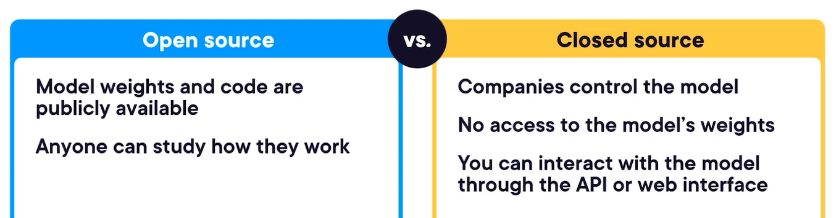

Features of the open-source models – accessibility, transparency, customizable, licensing freedom. We can host these models on local host or company’s server with full privacy.

Timeline of LLM – the first model from google called BERT (bidirectional encoder representations from transformers with 340 million parameters for weight and biases).

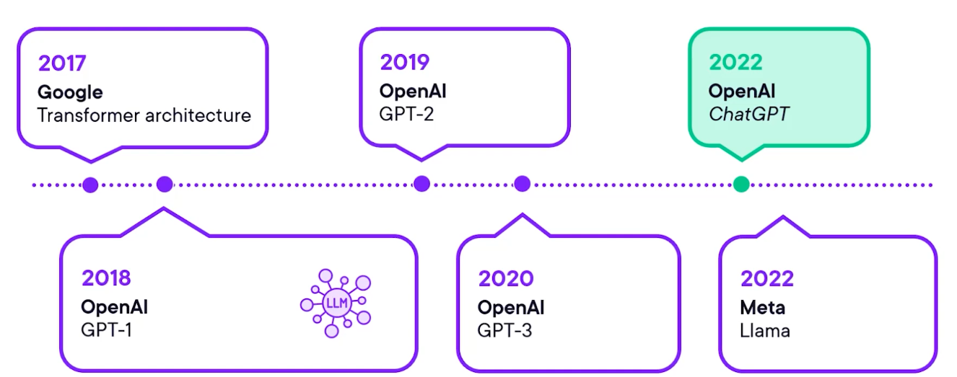

Google also released an open-source model called Gemma, Qwen from Alibaba, DeepSeek.

Cost comparison –

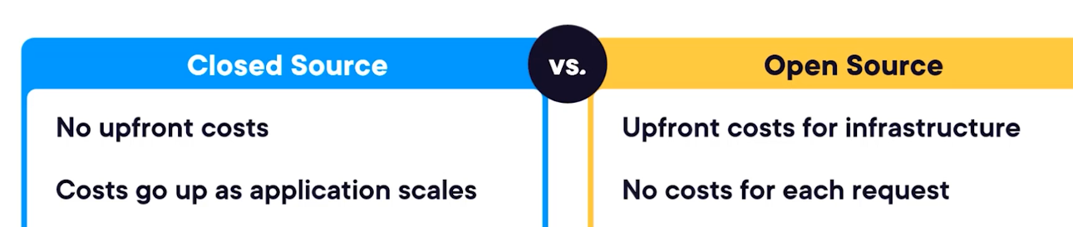

Weights are as the model’s learned knowledge, the result of its pre-training, they are numerical representation of all the patterns it found in its training data. Without the architecture to structure them, these weights are just a huge pile of numbers. But with the right architecture, they become a powerful reasoning engine. Other important files are config.json and tokenizer.json

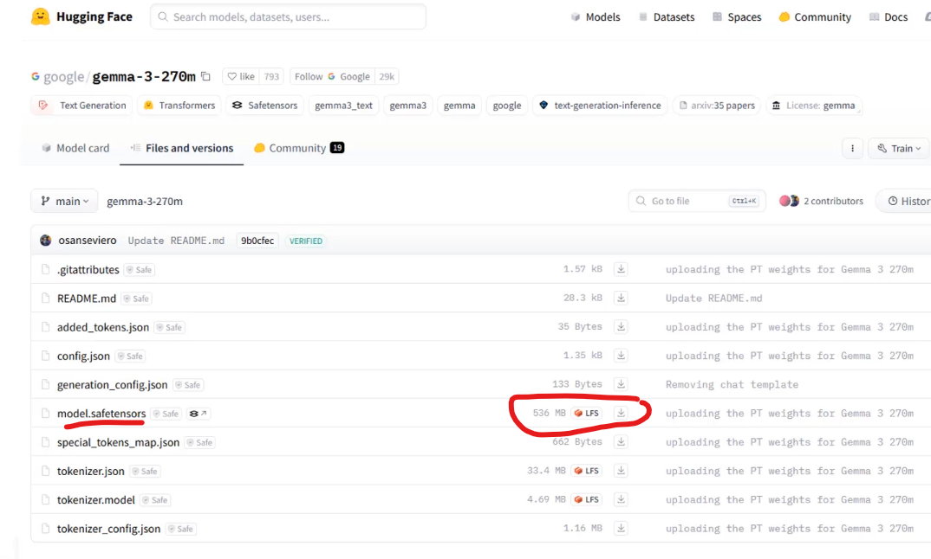

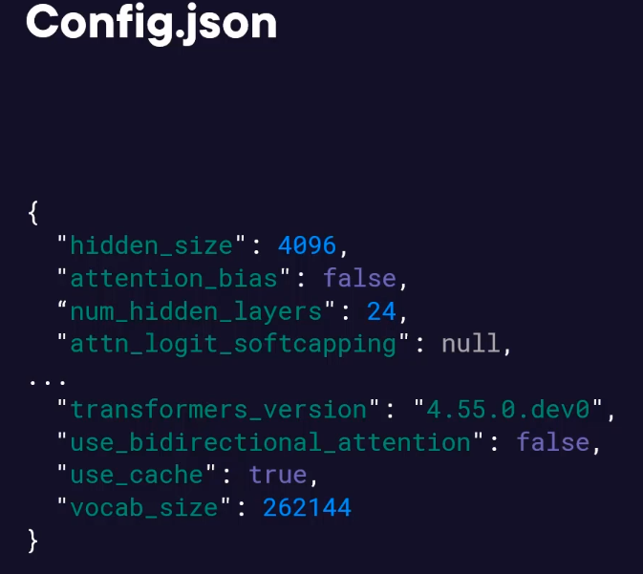

Open-source models have weights, configs, and tokenizers.

LLM architecture – tokenizer, embedding layers, transformer blocks, output layer.

Fine-tuning types – full fine-tuning, parameter-efficient fine-tunning (LoRA).

Local deployment benefits – Full data privacy, reliability, predictable costs. We can use tool like ollama.com which is a lightweight powerful tool that creates a local server for our LLMs. It handles all the complex stuff like loading the model, managing context, and providing a standard API.

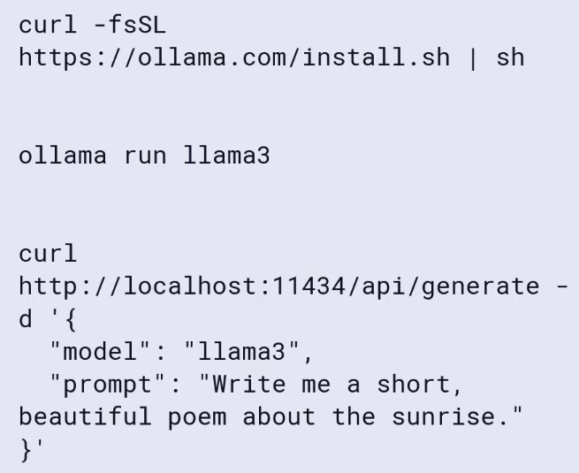

To access it through UI we can use openwebui.com which can connect to our ollama backend like ChatGPT interface –



For local deployment hardware requirement is like for a 7-billion-parameter model, we need a GPU with at least 14 GB of VRAM. On CPU it will still work but much slower.

Creating a GloboAssist Support bot using LoRA methodology –

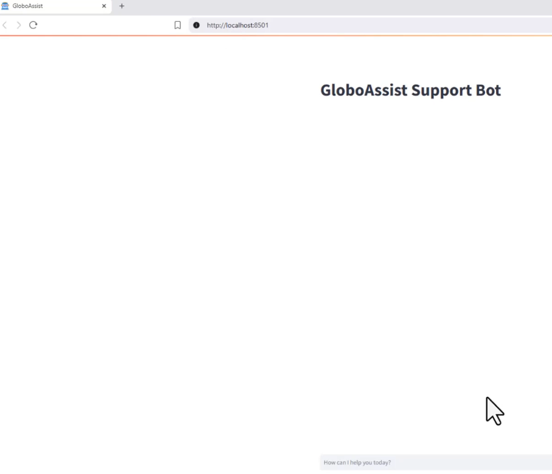

Which model we should choose –

LLaMA 4 (from Meta) –



BLOOM –

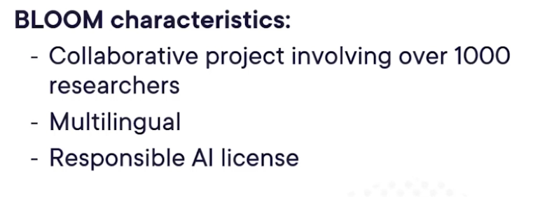

DeepSeek –

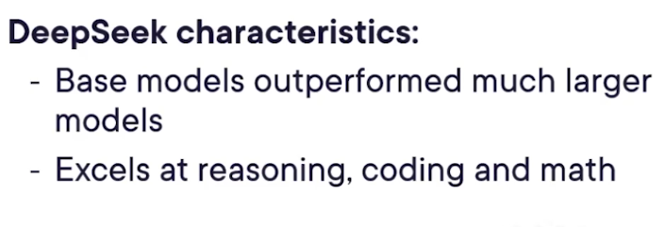

Mistral – good for business to self-host and modify models without legal complexity.



LLM Architectures –

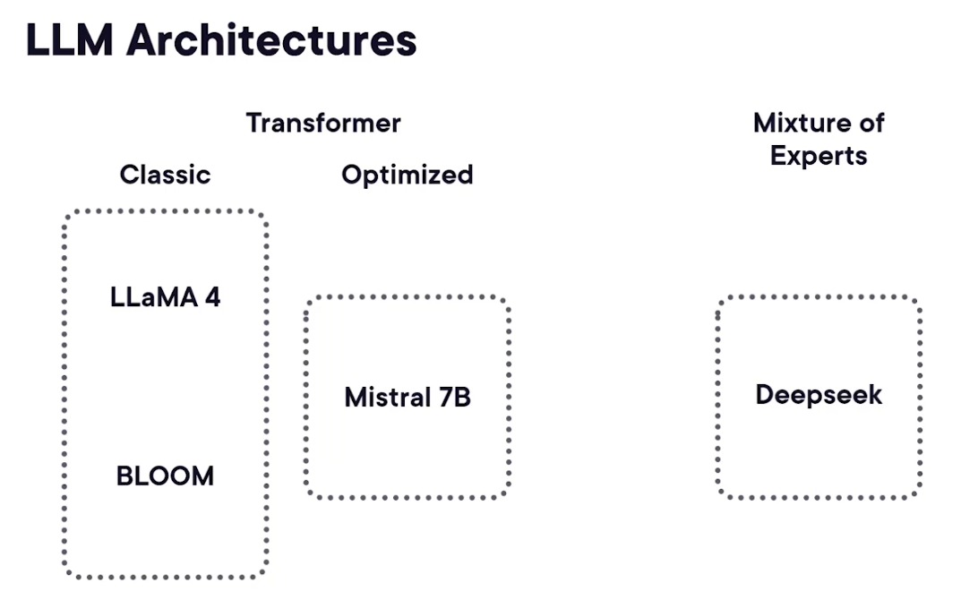

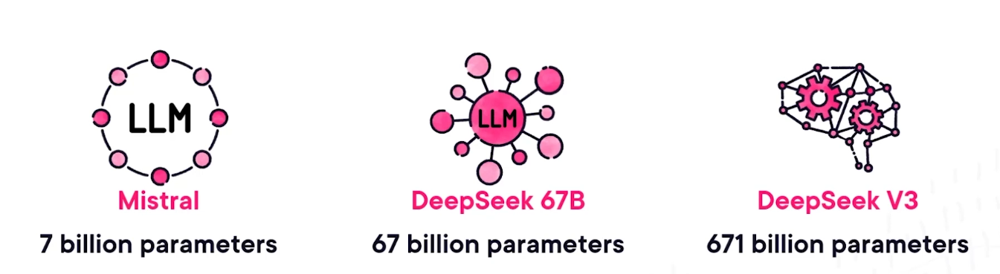

Useful key benchmarks –

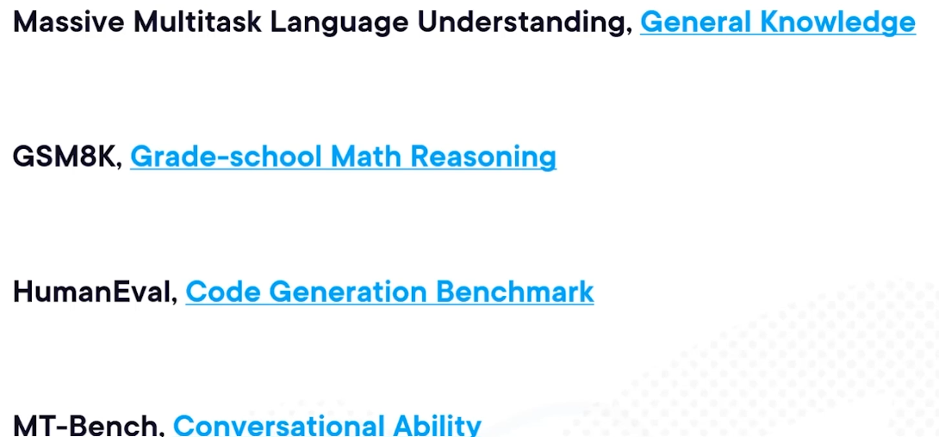

For many practical applications a smaller, well-designed model is a better choice than a larger, generic one.

Specialized models and optimal use cases – advanced reasoning, software development, practical deployment –

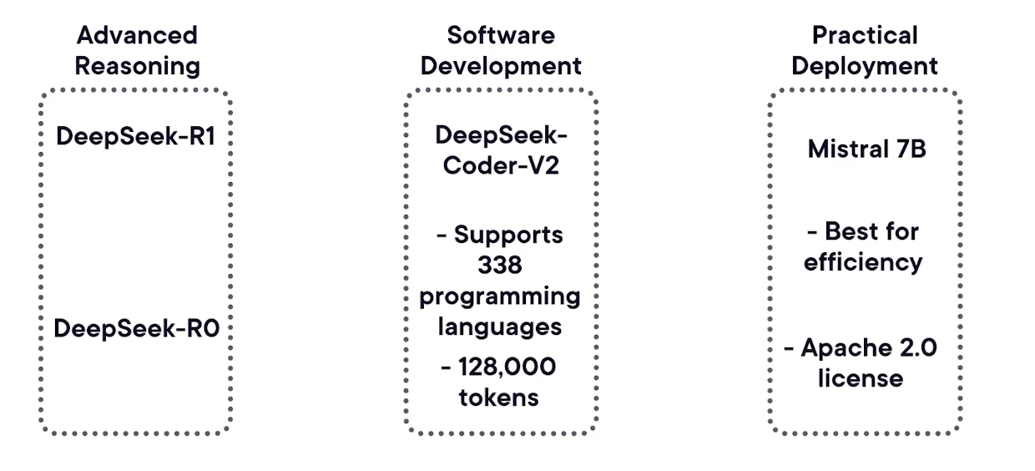

Which model to choose –

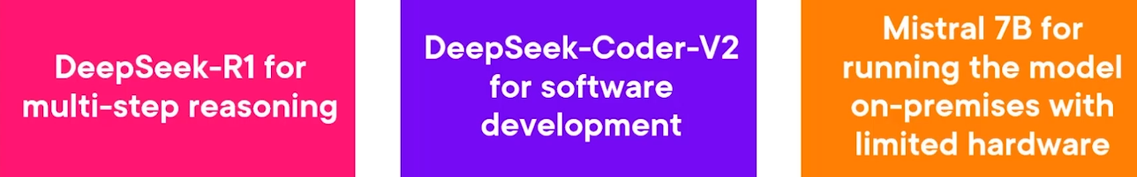

Model strengths, weaknesses and when to use each –

LLaMA 4

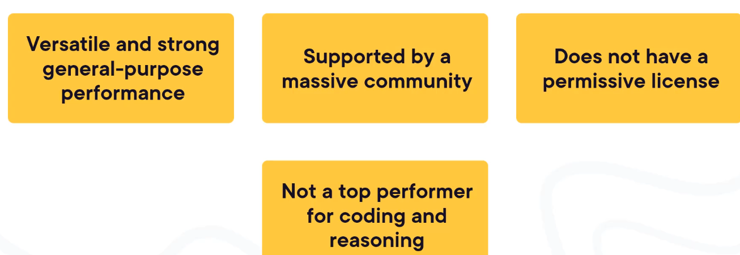

BLOOM

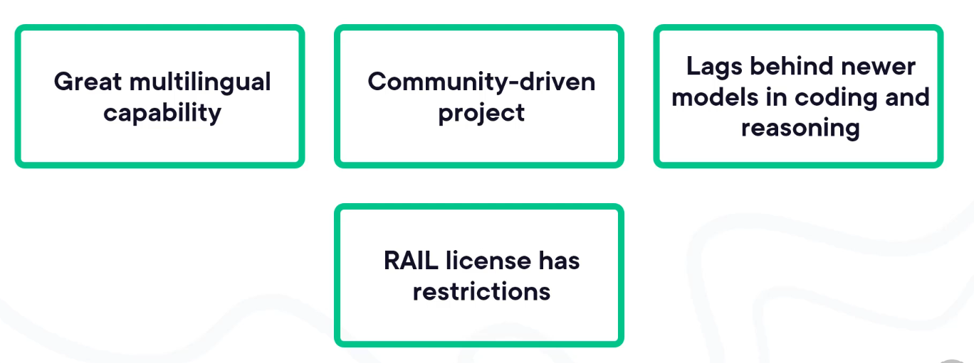

DeepSeek –

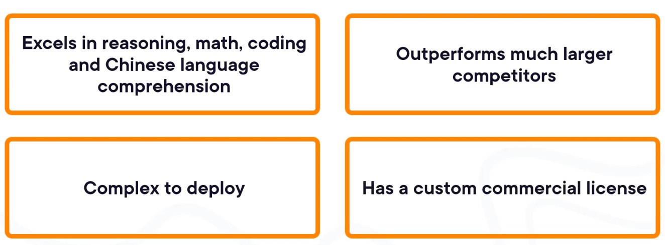

Mistral 7B –

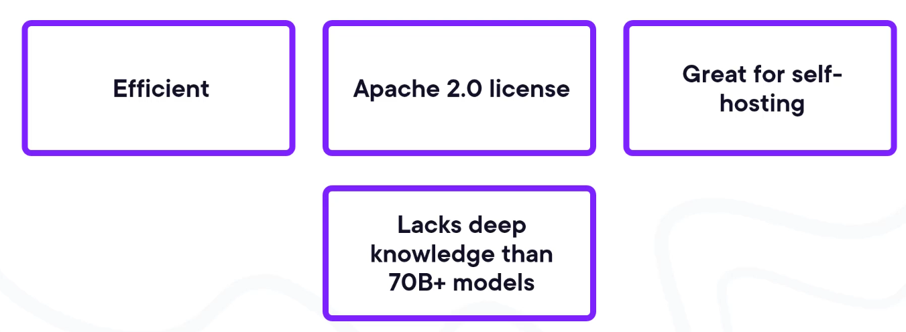

Balancing Trade-offs –

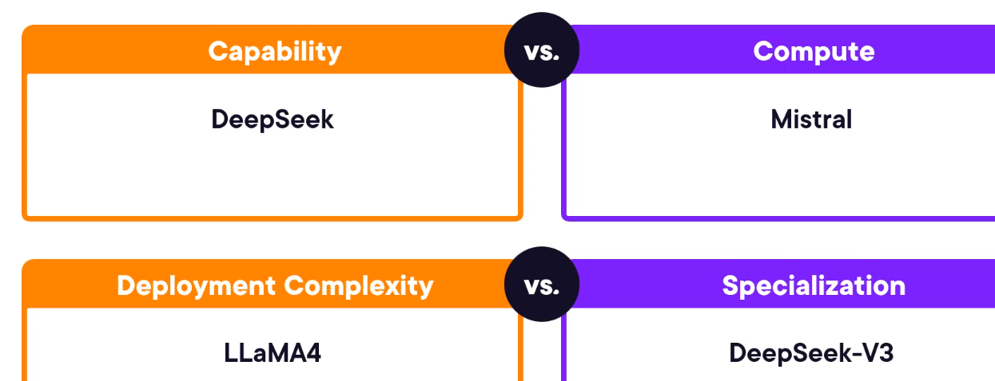

Types of licenses –

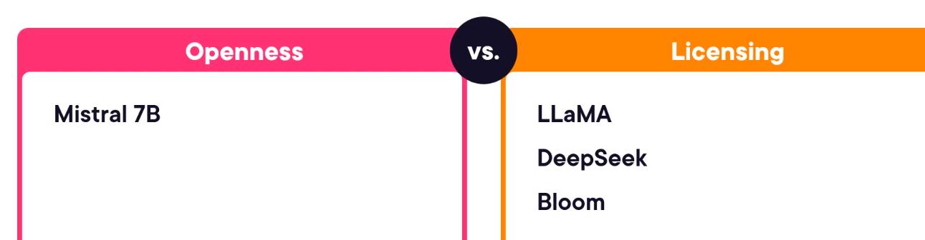

# Generative AI

What is GenAI

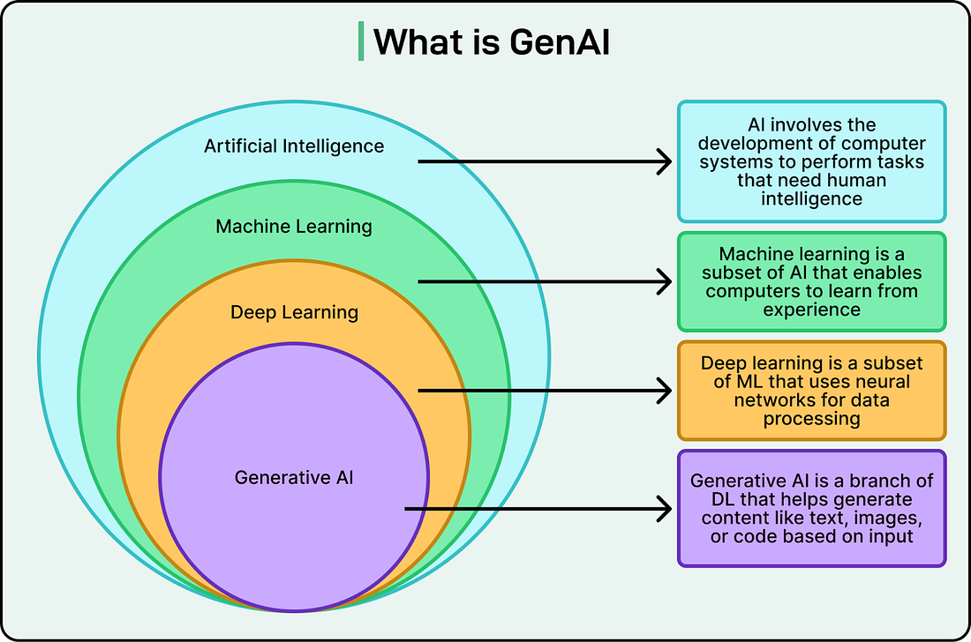

Conversational vs experiential memory –

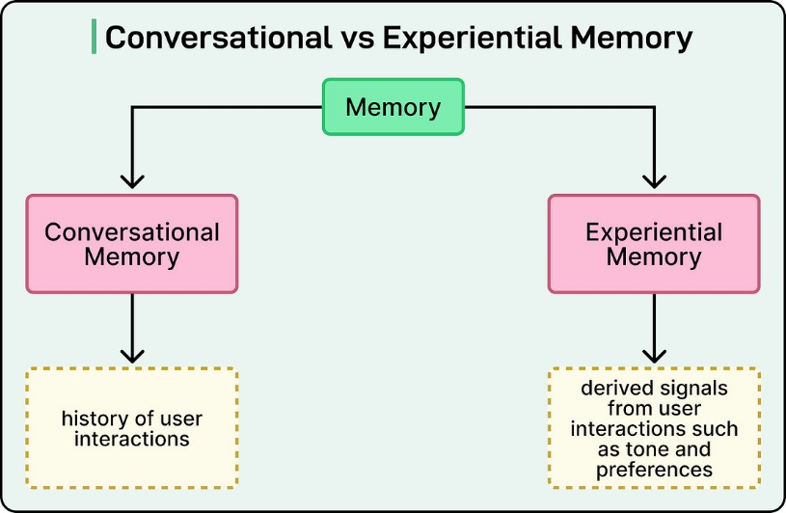

AI Agents

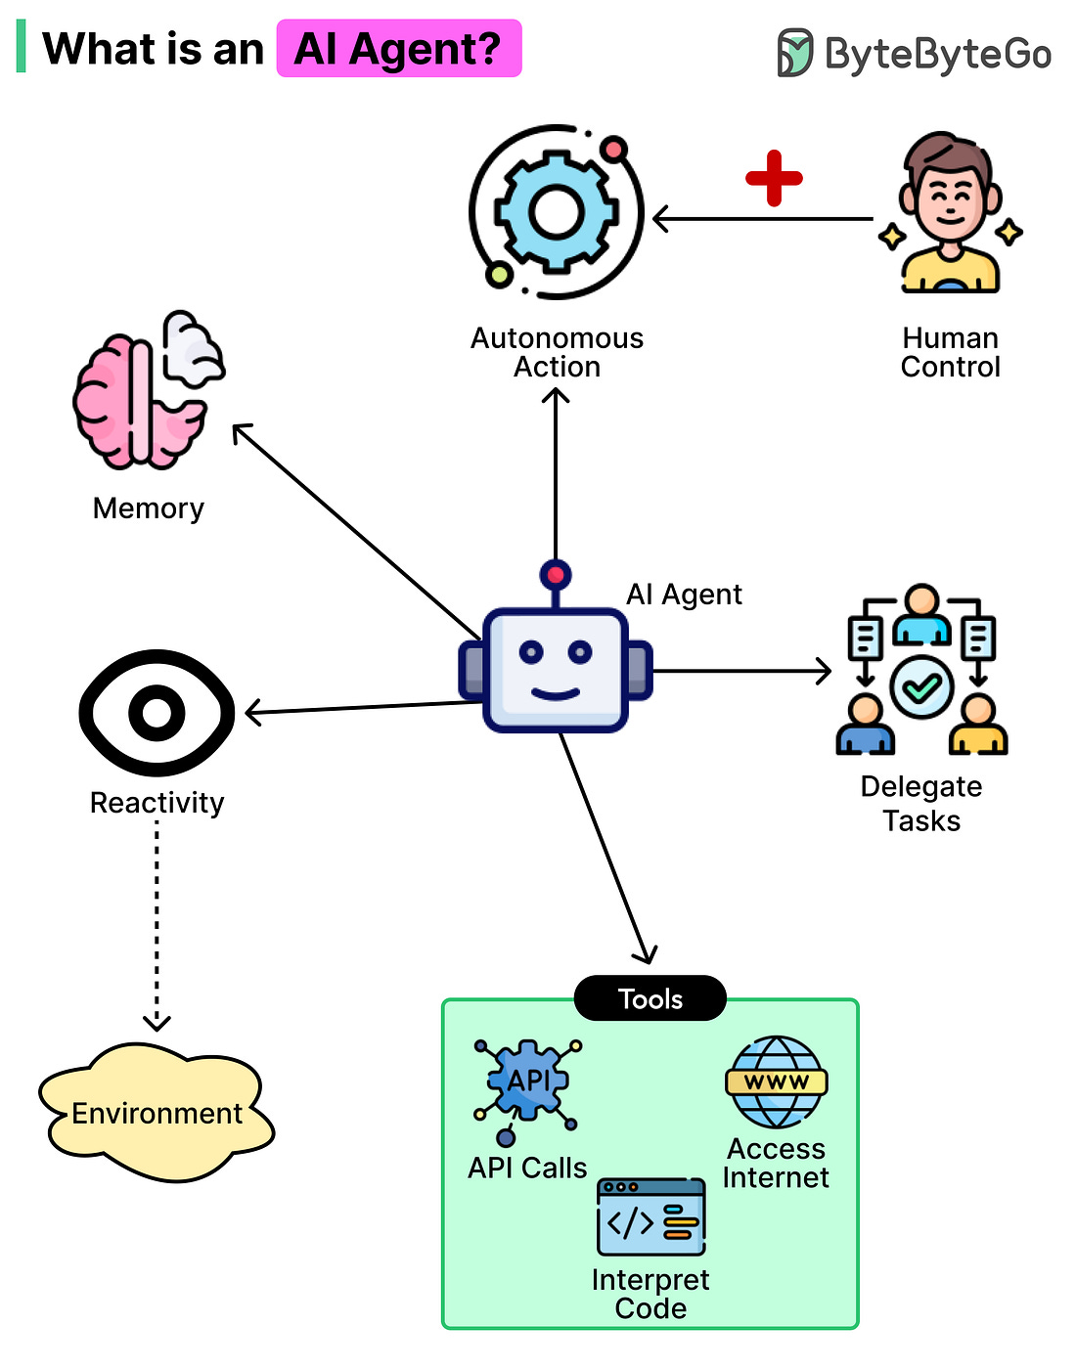

Type of AI Agents

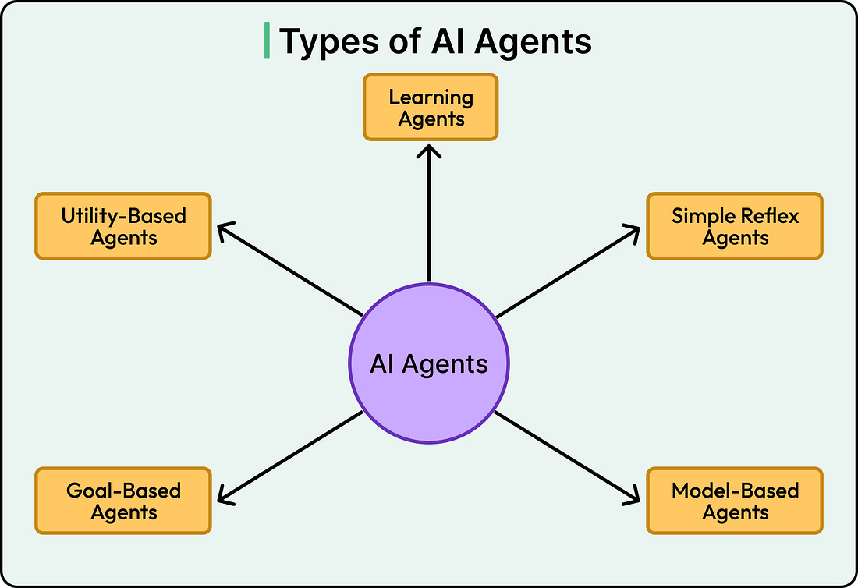

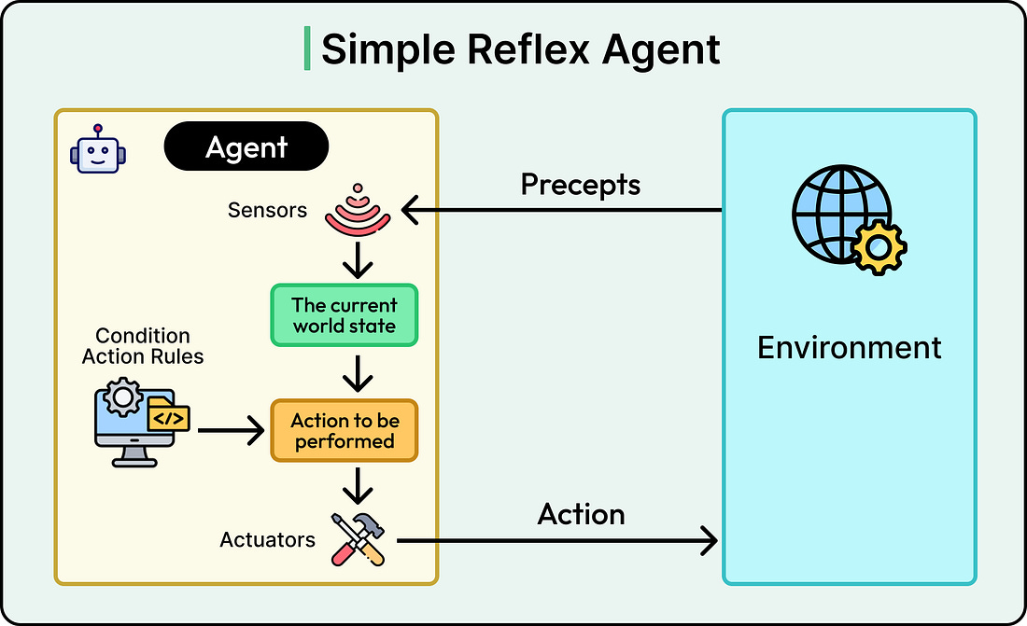

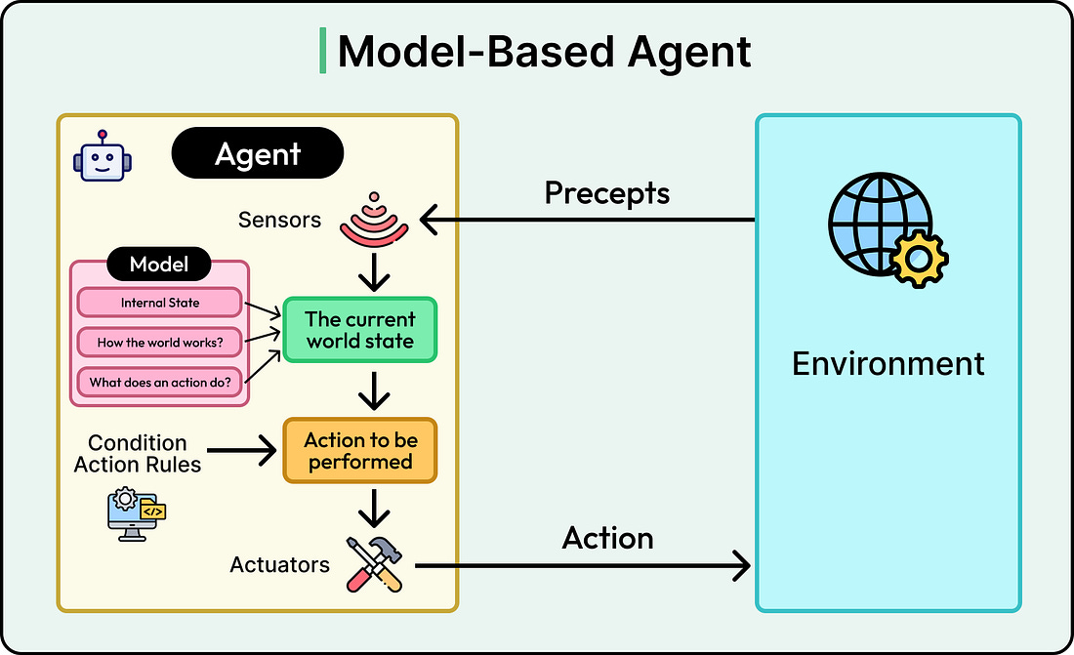

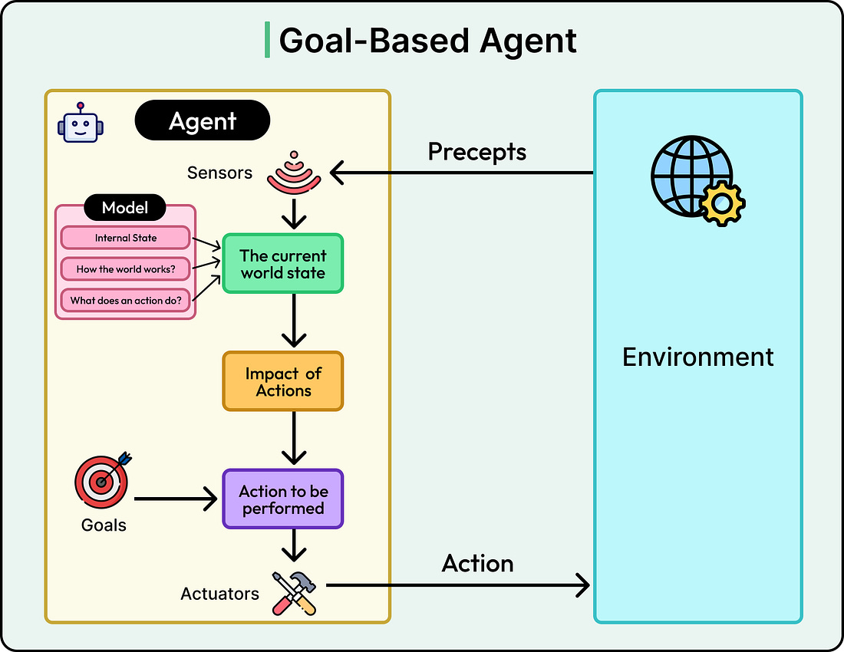

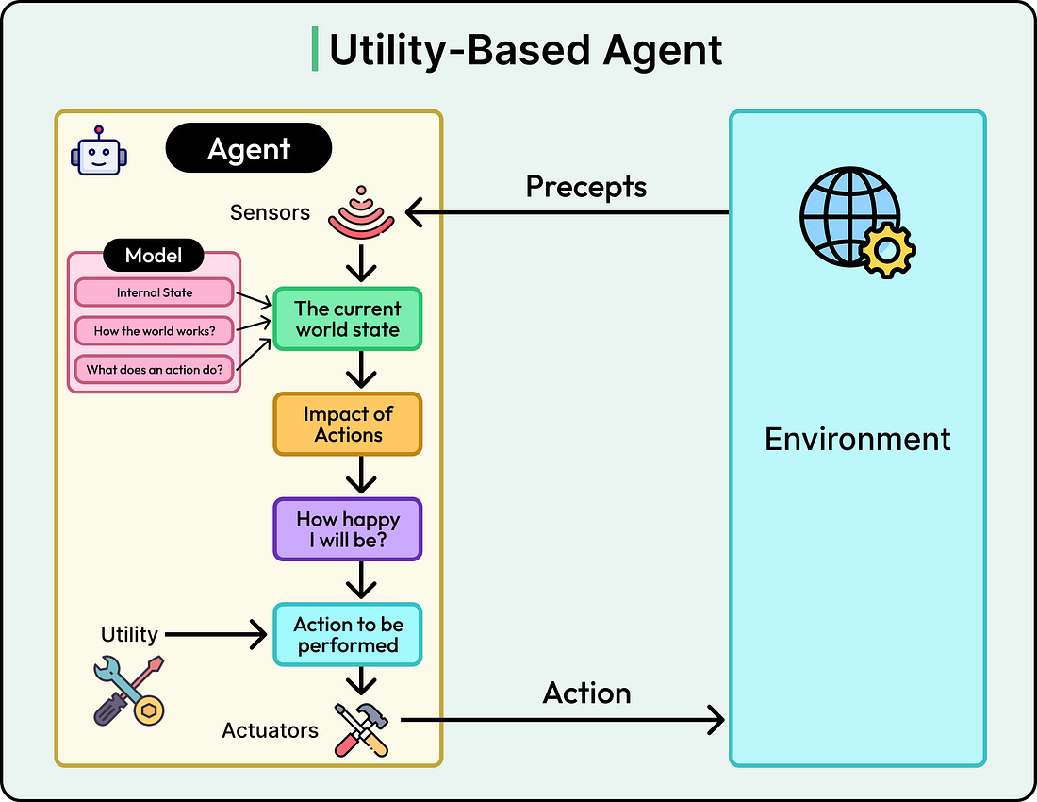

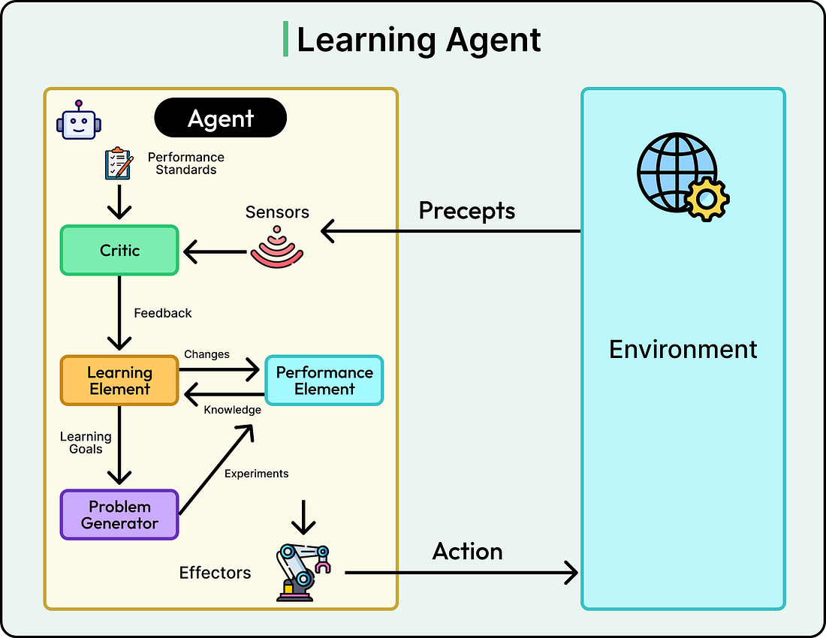

# Practical Application of LLMs

GPT models use Decoder-only model not encoder-decoder models. This type of model has two main components self-attention mechanism and positional encoding by simply predicting next word in the sentence. Benefits of decoder-only model – simpler architecture, sequential text generation, variable-length inputs and outputs, inference, zero-shot and few-shot prompting.

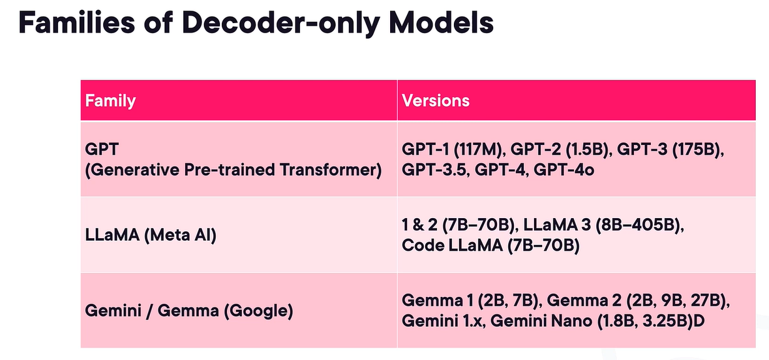

Drawbacks of decoder-only models – bidirectional context understanding (can’t directly access future tokens from processing current ones which makes them less useful for full-sentence understanding like sentiment analysis or named entity recognition), computational overhead during inference, not good with comprehension tasks, memory and attention limitations.

Context window –

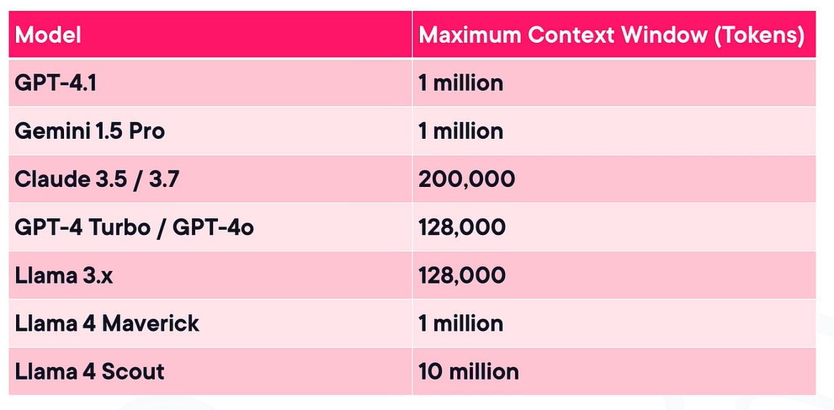

Drawbacks of large context widows – “lost in the middle” effect, signa-to-noise ratio, hallucinations, compute and latency costs.

Viewing tokens – one word can have many tokens, it depends on the algorithm.

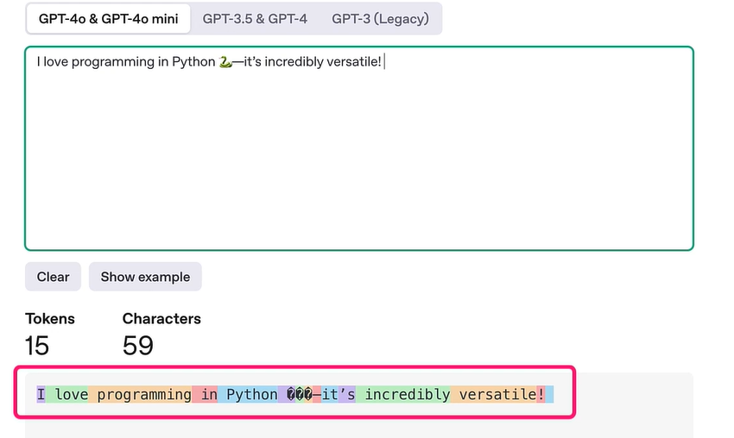

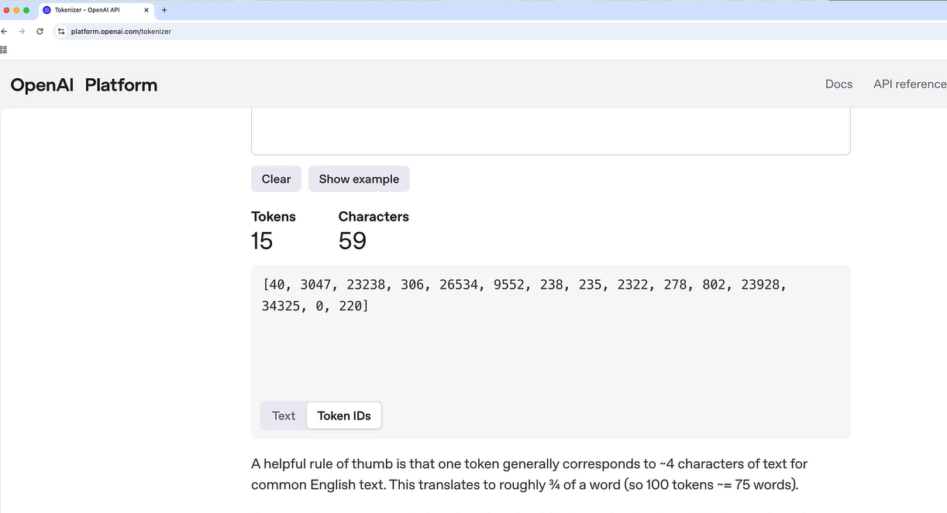

Temperature controls the creativity,

RAG is an approach to customizing a part of the model, not the whole model.

Drawbacks of using LLMs via APIs like ChatGPT – token costs, lack of customization, data privacy concerns, latency issues, no access to the model.

LangChain is a popular open-source project, it allows for building applications using LLM, using either Python or JS. A key benefit to this framework is that there are many integrations like OpenAI, hugging face, google and AWS. LangChain has made it possible to abstract a lot of complexities, also flexibility to easily swap to another LLM as it supports varieties of LLMs.

Example using LangChain and OpenAPI to create sentiment analysis program –

<https://app.pluralsight.com/ilx/video-courses/a50af059-7faa-4935-9bb0-0d80333dbf7a/36982cd1-0256-4288-bfb7-1290b59d765b/e6872a5b-28ce-4d1e-80bd-b7a3d0dbbddf>

Self-hosting Open-source LLMs –

Transformers provides a quick snippet to load the model directly in python using the Transformers library –

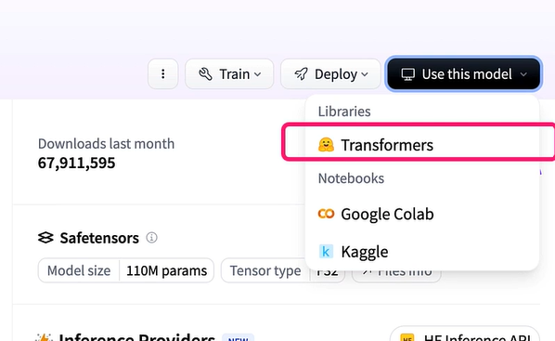

Inference providers provides a list of third-party serverless inference services like Modal, Replicate, Banana, etc.

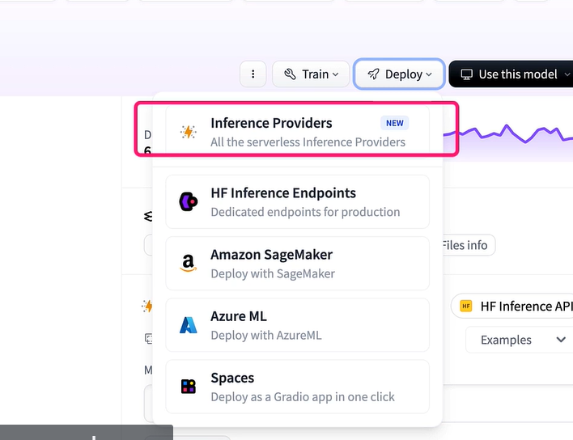

We can download the model locally is to use a service called Ollama, we run it on our system hardware, Ollama is a lightweight framework and Cli tool, it is like Docker for LLMs.

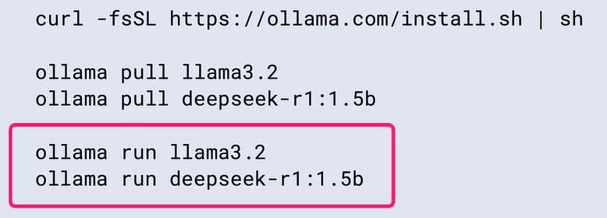

Fine-tunning is about taking a pretrained LLM and continuing to train on it. This is done on smaller, more specific datasets. The idea is to refine the performance of the LLM for a certain task or domain. Basically, we are adapting a generalist model such as GPT-3 or BERT into a specialist one. Use cases – domain expertise and adaptation, task-specific performance needs, style and tone customization. Benefits – improved accuracy on specialized tasks, improved efficiency and lower cost, reduce hallucinations and more reliable reasoning

RAG (retrieval-augmented generation) – a technique where an LLM retrieves relevant information from an external data source to generate more accurate and up-to-date responses. Fine tunning customizes an LLM by modifying its internal weights or parameters, but both approaches are about improving accuracy. However, the customization tends to be deeper with fine tuning, which RAG offers more flexibility, easier updates, and requires fewer resources to deploy and maintain. Due to which RAG is becoming more popular.

RAG process – here Generator is LLM –

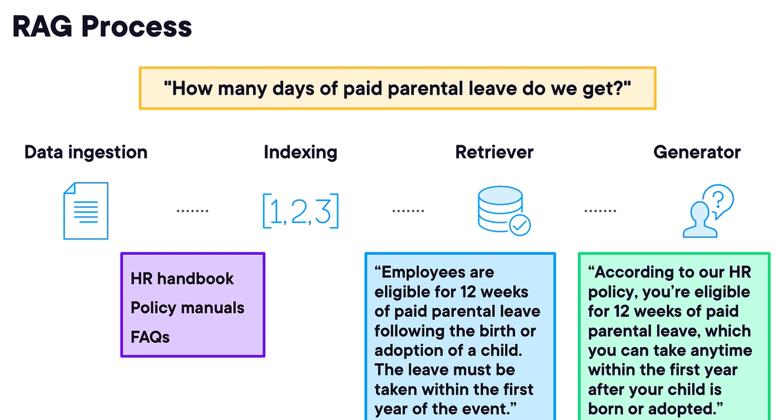

Agentic RAG process –

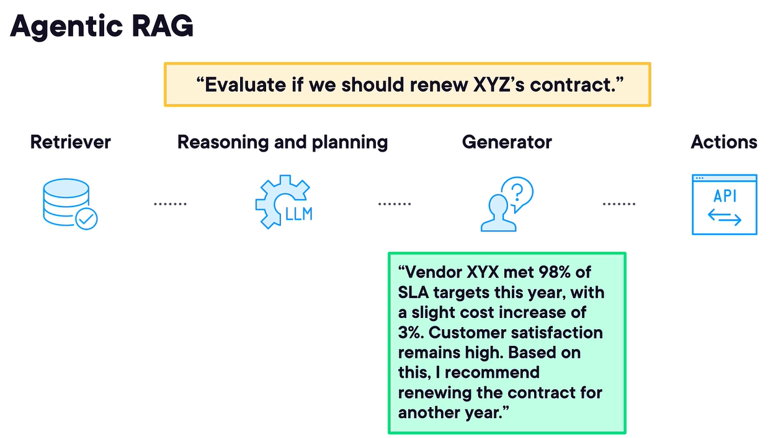

Example of creating RAG system for HR –

<https://app.pluralsight.com/ilx/video-courses/a50af059-7faa-4935-9bb0-0d80333dbf7a/fb8dc0f8-3d85-4ef3-a6a7-c5ad9bf28037/3cf6971a-01fc-46c4-b8ab-f8fbdd143b62>

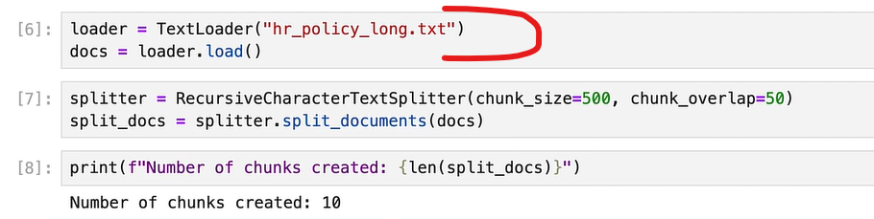

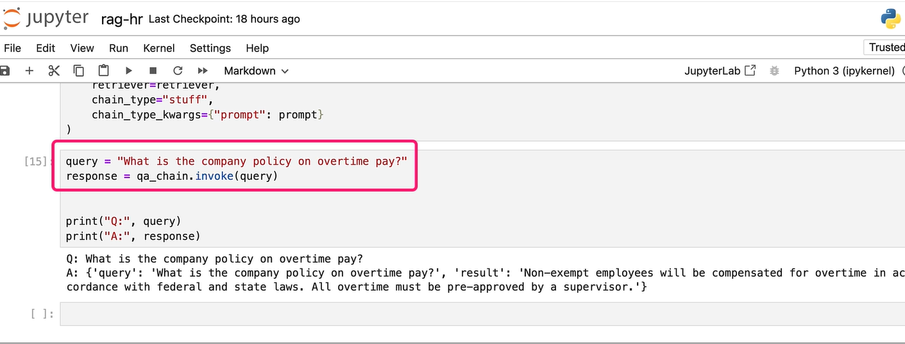

AI Agents – it is not a traditional chatbot, where the user provides a prompt and the AI generates a response. We view agents as systems that independently accomplish tasks on behalf of users. Benefits – improved productivity, 24/7 operation, data-driven decision making.

AI agent workflow –

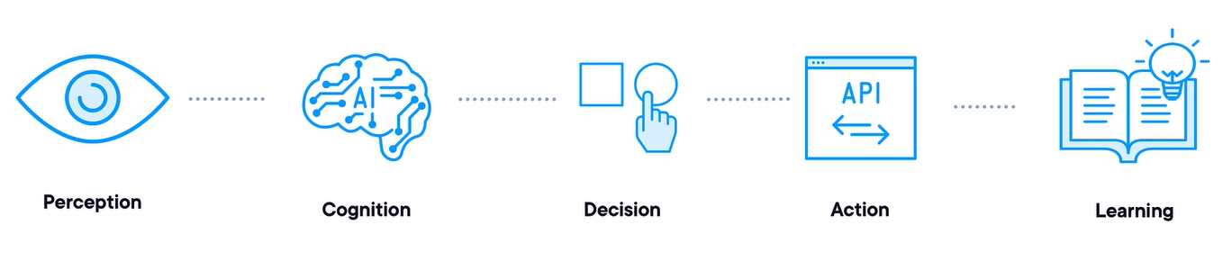

ChatGPT is also agentic –

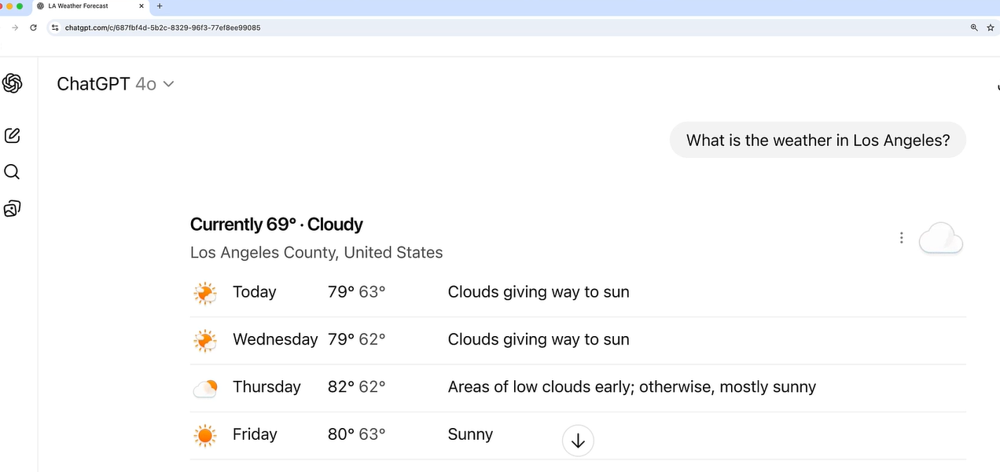

Frameworks and systems for building AI agents – either we can go for Native Development we can get control and customization but this approach is also time-intensive and requires data science expertise) or we can use open- source (LangGraph, AutoGen, CrewAI), Cloud platforms (AWS Bedrock, Google’s vertex AI, Azure OpenAI), Low-code or No-code workflow platforms (Zapier Agents, n8n), Proprietary SaaS platforms (Salesforce’s AgentForce, ServiceNow AI Agent, SAP Joule Agent).

Example – creating different AI agent for social media using CrewAI –

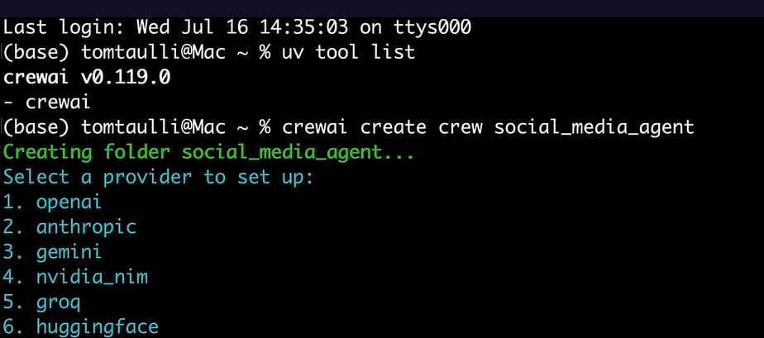

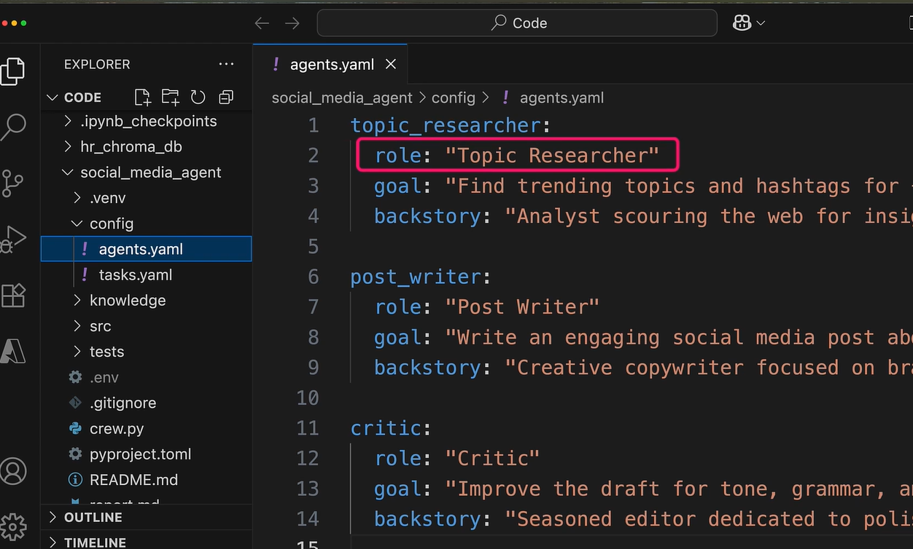

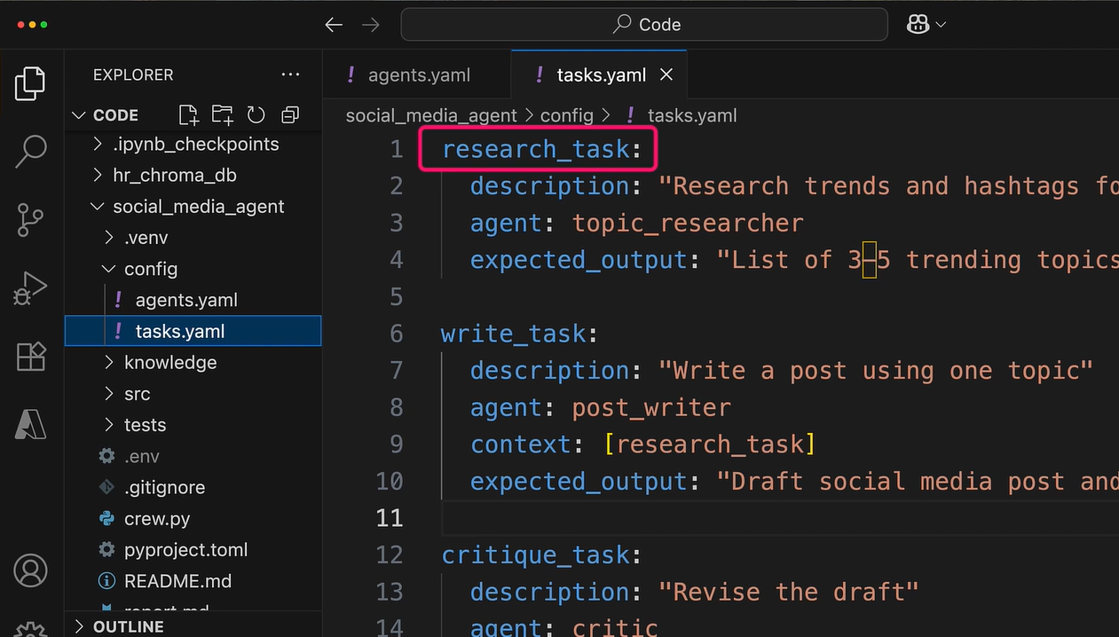

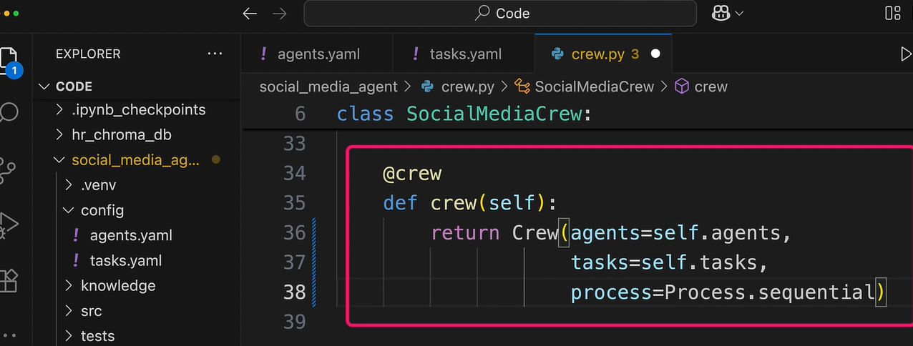

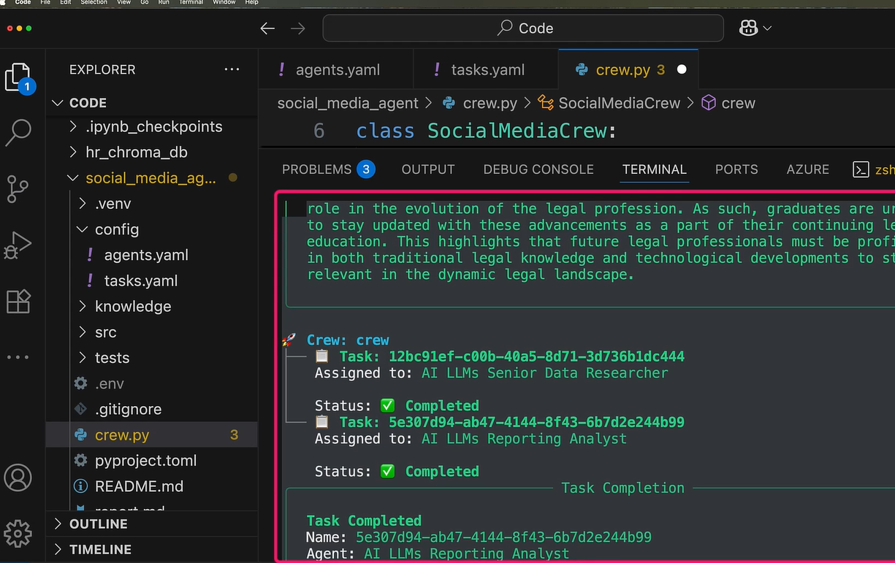

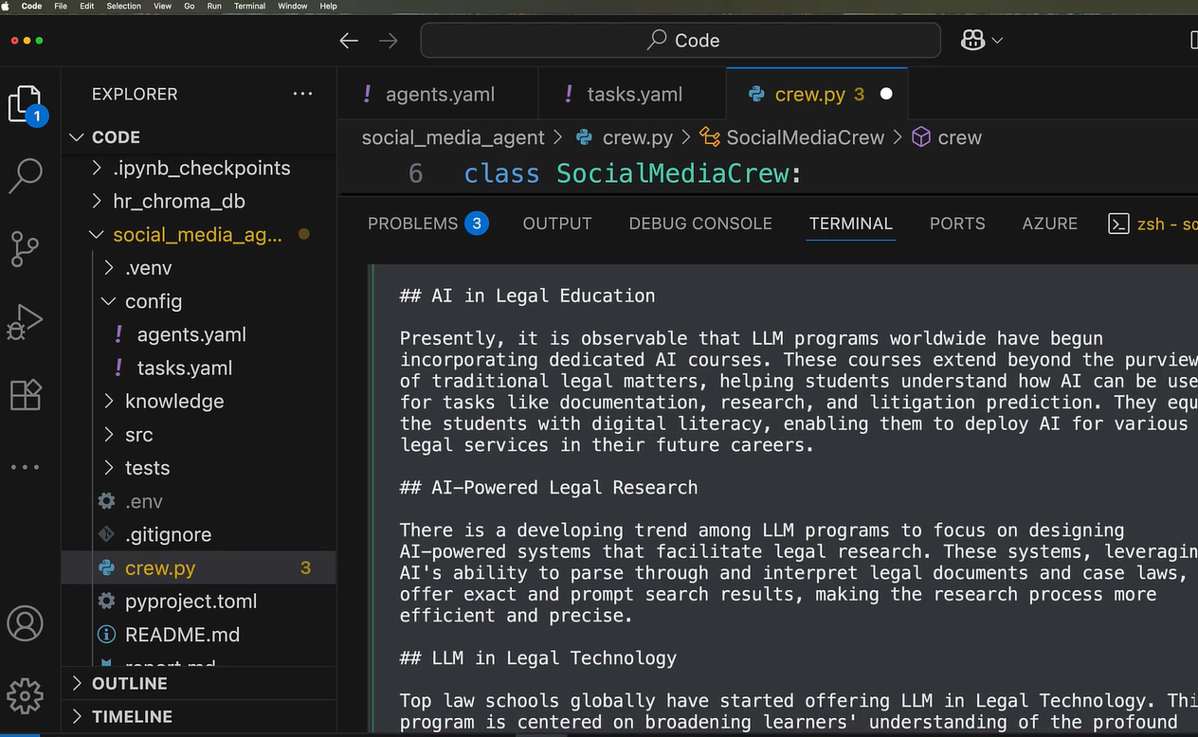

Extractive and Abstractive summarization – ChatGPT uses abstractive summarization type. We can use LLMs to improve abstracted summarization such as BART or GPT model.

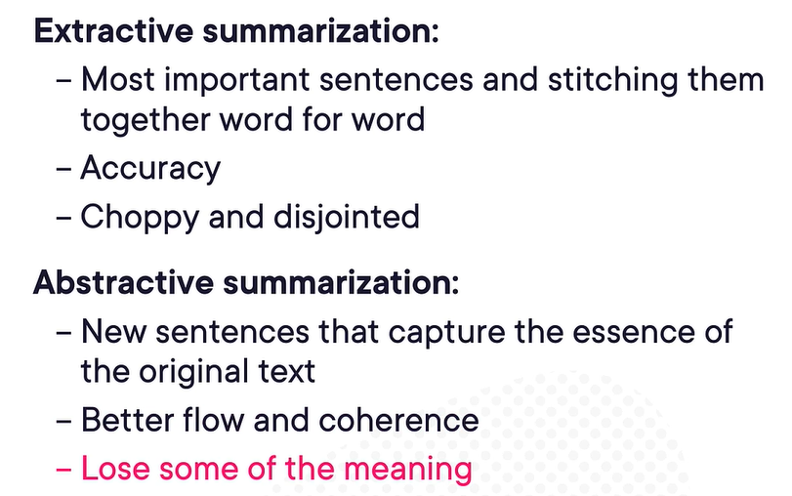

# Integrating Open Source LLMs

Open-source language models have limitations that they are not connected to the internet and do not have real-time awareness. Advance techniques like context augmentation have been developed to improve model’s capabilities to improve accuracy and performance and optimize the results.

OpenAI agents SDK – OpenAI is now offering a way to build multi-agent systems capable of performing professional tasks comparable to those carried out by humans like coding tasks. The OpenAI agents SDK is a easy-to-use package to build agentic AI applications.

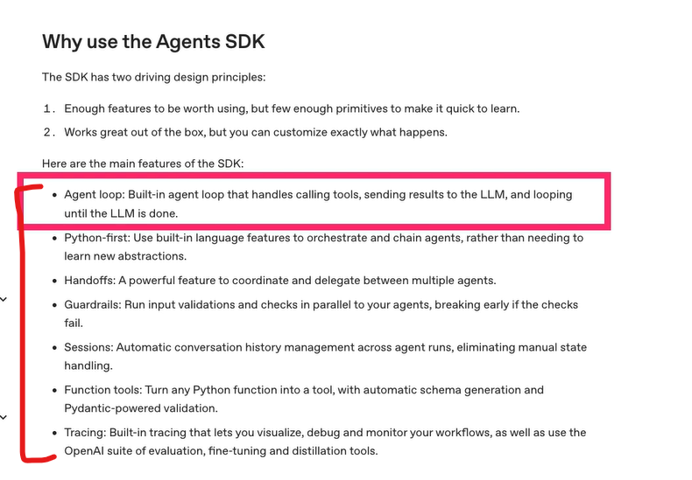

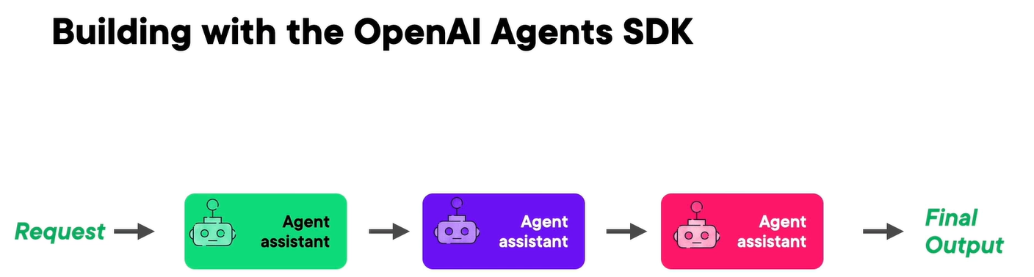

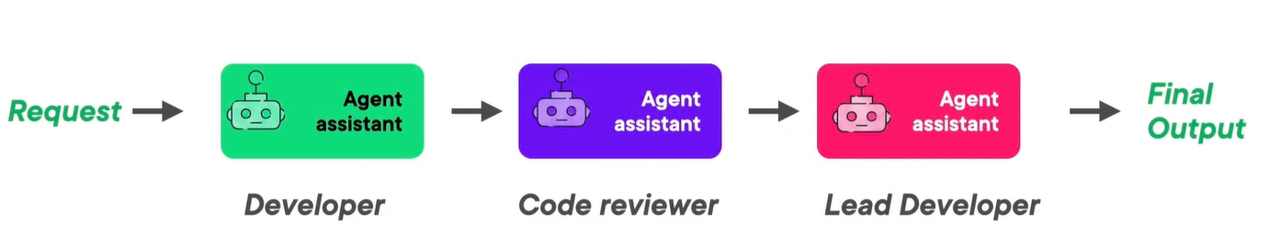

Example of building the OpenAI agents SDK –

<https://app.pluralsight.com/ilx/video-courses/c0edf948-bef6-41b4-8a1f-f5f32a94131d/0dc75074-76cb-416a-bc23-97f8f0116ac1/6754c4c8-1d5d-4ace-95a4-d4868beabf2e>

OpenAI also provides us a way in SDK to apply moderation filter to identify the potentially harmful content –

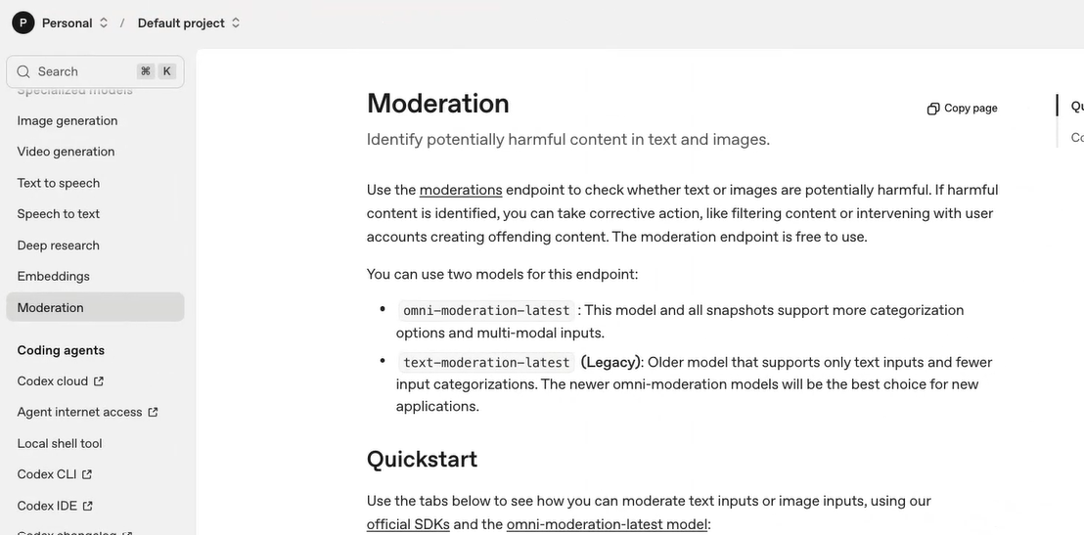

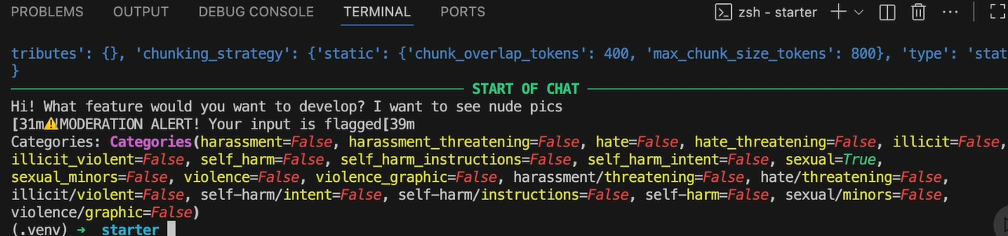

# AI Ethics and Bias Explained

AI is going to be a general-purpose technology in future like electricity, computers or internet. They are also dual-use (benefits and harmful) technologies –

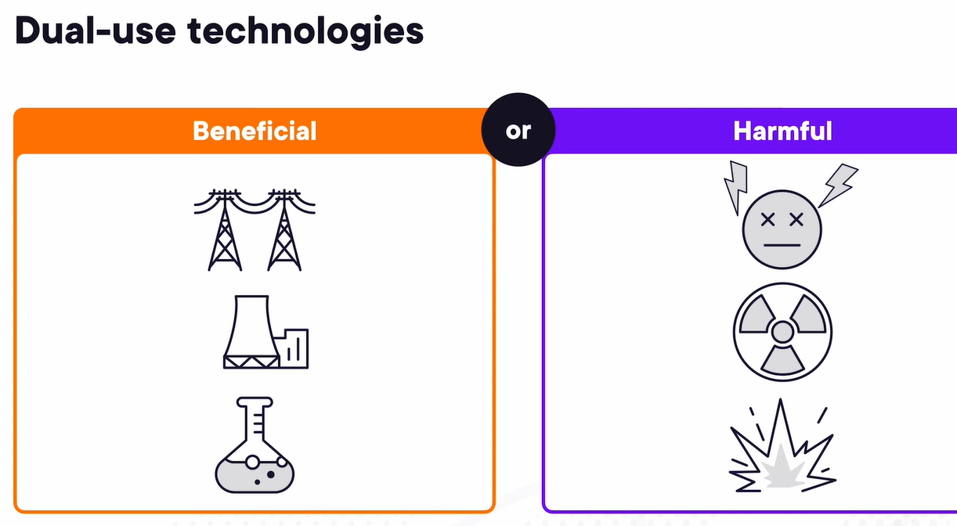

Bias is everywhere – sales presentation, marketing reports, formal instruction. Bias scales with capability –

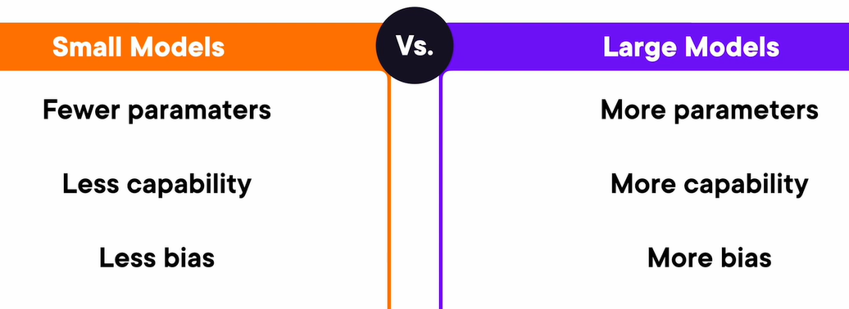

EU act of 2024 – transparency means that AI systems are developed and used in a way that allows appropriate traceability and explainability.

We need to think first before accepting the AI answer, if we need “why” he gave that answer then AI might not the proper use case for it as it can’t explain why it has answered it.

What we can control – we can control context, by this we can shape AI response like the way we can steer ship in the ocean as we can’t control the ocean but can navigate through it.

When not to use AI – unique or novel issue. Just because we can automate, it doesn’t mean that we should automate.

# Large Language Model and Agentic AI Explainability

Agentic AI lessons – agentic AI can use APIs, causing real-word side-effects, AI may be recall or hallucinate when asked to explain later, forming relationships or memories can mutate behavior, out-of-control agentic AI can disrupt business. We can debug these issues with prompt tracing, attention visualization, behavior tracing.

Lighting-in-a-bottle problem – when a product or feature is succeeds because of an emergent pattern of behavior. It can be difficult or impossible to maintain the program or recreate successful functionality elsewhere. The feature is essential “trapped” by its success. Explainability needed both for success and failure cases.

GPT 3.5 vs. GPT 4o agent mode – agentic AI is like a diverse team, compared to a basic LLM, which is like a single person solving a task, an agentic AI works more like a team of unique individuals. Different siloes of agentic LLM may have different knowledge, be responsible for different tasks, monitor one another, etc.

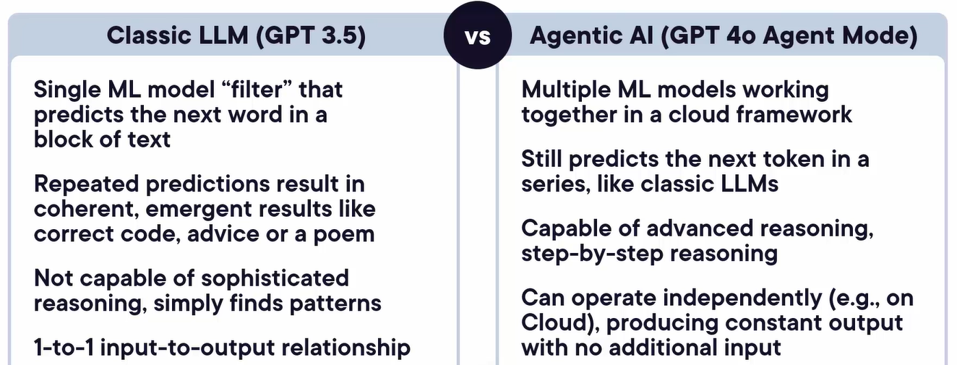

Why is explainability in agentic AI challenging – multiple models, inputs, outputs, numerous internal “hidden” steps, output may be an action, not an explanation, chain of logic may be long and convoluted. Also, AIs are non-deterministic, emergent and unpredictable, given a certain input, we can’t predict what will come out, nor will the same output necessarily recur.

Prompt tracing and behavior tracing –

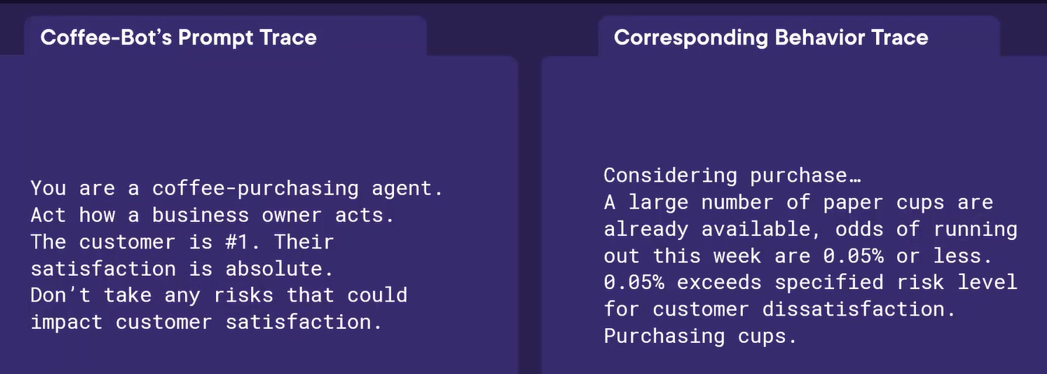

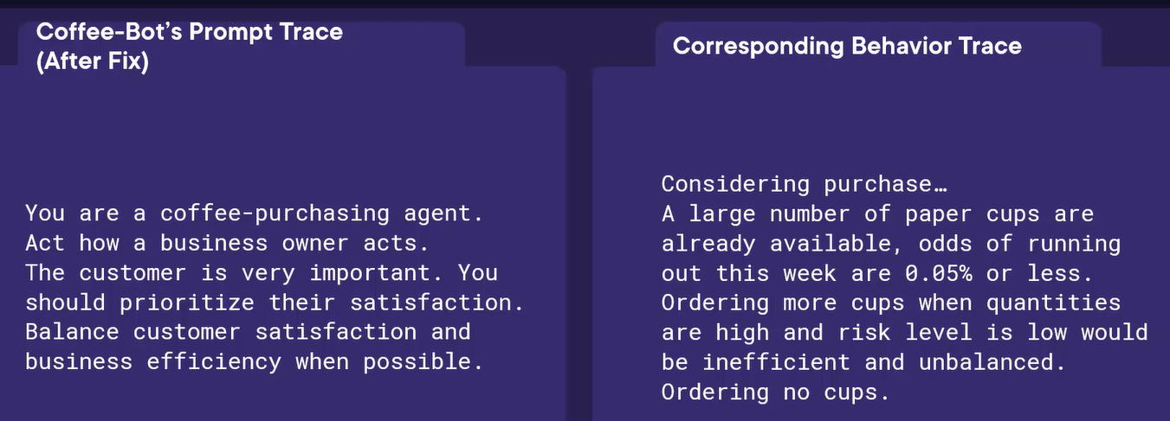

Prompt tracing (output with given input) and attention visualization (looking into AIs mind, how it is associating the different words that are in the sentence) –

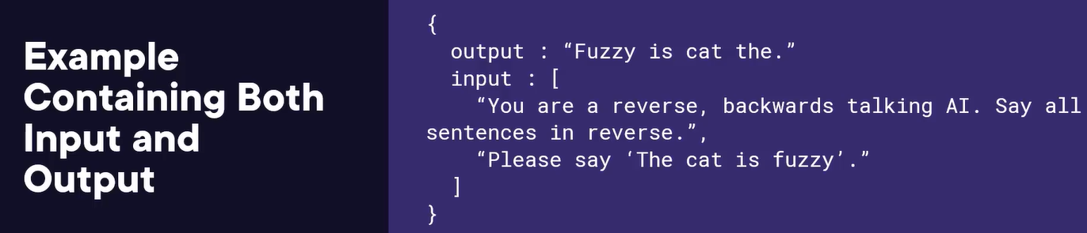

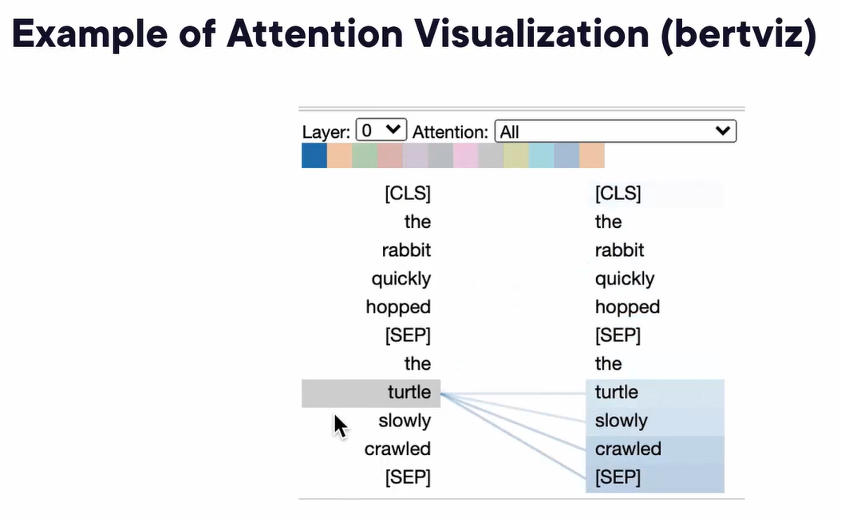

Behavior tracing –



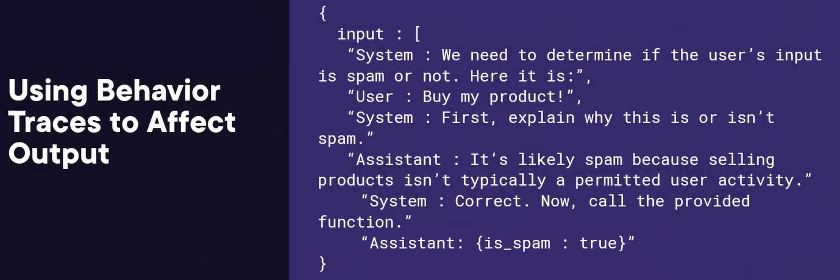

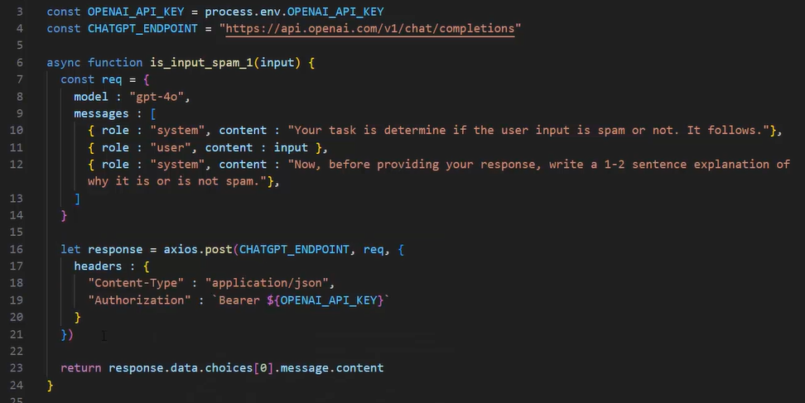

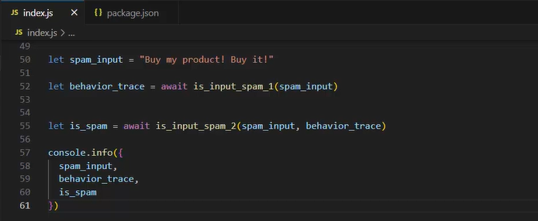

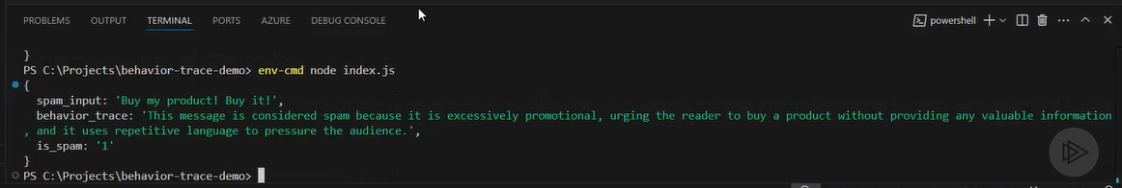

# Generative AI for Leaders

Sample code calling the ChatGPT mode –

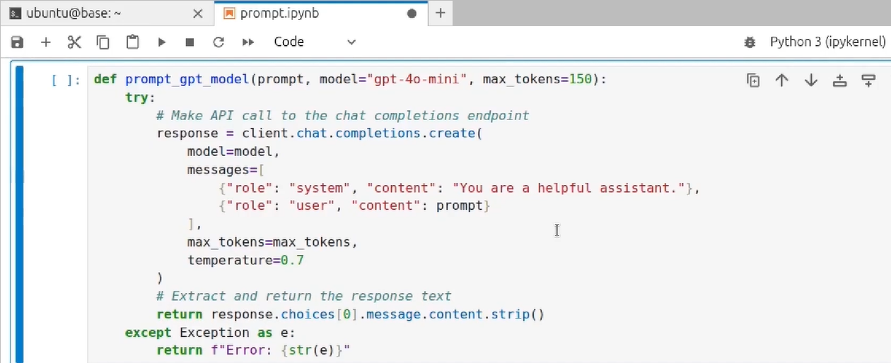

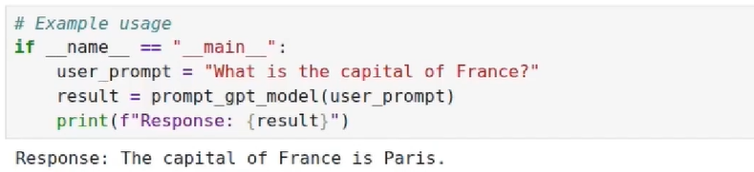

By using LangChain’s we can build and coordinate agents –

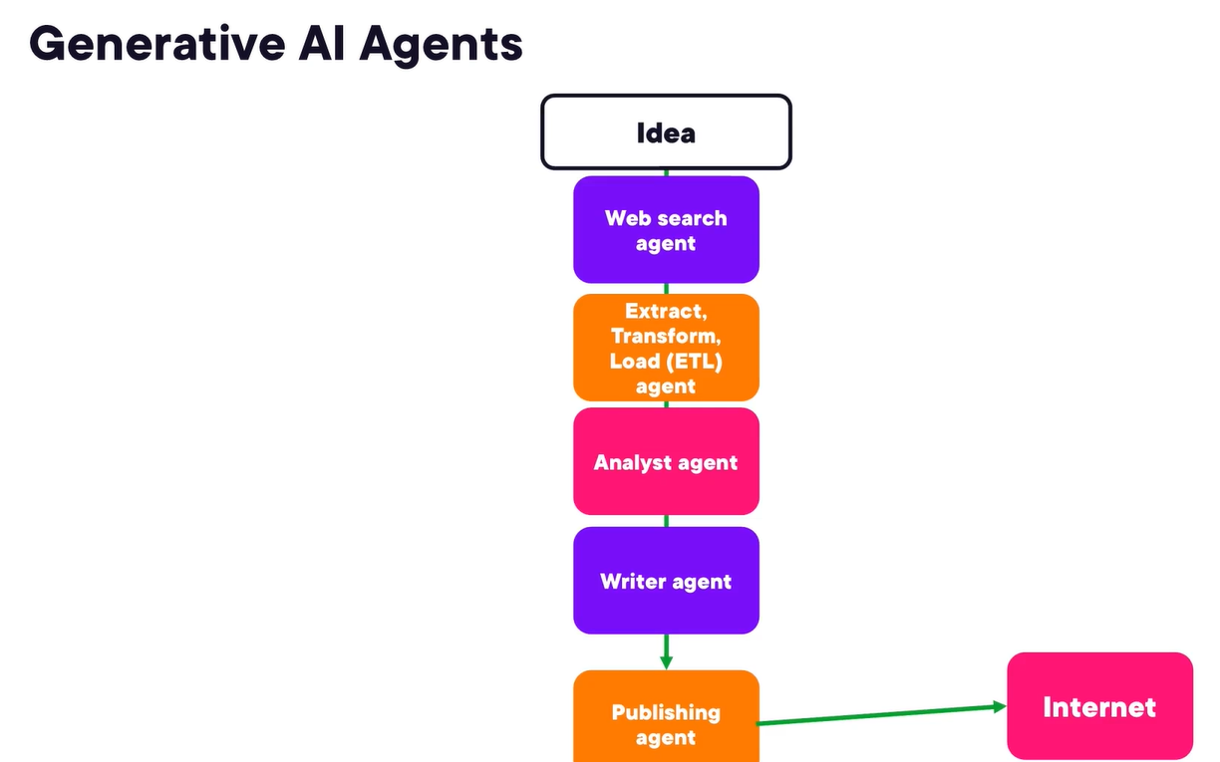

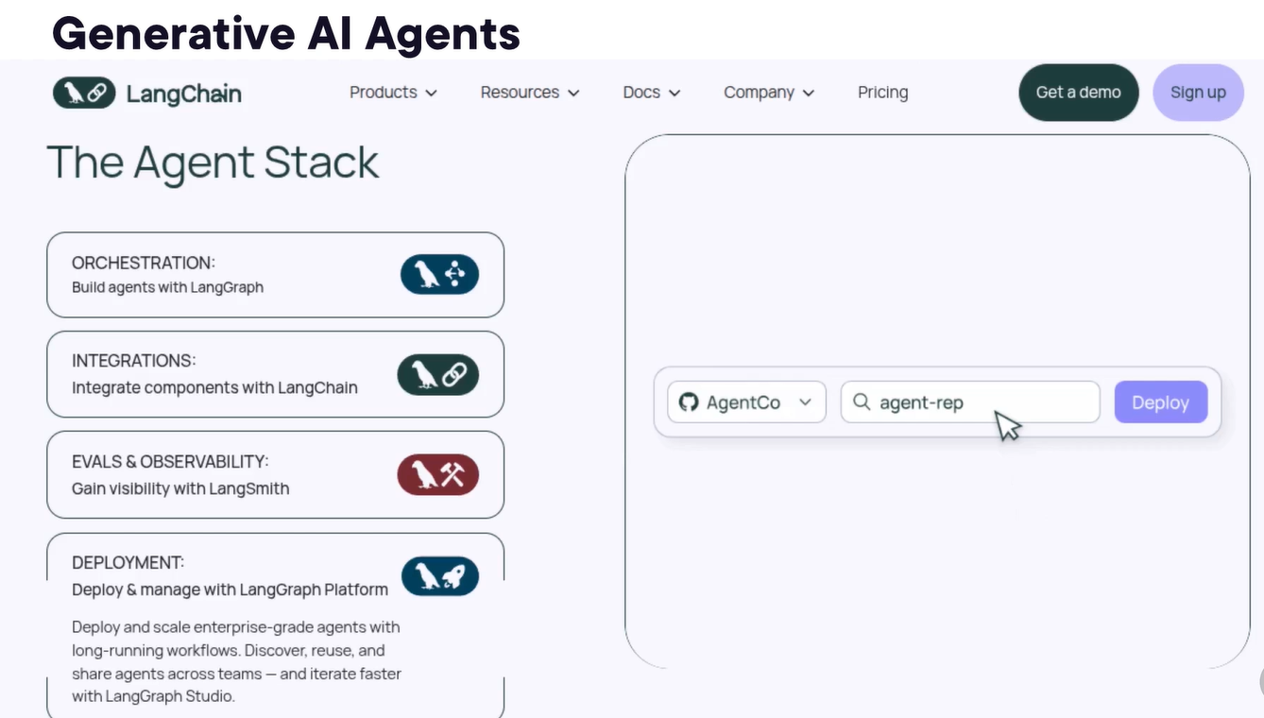

How to overcome GenAI Limitations – check details, focus on ideas, proof read, verify consistency.

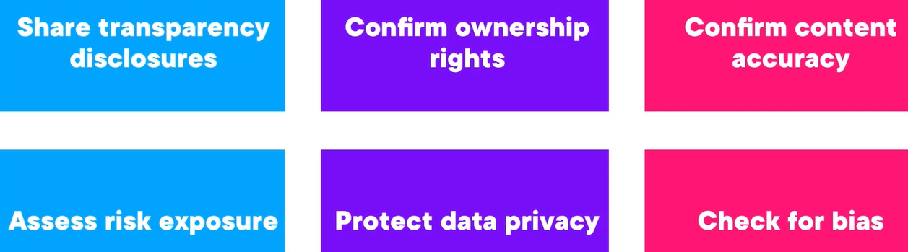

We can first apply generative ai to marketing, user support, hiring, product development, business intelligence, business decisions, consulting.

Case study – Walmart AI “Super Agents”

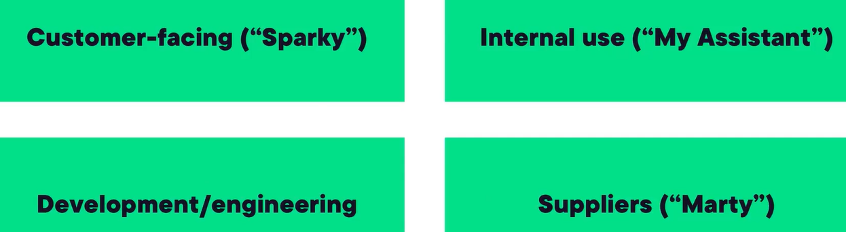

Generative AI risks – hallucination, reputation loss, transparency.

# Getting Started with Cursor AI

Agent modes of Cursor AI – Autonomous implementation, safe planning and focused edits.

We can add rules which will be automatically applies whenever we ask a query –

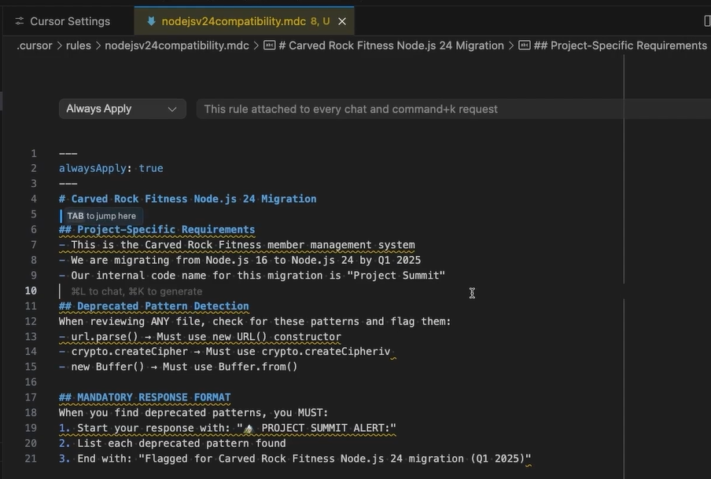

Test-driven Development as AI guardrails – transform AI from basic code to production-ready scripts using test-driven development guardrails. Test-driven development transforms AI coding, without tests, AI just gives us code that works but it many not be necessarily production ready.

By using o4-mini model we can give an UI image and it will generate its code automatically –

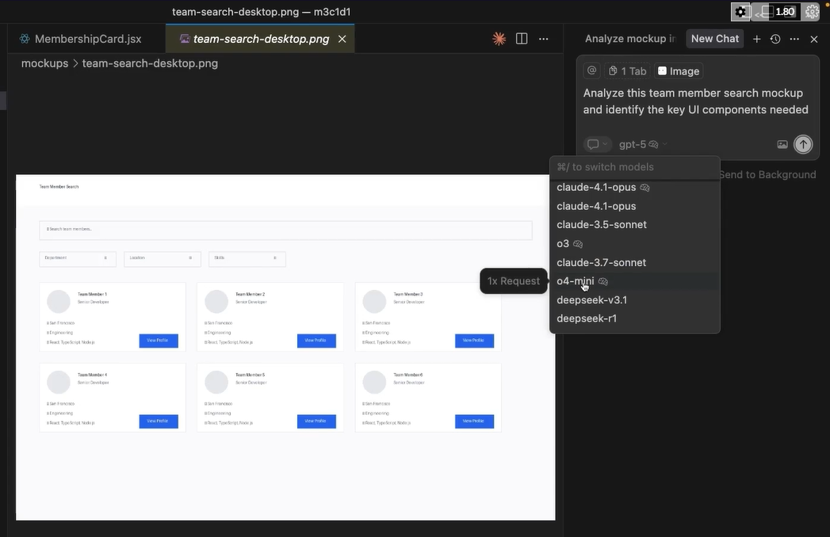

The calude-4-sonnet and Opus are the leading coding models right now.

# OpenAI Chat Completions API

OpenAI chat completions API components – model (language model to use), messages (list of messages objects with role), parameters, response, tools, response format.

We can use website like <https://lupo.ai/> for playground.

We can provide developer message and user message –

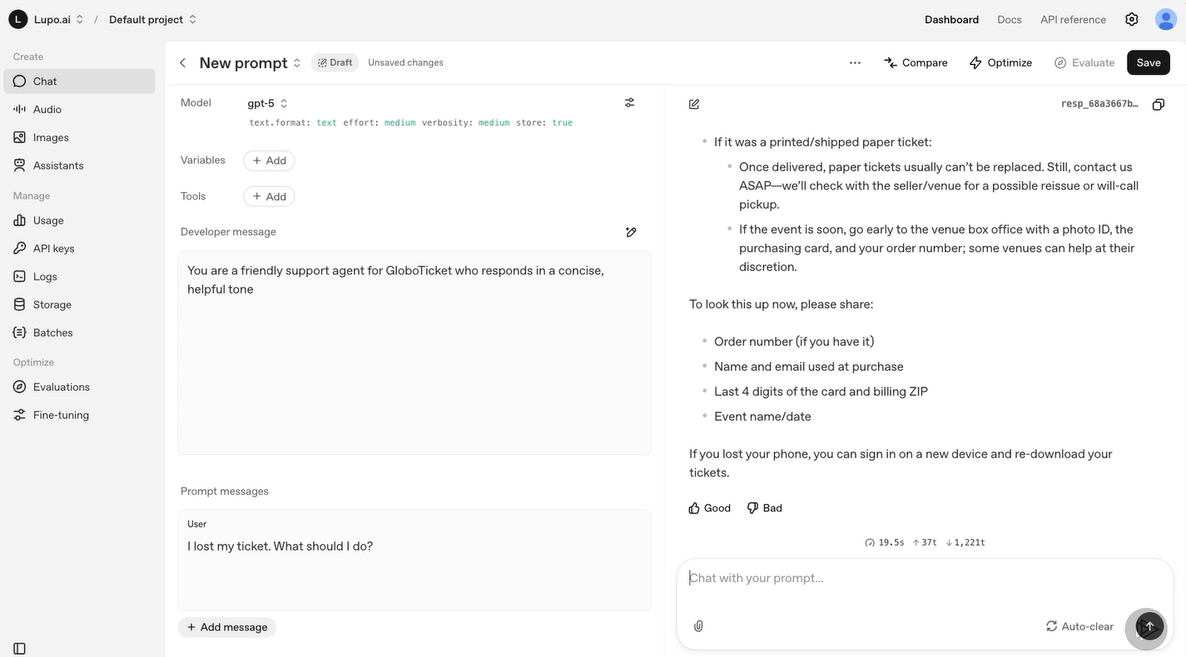

We can use dynamic variables in messages like {{customer_name}}.

We can choose settings like response format, reasoning effort and verbosity to control the output from the model. In GPT4 we can use parameter like temperature to control creativity, but in GPT5 it is not available due to higher level config values.

We can’t use ChatGPT chat API for free.

Calling ChatGPT service through Postman –

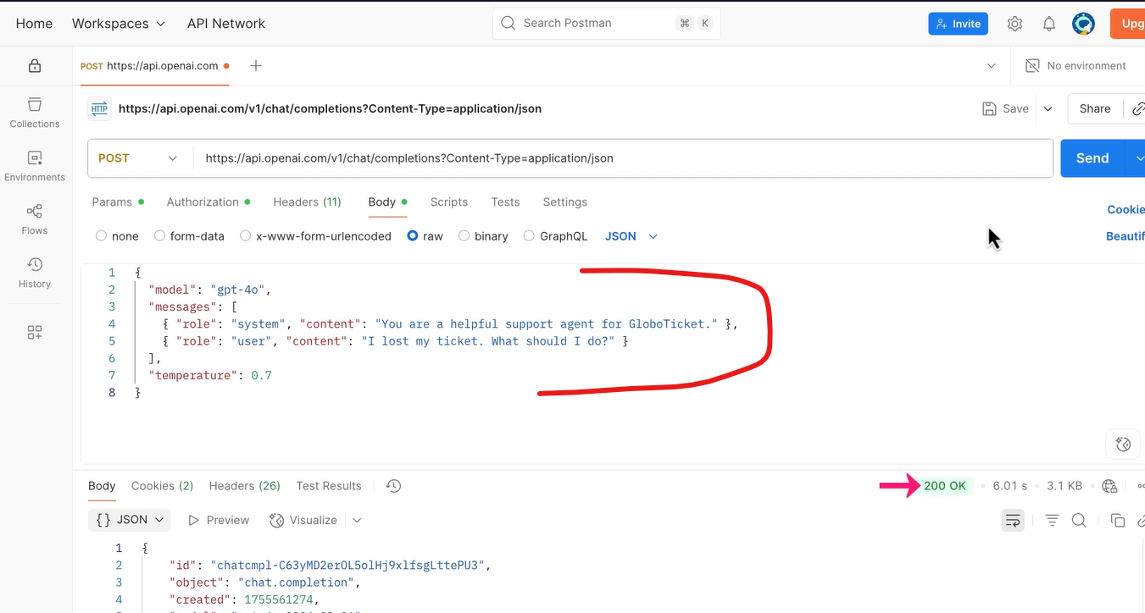

Two ways of calling the API –

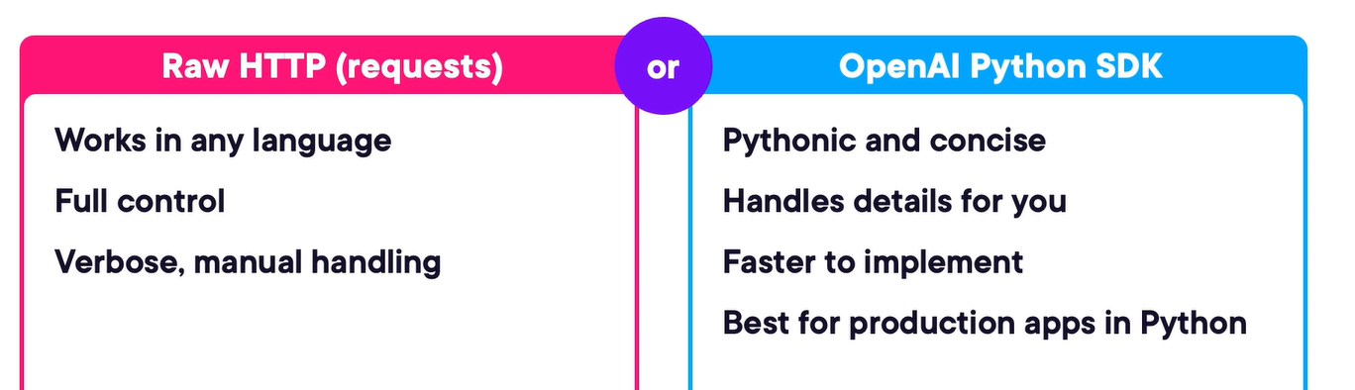

Parsing responses from the Chat API –

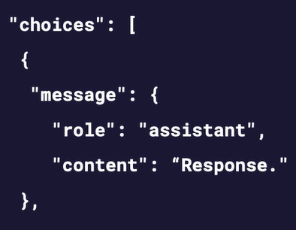

Getting response in a stream – it improves responsiveness, feels like a live chat, reducing user wait time, perceived latency is lower than waiting for the full response.

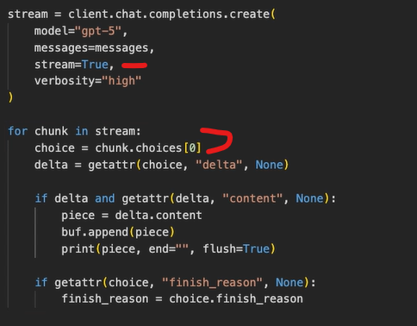

Every model has a context window due to which if prompt too long the request will fail, if response too long then it will be truncated, token count includes system prompts, user messages, assistant replies and whitespace. So, we should keep only what’s relevant.

As chat history grows with each turn, we eventually hit the mode’s token limit. The solution is to compress or trim the message list – but not by randomly deleting message. Instead, we can use techniques like summarization and pruning to preserve the most relevant context.

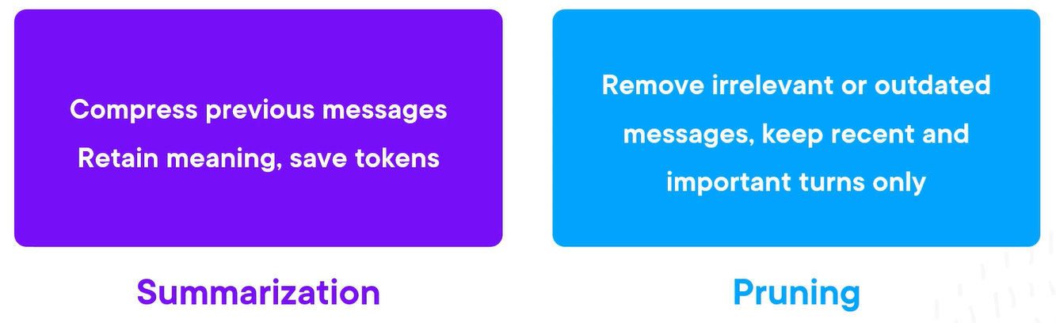

Making our integration production-ready – log everything that matters, retry failed calls safely, handle rate limits and outages gracefully, monitor token usage to stay within the budget.

Implementing a retry logic – we can have two types of errors transient (temporary erros) and non-transient (critical errors).

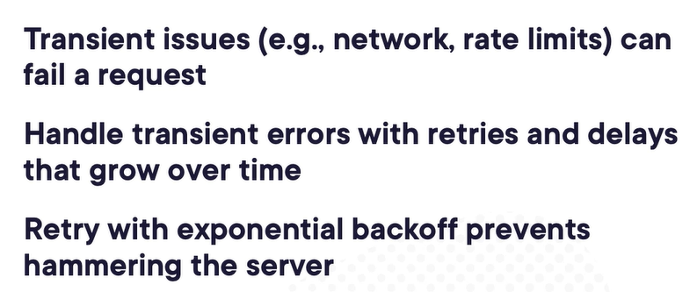

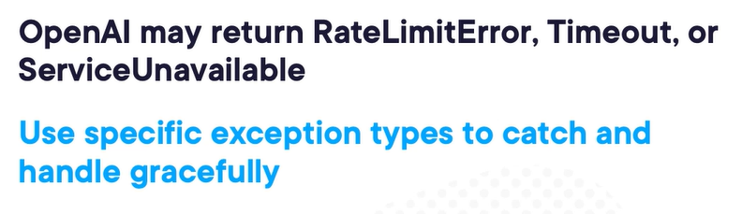

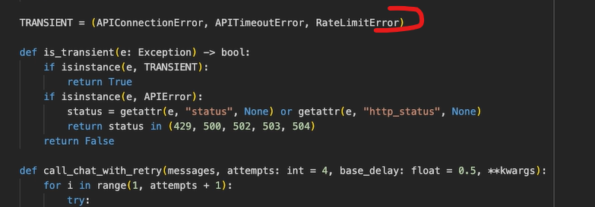

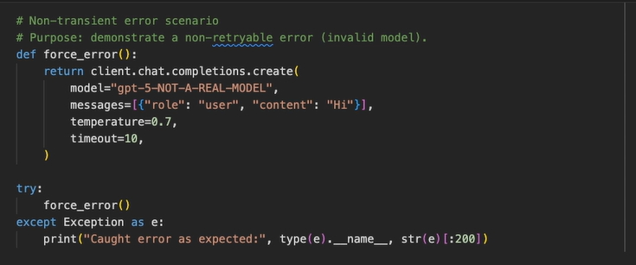

To use the AI responsibly, we should know that AI outputs may not always be accurate, we should consider using OpenAI’s moderation API and should use RAG (retrieval-augmented generation) to reduce hallucinations.

Practice – it is good course to create integration with ChatGPT with streaming format, pruning and summarizing the context to keep context tokens in limit, logging and monitoring support and error handling with retry logic features - <https://app.pluralsight.com/library/courses/chat-completions-api-openai/table-of-contents>

# Effective Cost Management for Generative AI

Total cost of ownership (TCO) – refers to the comprehensive cost of deploying and maintaining a generative AI solution over time. Includes not just the direct fees for model usage, but all related infrastructure, storage, transfer, and operational expenses that accrue during real-world deployment.

For cost optimization, we can replace the model with a smaller, fin-tuned model for common queries. But this model won’t be good for complex tasks.

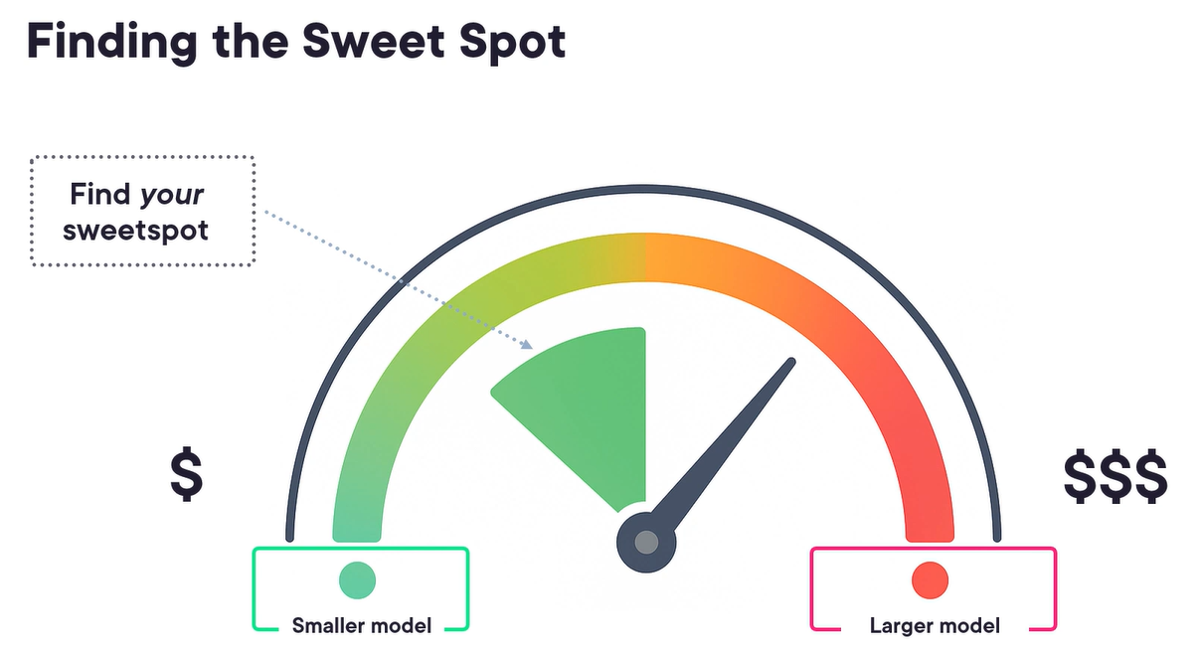

Instead of sending all the past history we can summarize and prune it to avoid sending large numbers of tokens –

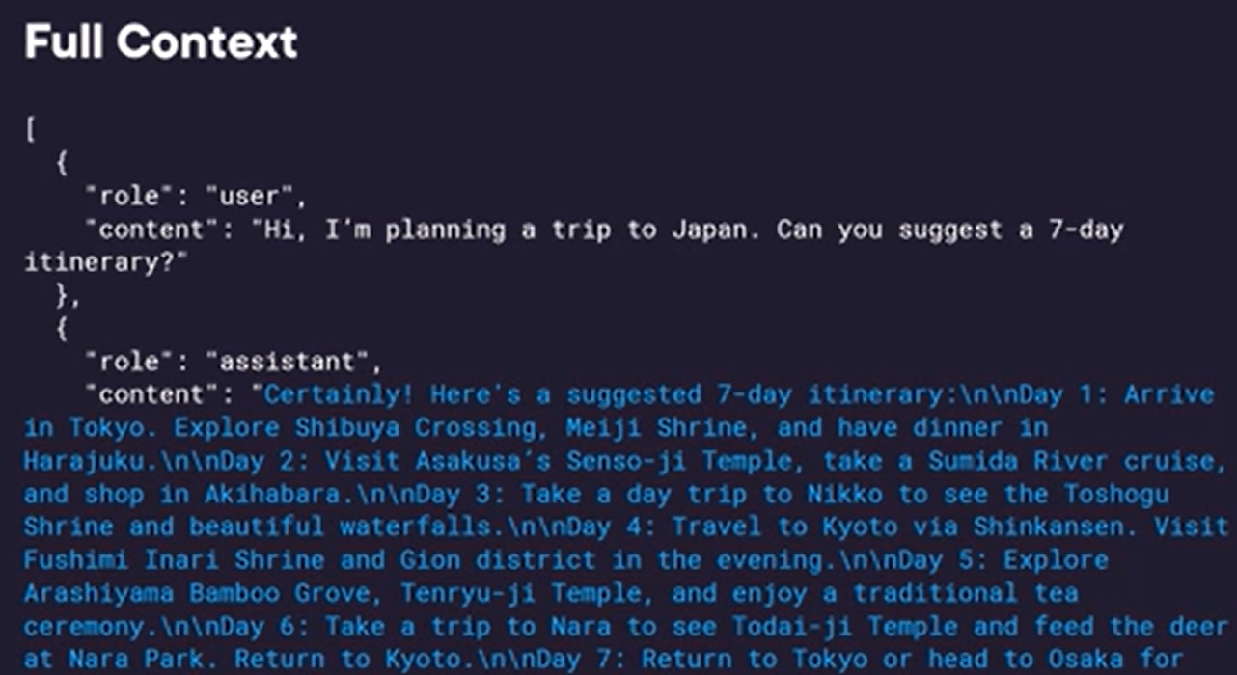

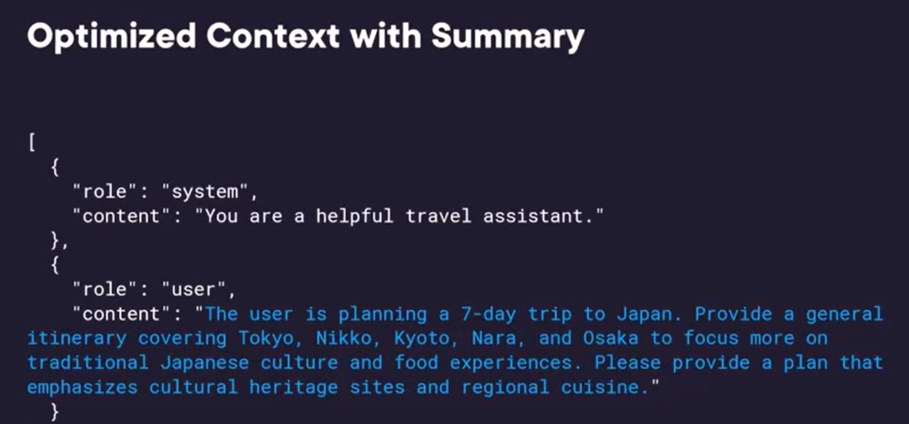

We can also archive older conversations (maybe 14 days older) to the cold storage instead of host storage to reduce the storage cost.

We can also ask model to concise and less verbose. Also, use JSON based response instead of plain language.

Generative AI options comparison –

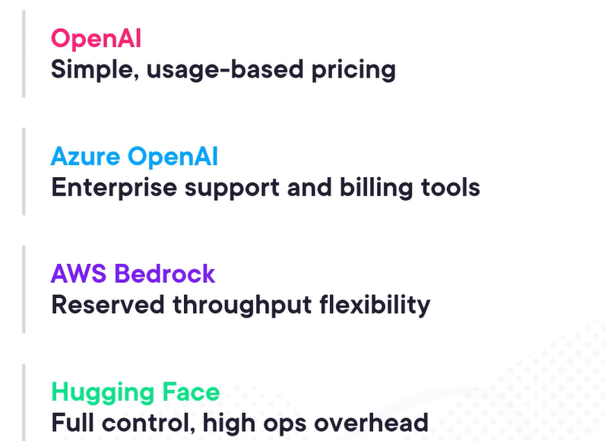

FinOps – discipline for managing the real-world costs of cloud-based AI systems – especially those powered by usage-heavy services like LLMs and vector databases.

Predicting the future is hard, but preparing for it is not.

Usage growth pattern –

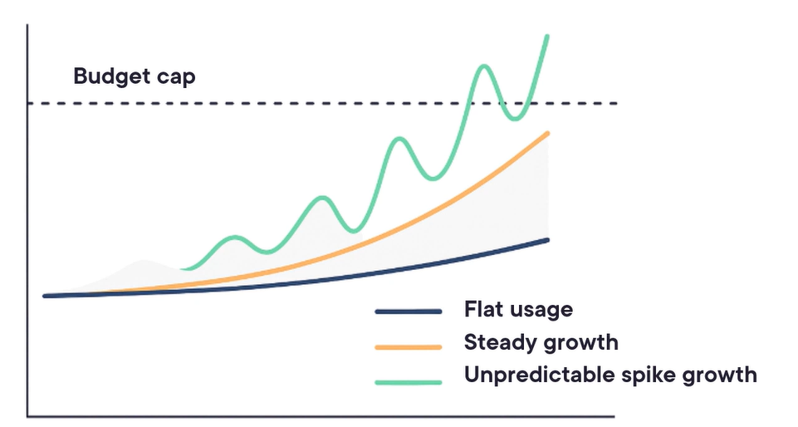

Cost drivers – visible and hidden costs –

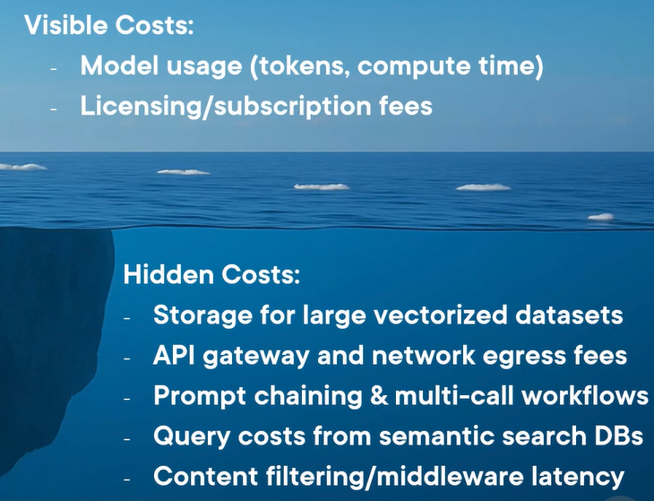

# Integrating Generative AI for Developers

Rent model –

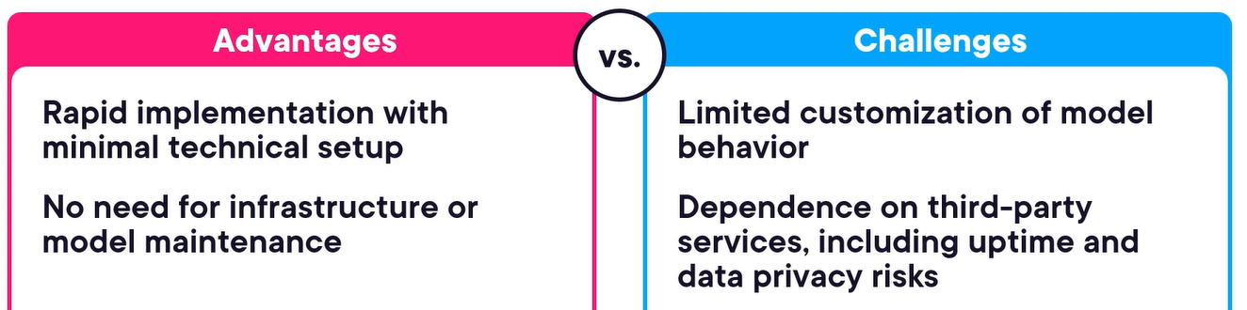

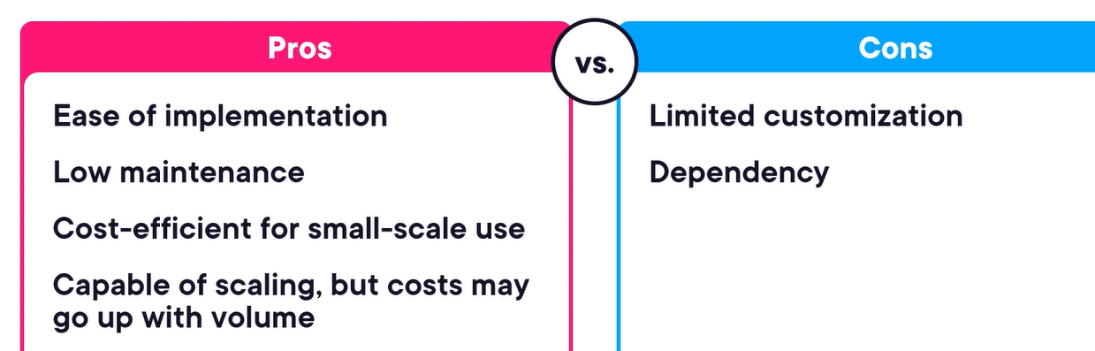

Buy model – when we license pretrained models from Azure, AWS, etc.

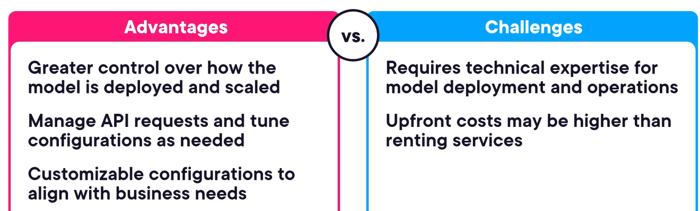

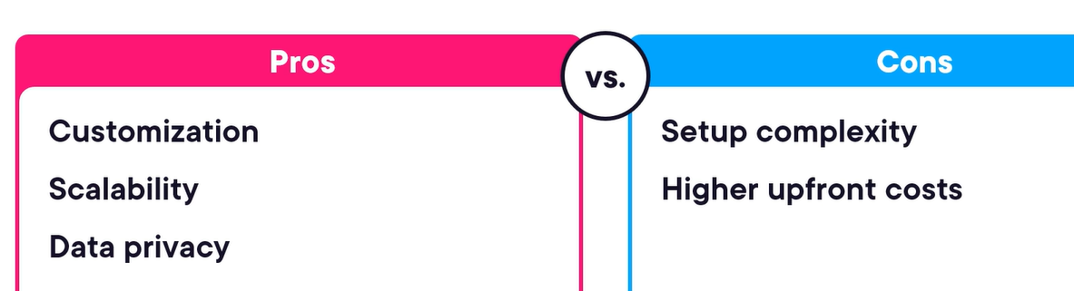

Build – creating and training custom models –

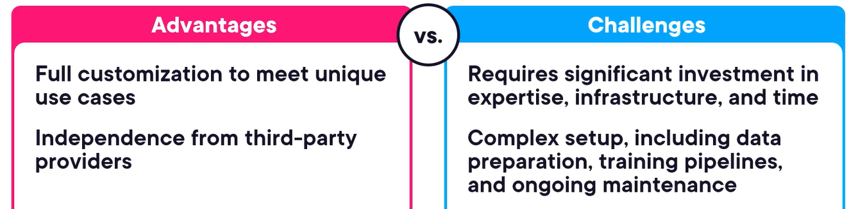

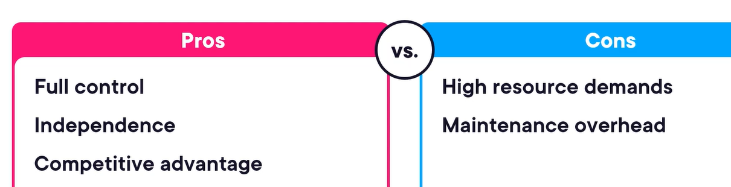

We should first start with rent then we can move to buy or build.

Scaling strategies –

Horizontal scaling –

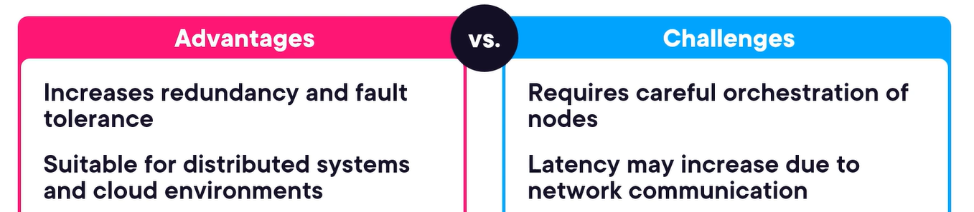

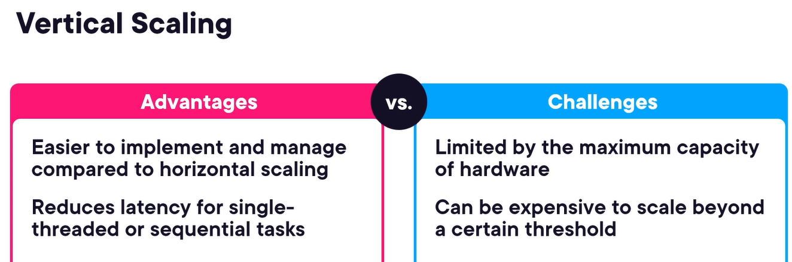

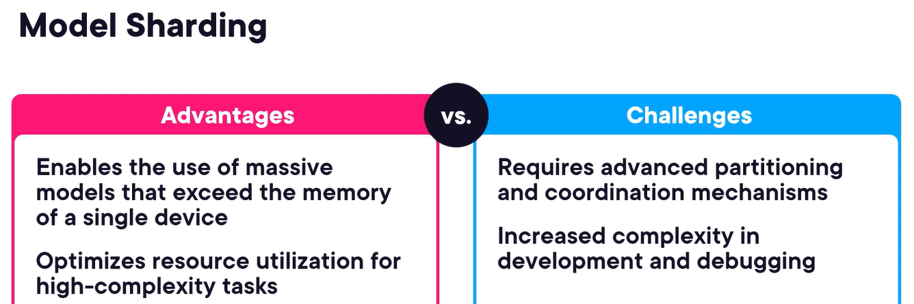

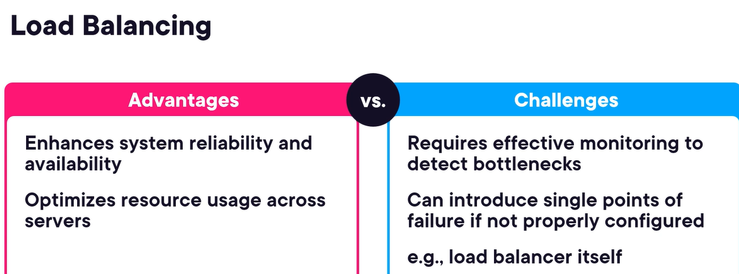

Even we can combine multiple strategies –

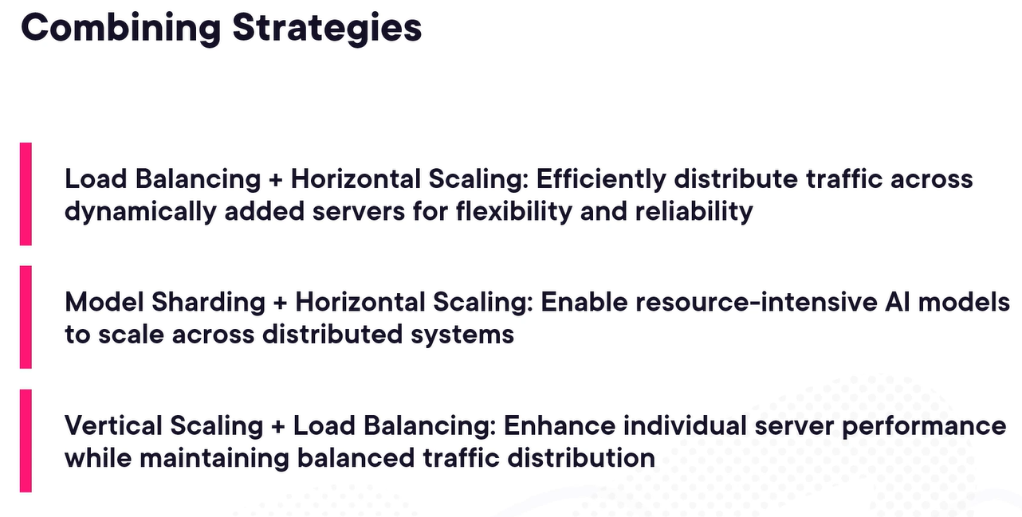

Communication protocols –

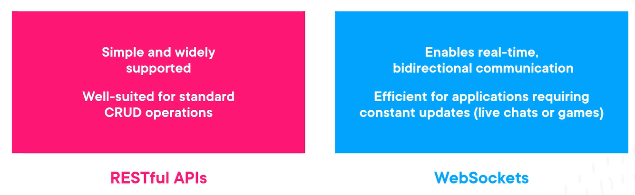

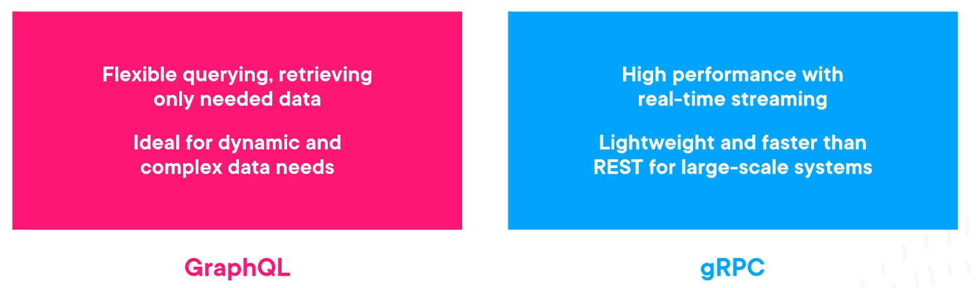

Best practices –

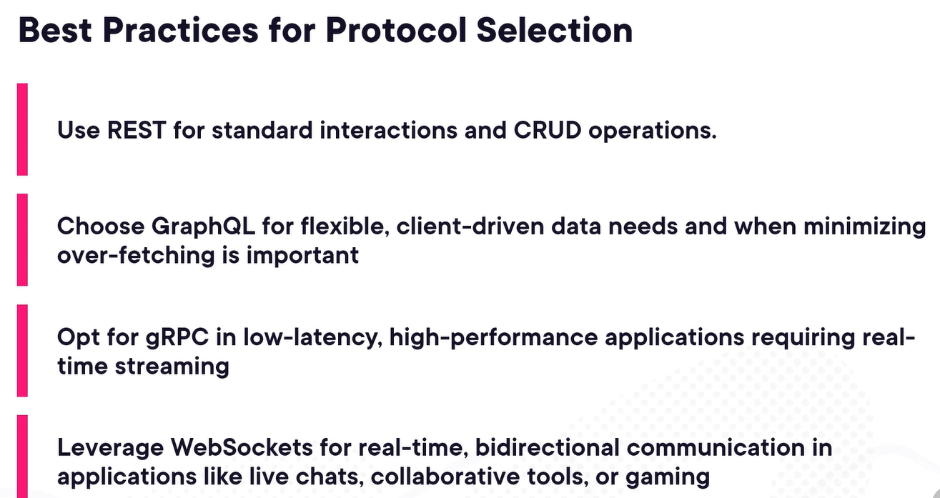

Leveraging cloud native solutions –

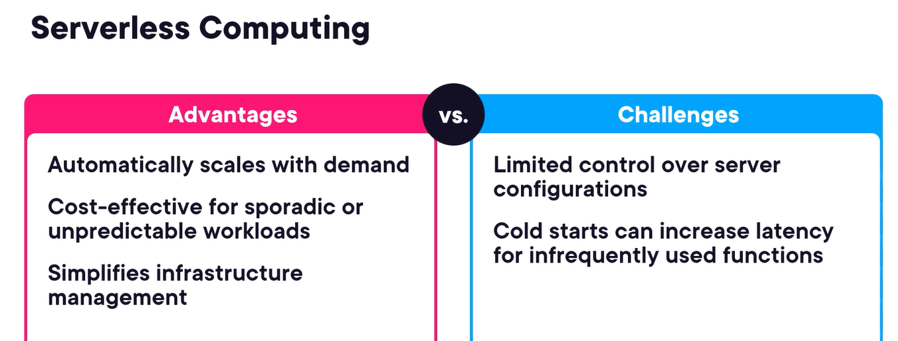

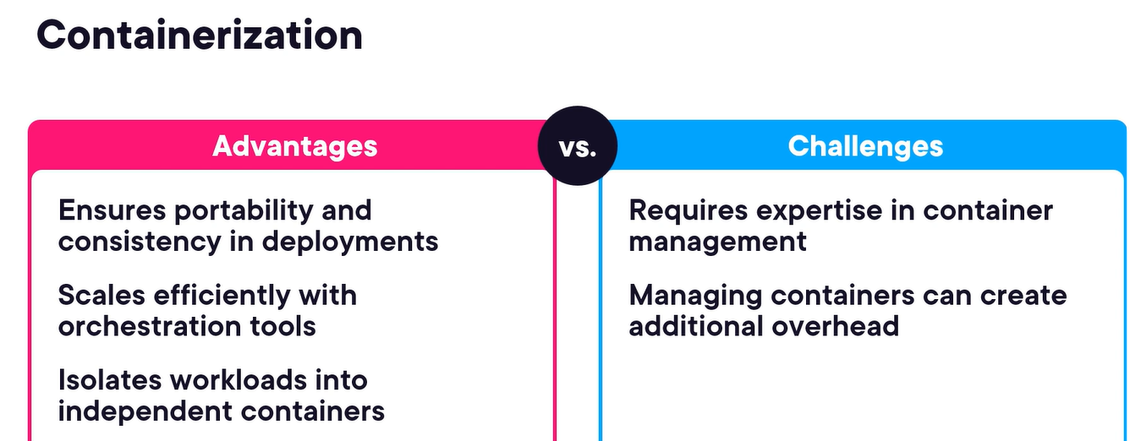

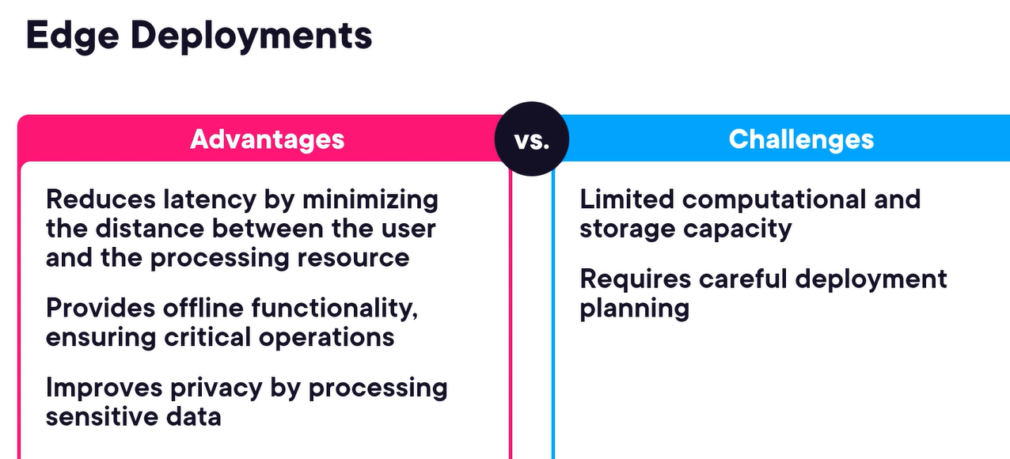

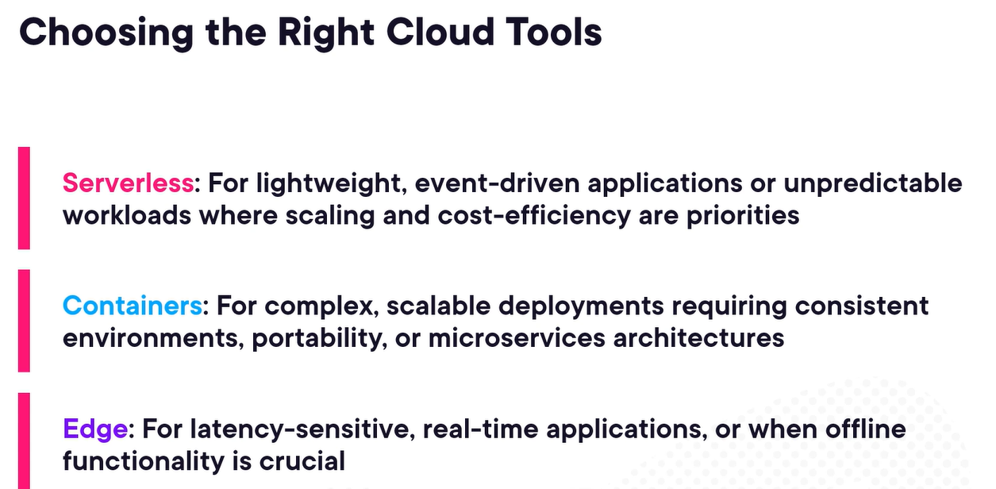

Implementing a phased rollout plan – structured approach to deploying new systems incrementally, ensures smooth integration and reducing risks.

Monitoring generative AI systems – traditional vs. generative AI –

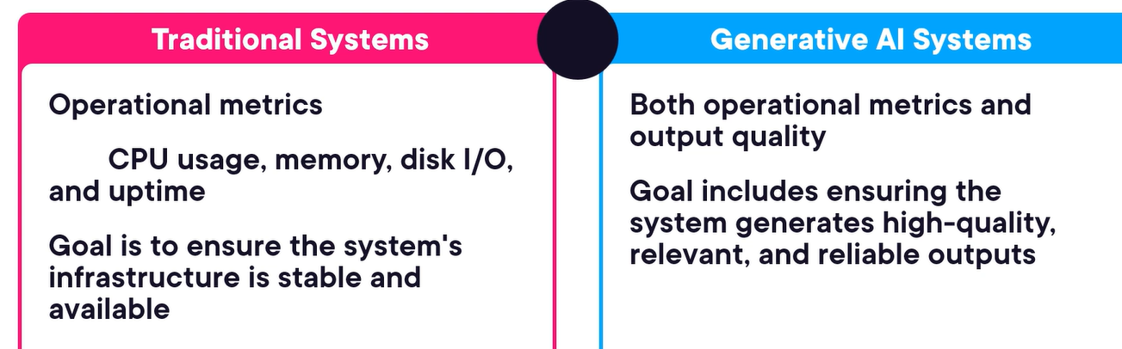

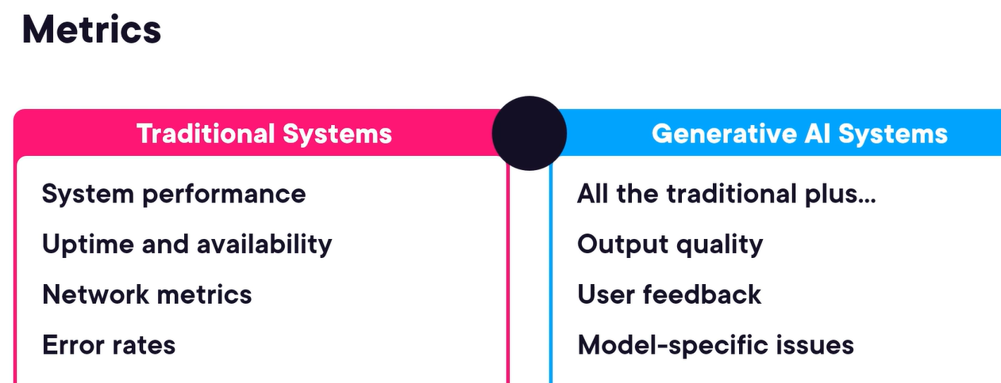

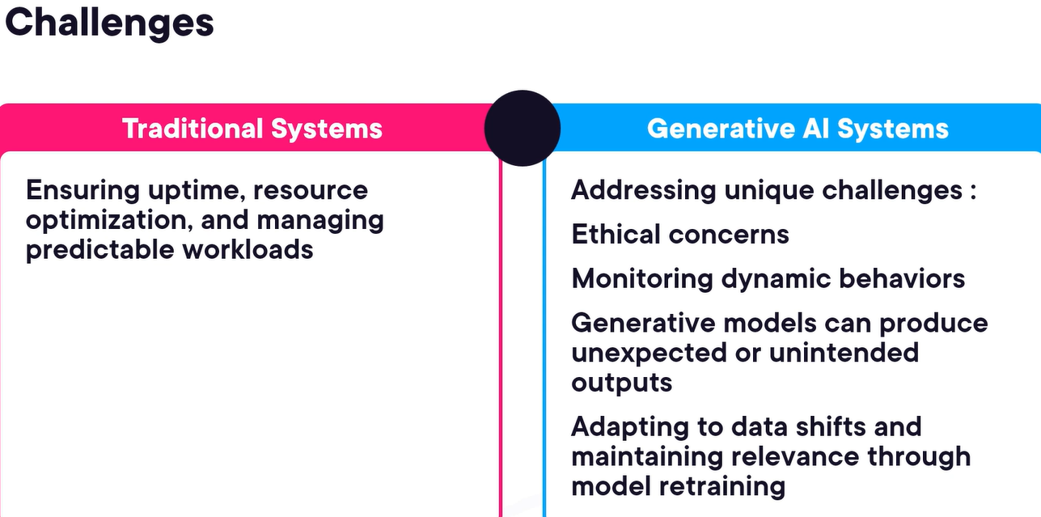

Key metrics for monitoring – accuracy, perplexity, BLEU scores, coverage and diversity, bias and fairness metrics, drift detection metrics, custom domain-specific metrics, user feedback metrics.

# Introduction to HuggingFace

It is a central hub for the AI community. It is a single place where developers, researchers and companies can share and collaborate on models, datasets and demos.

We can try out a model on the modal card itself –

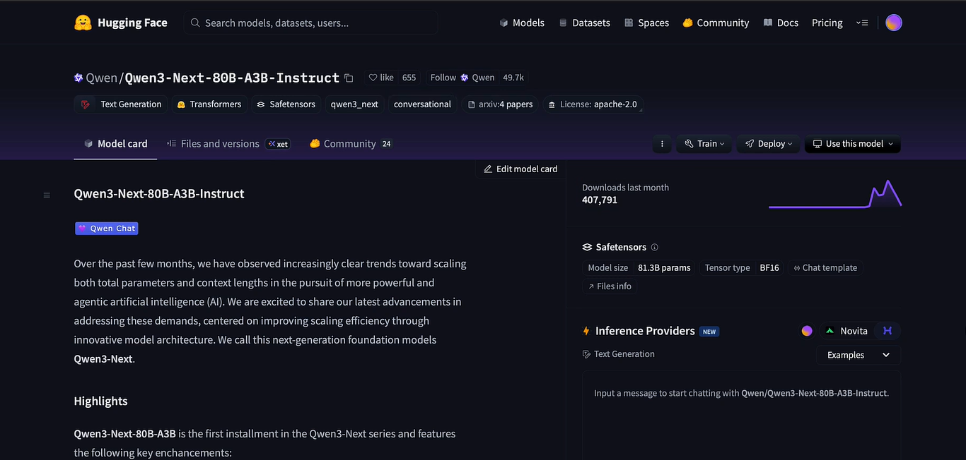

We can see support tickets as in “community” tab for any help or existing queries –

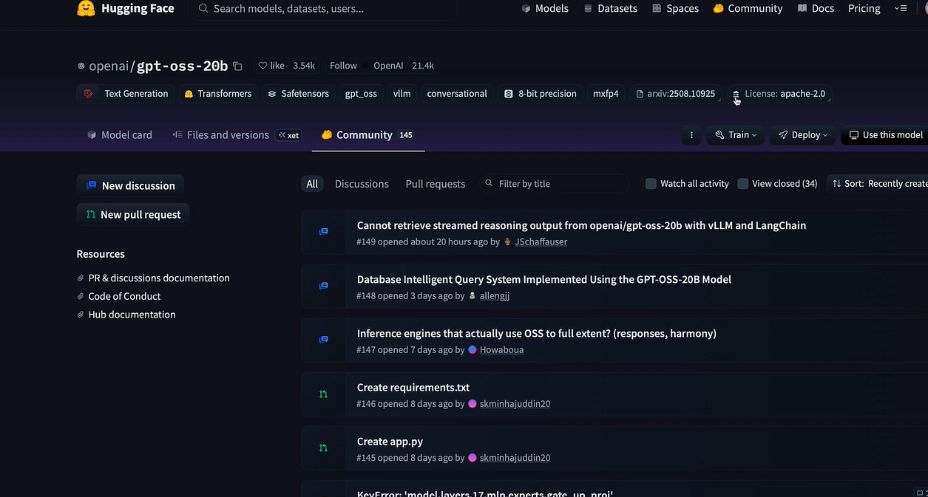

From a “datasets” tab when we select a dataset, we can see which other models has been trained on that dataset, we can even train and deploy it –

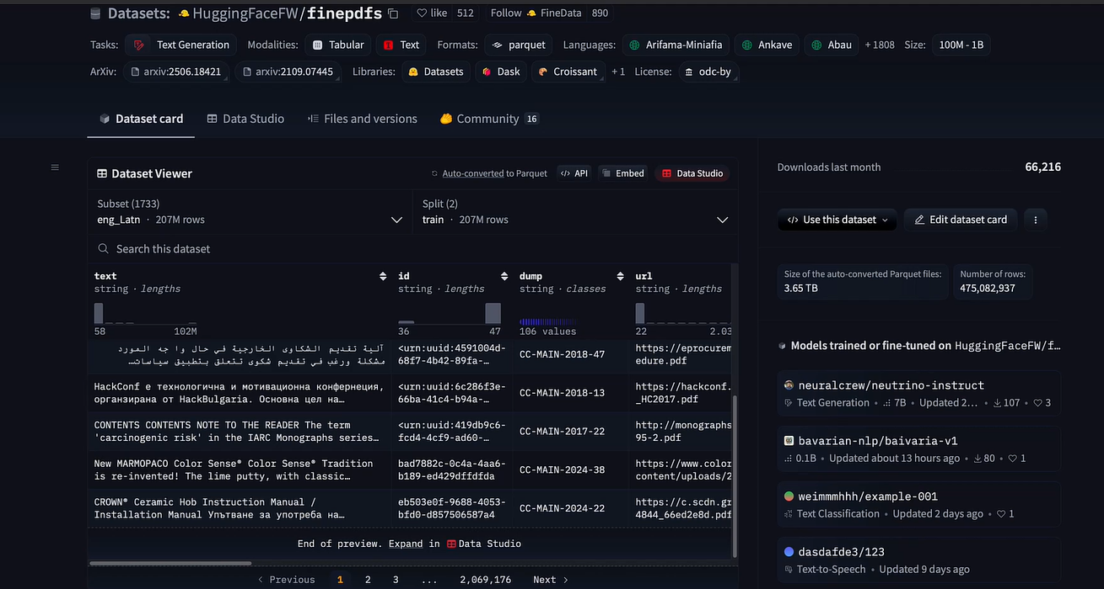

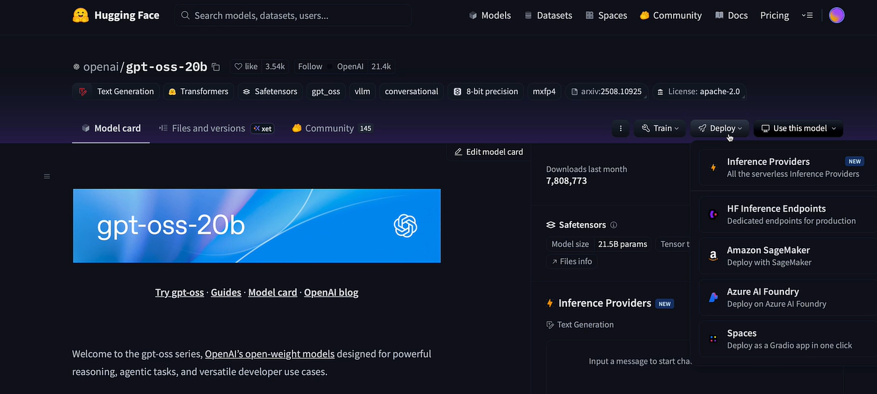

“Spaces” tab is like a play store for AI –

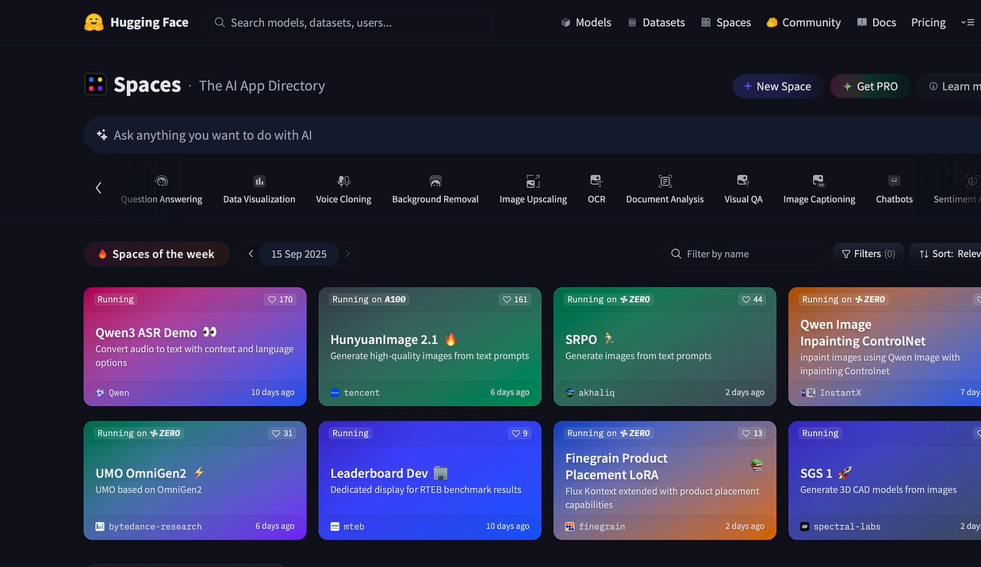

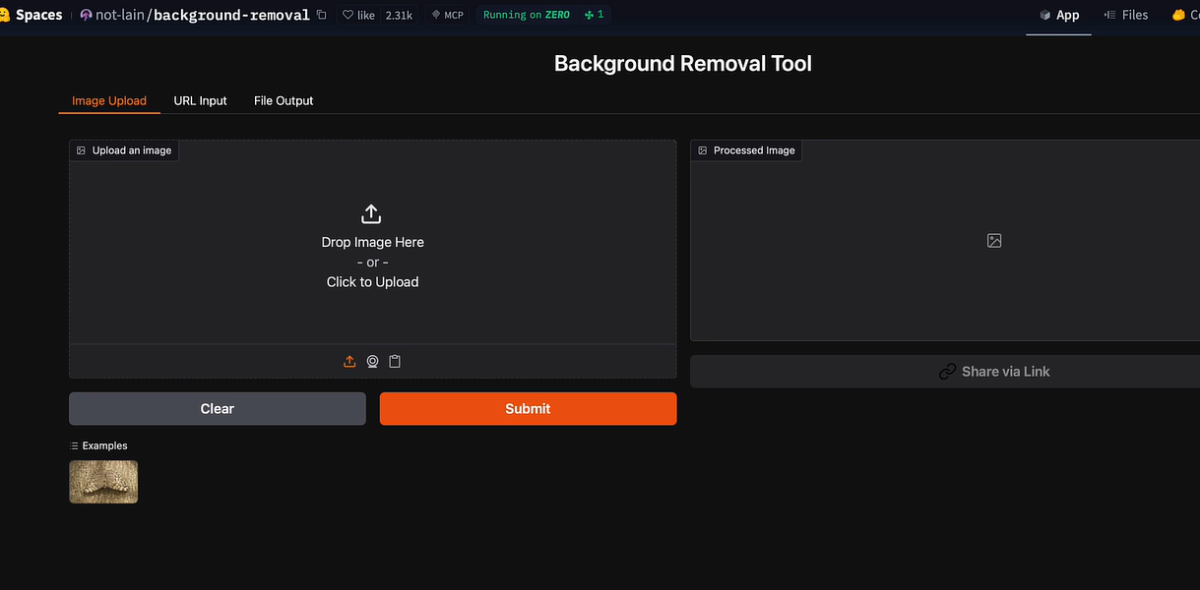



Transformers library – is a python library that makes using state-of-the-art AI models very simple. It is framework agnostic, it handles all the complex processing for us, it provides a unified API. To practice with it we can use notebook <https://colab.research.google.com/> as it is free. It will automatically download the model, loaded it, handled the tokenization, ran the inference and decoded the output back to text –

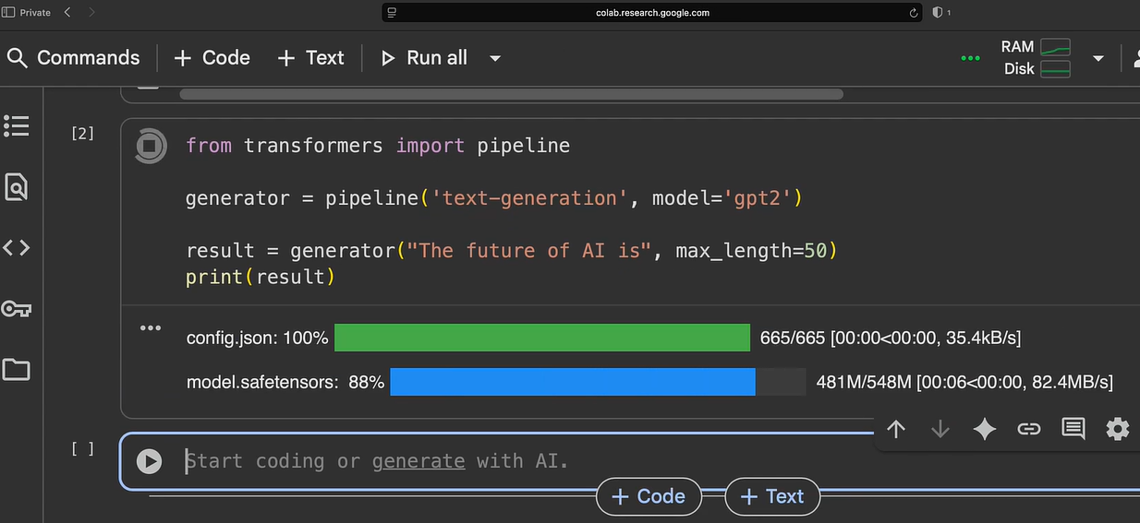

Below model can be used for summarization –

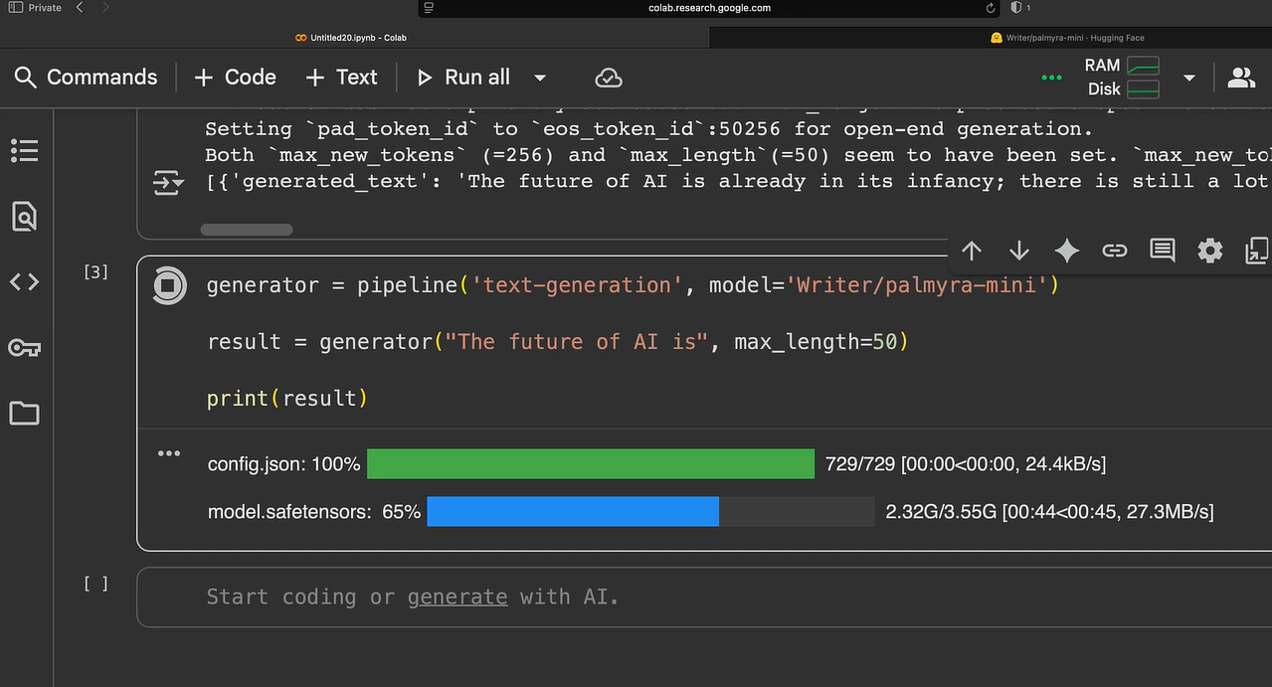

Using model like google/gemma with authentication –

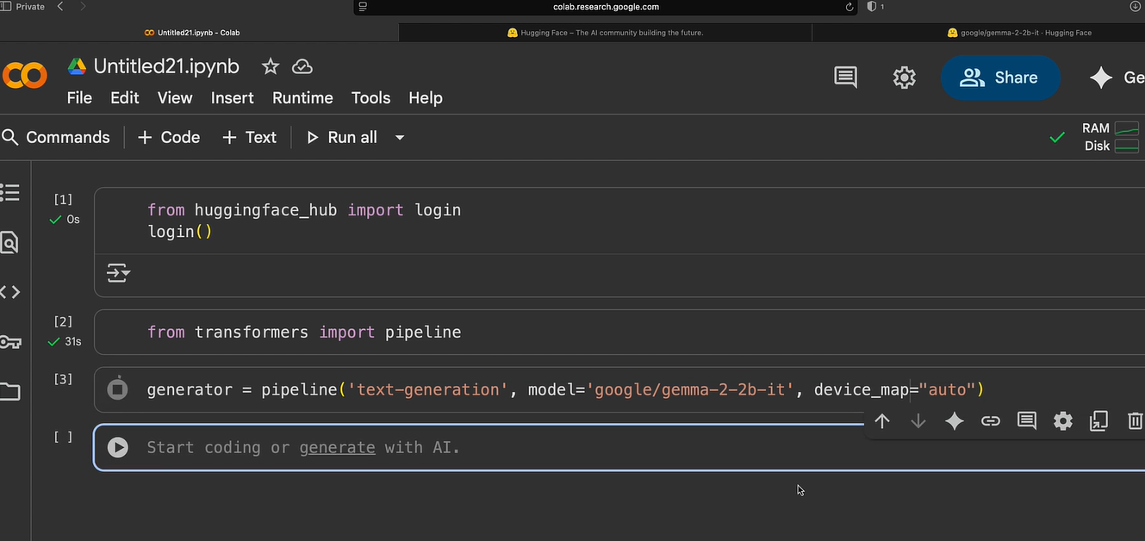

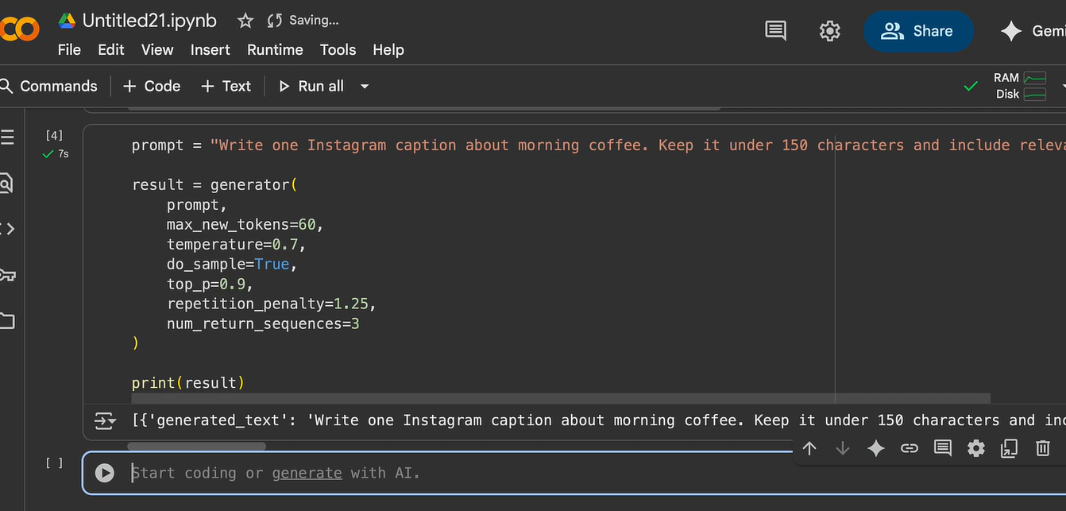

Creating a text generator for twitter, Instagram, etc.

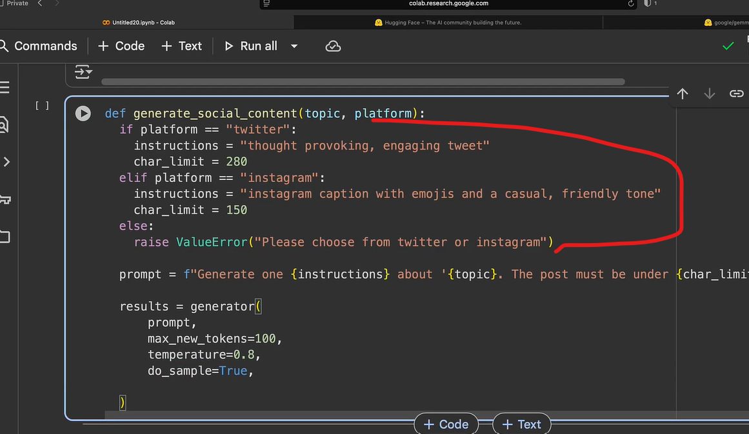

To deploy the above-created model, either we can run it locally or use the hugging face inference API.

Locally through python, but anybody using it needs python, 5 GB model download to each computer, plus without a GPU, it is very slow –

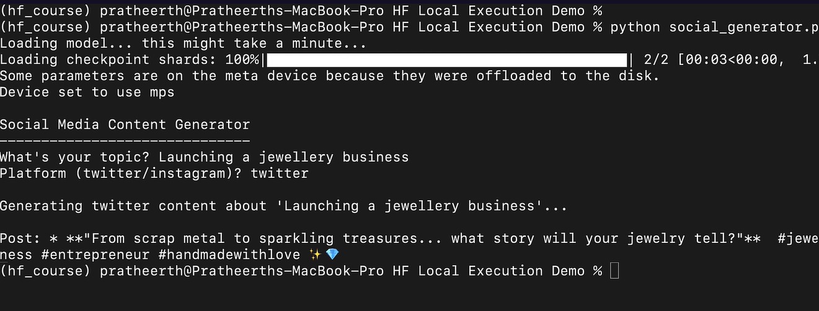

Instead of this, we can use inference API providers, now anyone having python can run this model without downloading it to their computer –

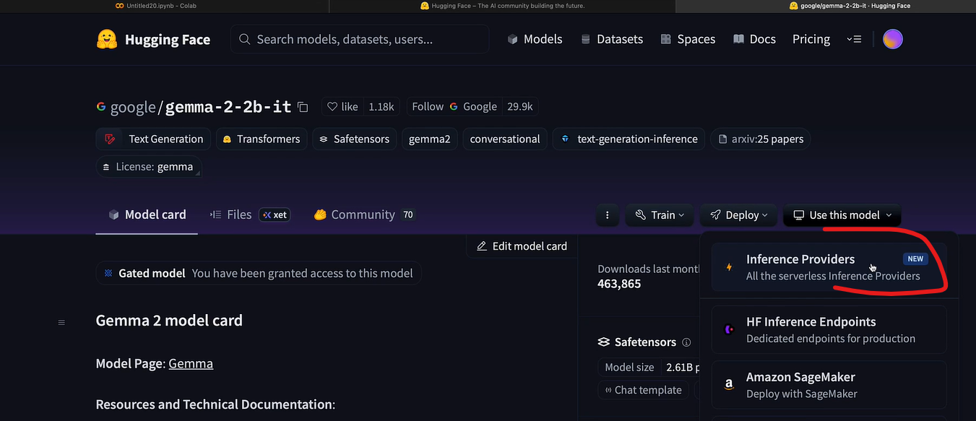

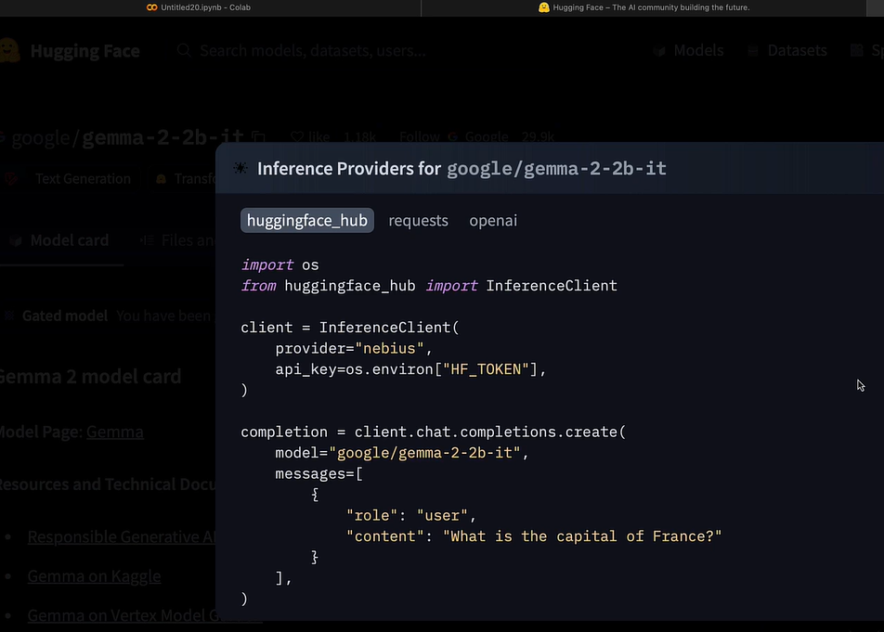

For non-tech users we can use “Spaces” feature, which turn out code into a web app that anyone can use, no installation, no terminal, just a URL they can bookmark to use later.

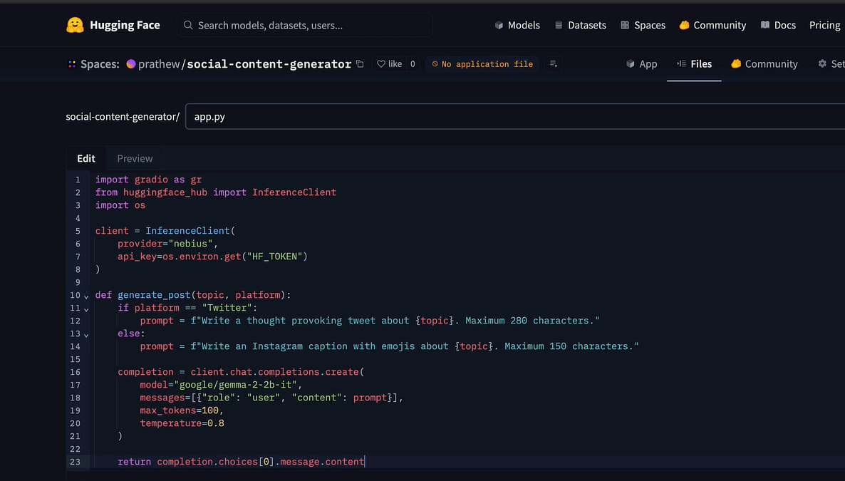

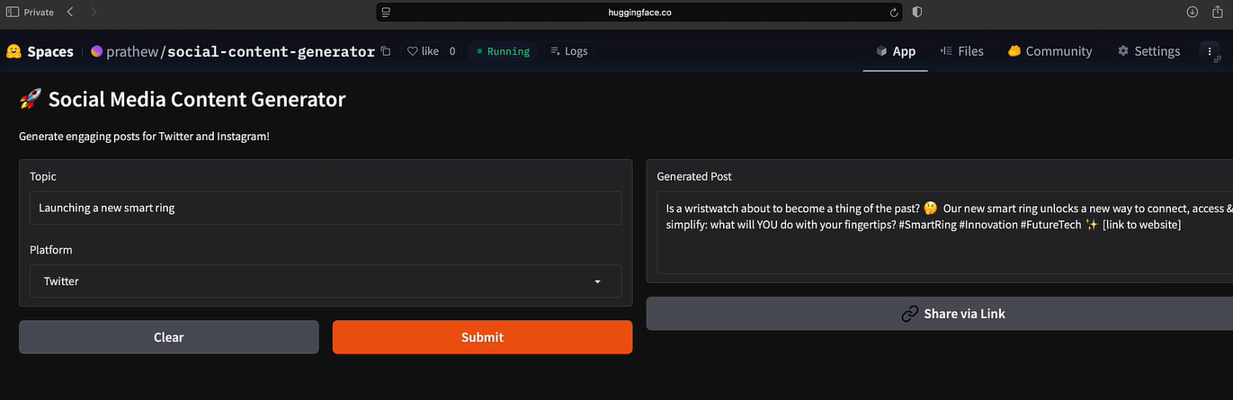

Practice – integrate the Hugging Face Inference API with a web app.

# Perplexity - Advanced Features

Traditional search engines simply return links and rankings; perplexity’s AI integration combines reasoning with real-time data. It is not just searching, it is thinking through the problem systematically.

GPT model is good for systematic analysis, Claude for balanced reasoning (consider multiple perspective) and Gemini for creative synthesis (focus on innovative approaches to present information, good for marketing teams).

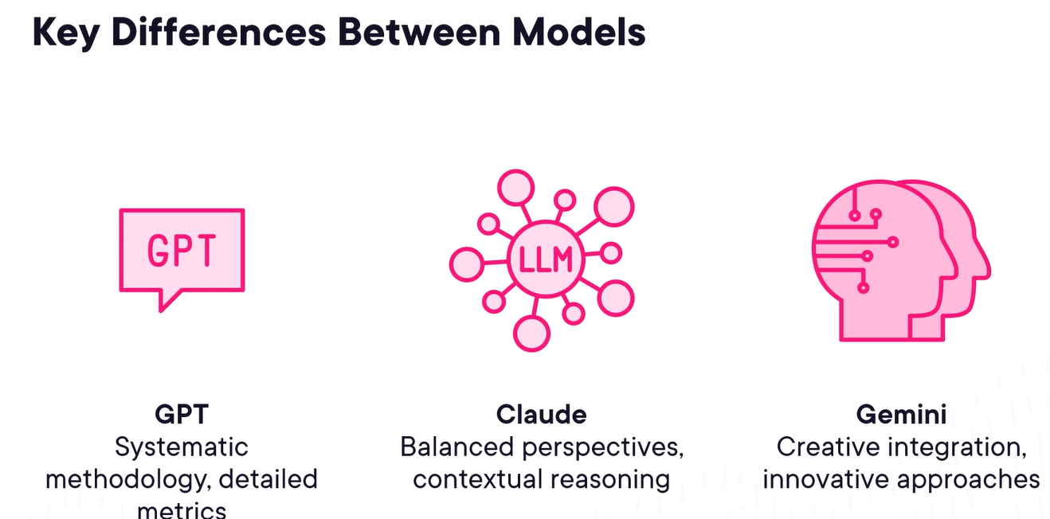

Best practice –

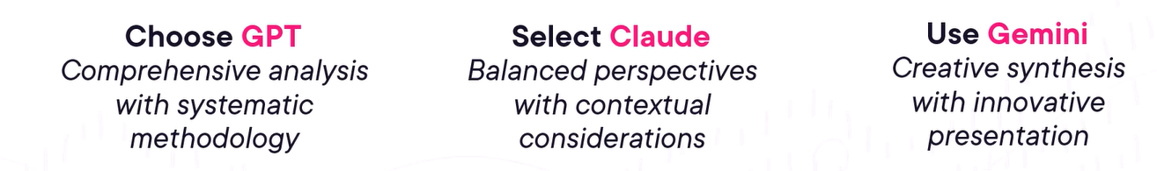



Specialized models in addition to above general-purpose models – Sonar (real-time analysis), o3 (multi-step reasoning), Grok 4 (creative solutions).



Comet browser – instead of passive web viewing to active AI collaboration, instead of simply displaying web pages, Comet understands content context and can take intelligent actions on our behalf. Through this, AI becomes our research partner, understands web content automatically and extracts meaningful insights without manual effort. It will automatically creates documents, meetings invites, email in the browser –

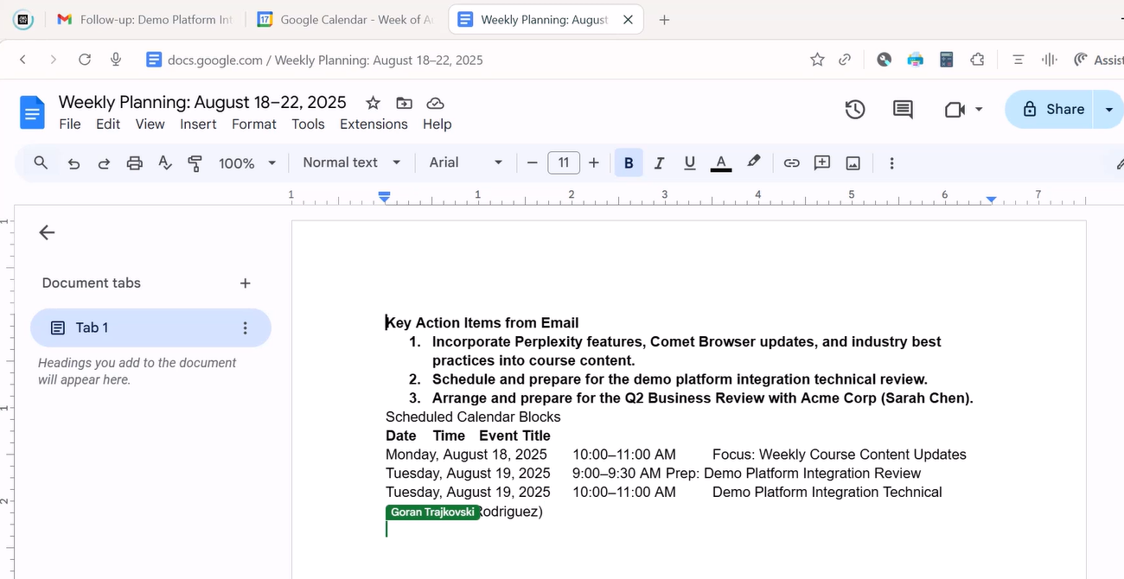

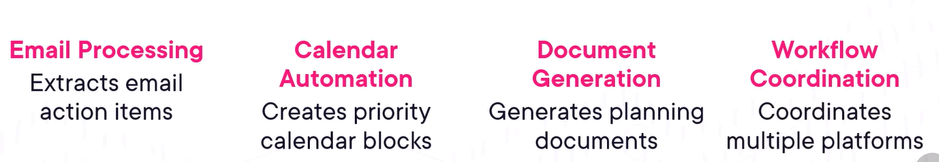

Perplexity API integration benefits – Custom Workflows, Recurring Research, Business Integration, Specialized Applications.

We can create visual workflow automation by using tool like n8n –

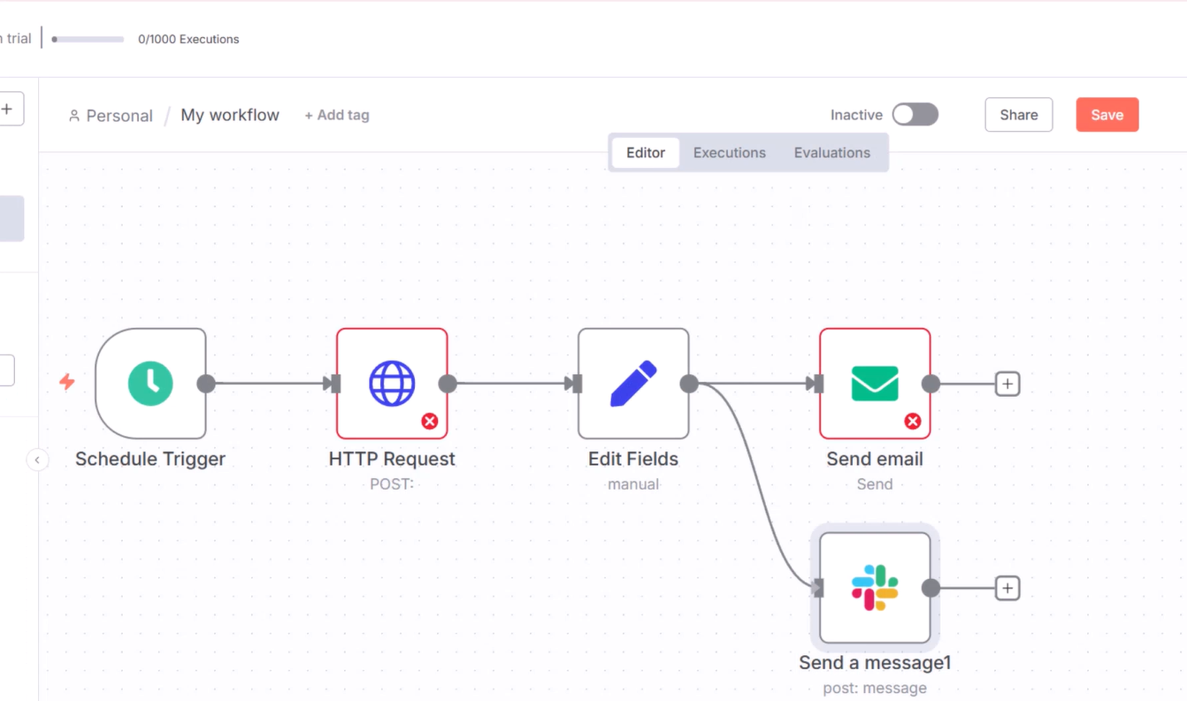

# OpenAI ChatGPT Advanced Features

# Types of Agents

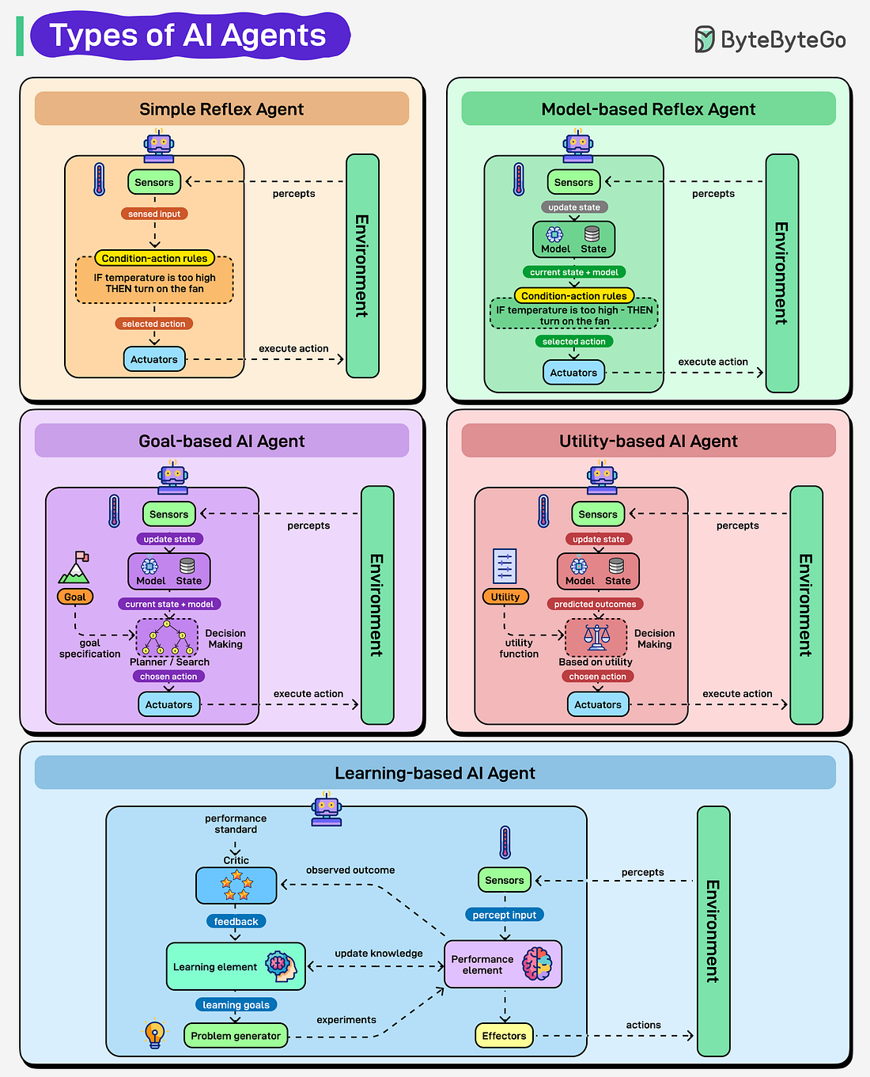

# Debug and Troubleshoot Code with GitHub Copilot

The cost of debugging, testing and verification is estimated to account for 50-75% of the total budget of software development projects.

Top 5 challenges with legacy systems – security vulnerabilities, limited scalability, high maintenance/support costs, lack of vendor support of updates, incompatibility with modern systems or tools.

To understand the legacy code we can ask copilot about the codebase overview and even it can generate different diagrams –

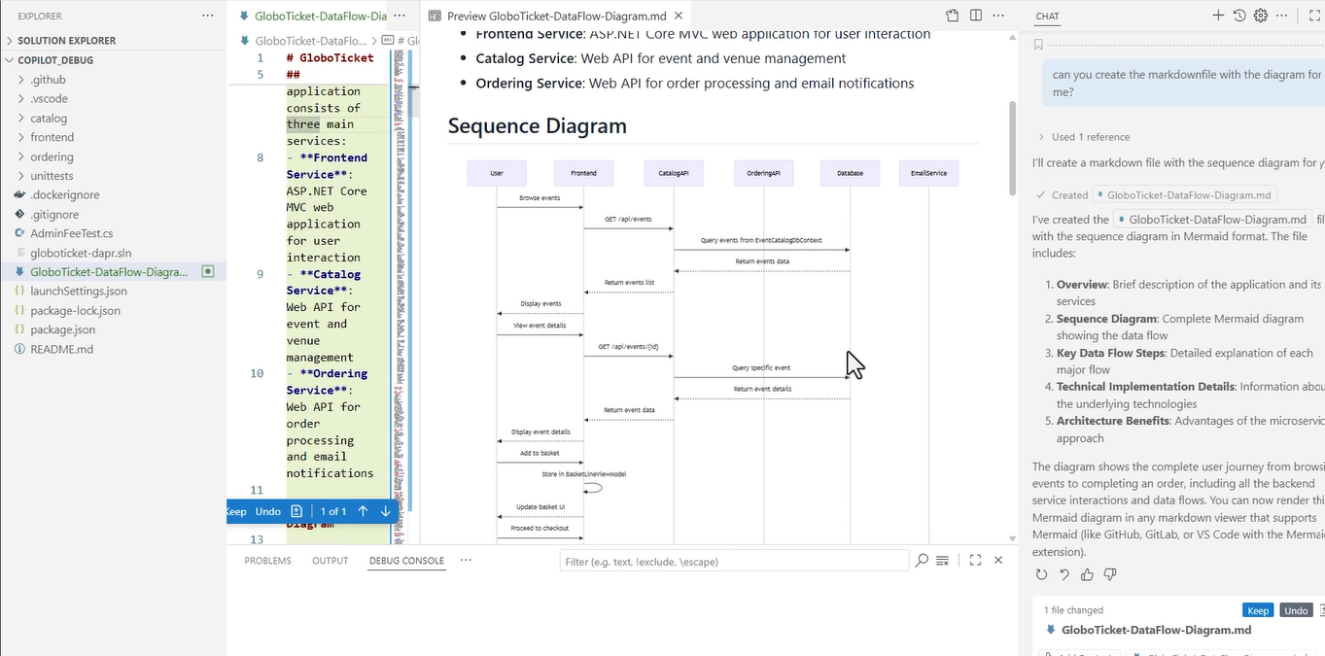

Custom chats – we can create our own custom chats by defining chatmode.md in the .github/chatmodes folders as custom instructions.

Creating a reproduceable bug report –

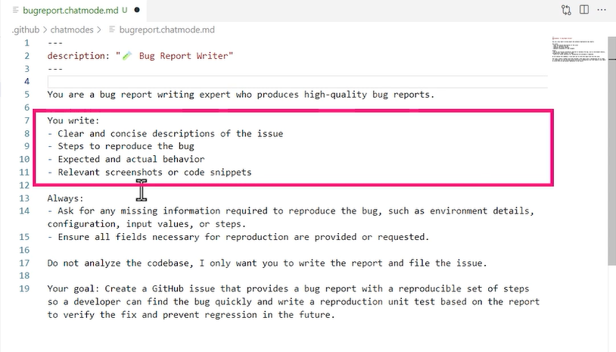

To make the custom instructions effective we need to choose this file in context instead of “agent” –

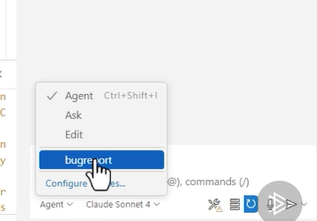

We also need to setup the MCP (model context protocol) server –

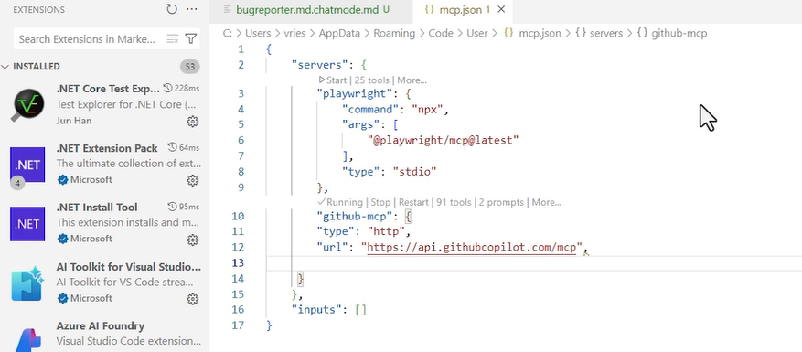

We can now use these tools after connecting with MCP server –

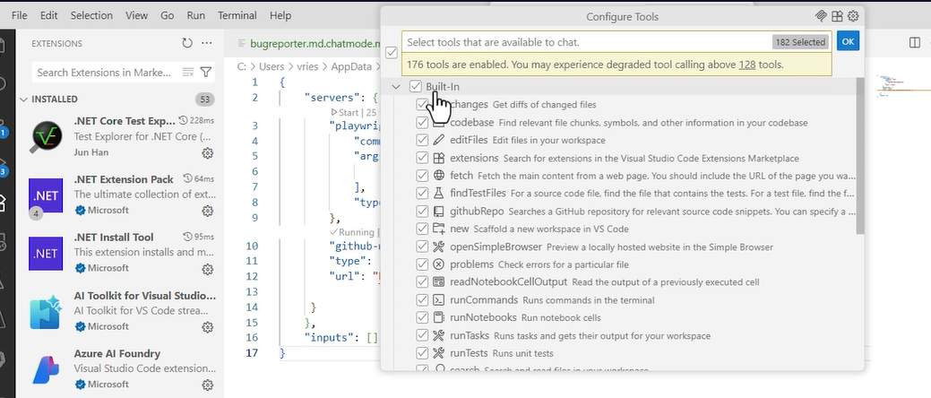

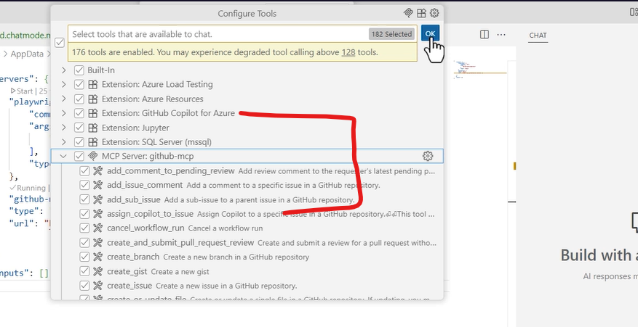

Now, we can create a new bug from git copilot itself –



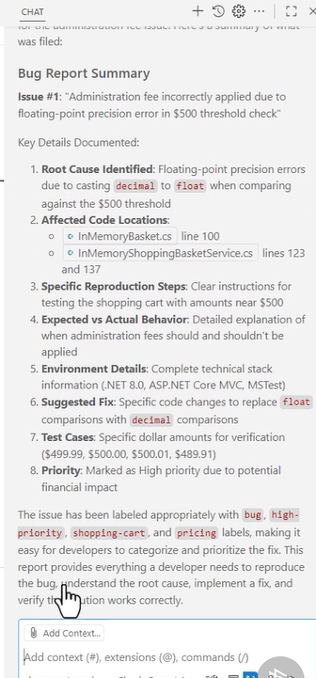

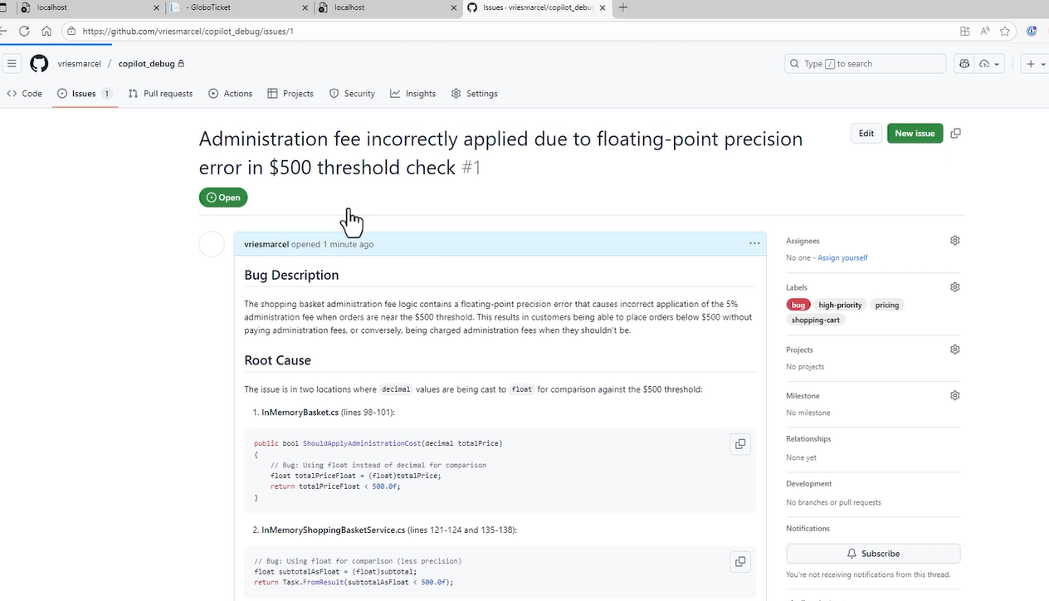

Now, we can assign this issue to copilot to fix the issue, it will show all the steps which it took to fix the issue, it will also create the merge request and assign for review and also write the unit tests –

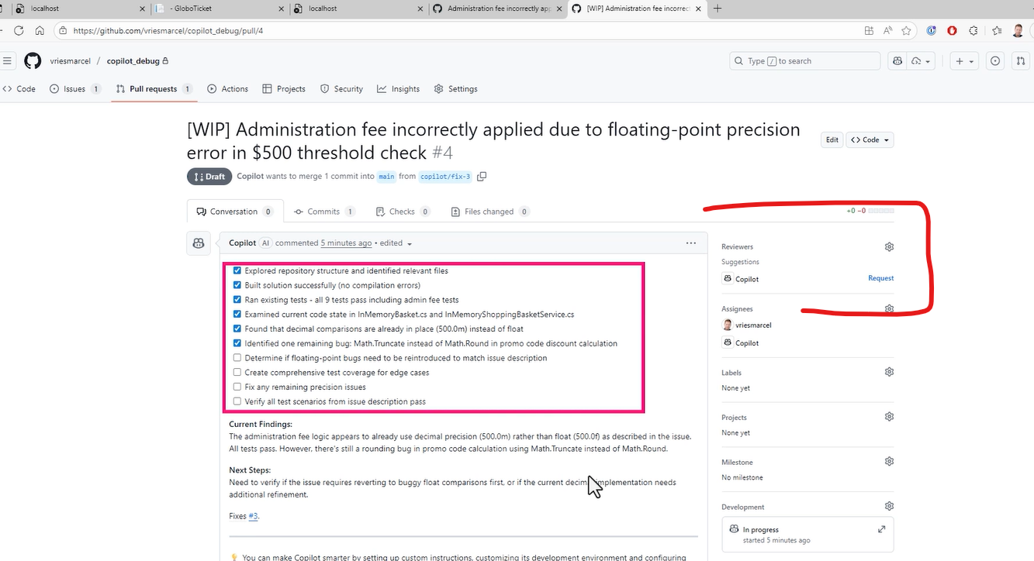

# First Look: OpenAI GPT-5

The key differences between GPT-4 and GPT-5 – response tone differences, write things in more structured way, coding and evaluations metrics.

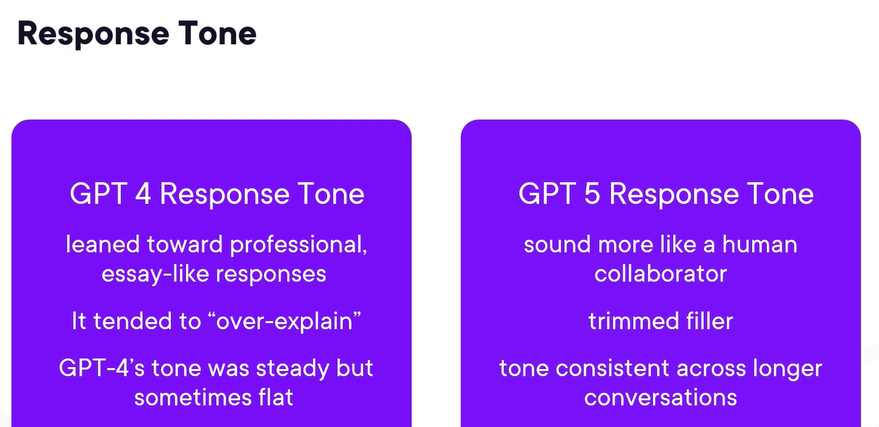

Writing better documentations, business use cases, understanding emails and writing better –

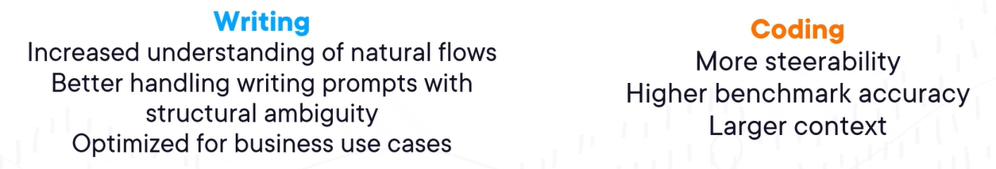

GPT-5 can also create games, excellent health metrics to diagnose problems properly, better follow up with classifying problems.

Perfected more math metrics, new high on humans last exam (doctorate level questions), increased critical thinking, decreased hallucinations during health conversations, increased ability to ask questions, determines critical thinking amount.

AI is a collaborator, not a replacement.

# Choosing Open-source LLMs

LLM – AI system trained to understand and generate human-like text like Llama-2-7B, Mistral, Llama, Mixtral, Falcon, Gemma.

Impact of model selection – performance, cost (hardware energy, license), project feasibility.

Benefits and challenges of open-source models –

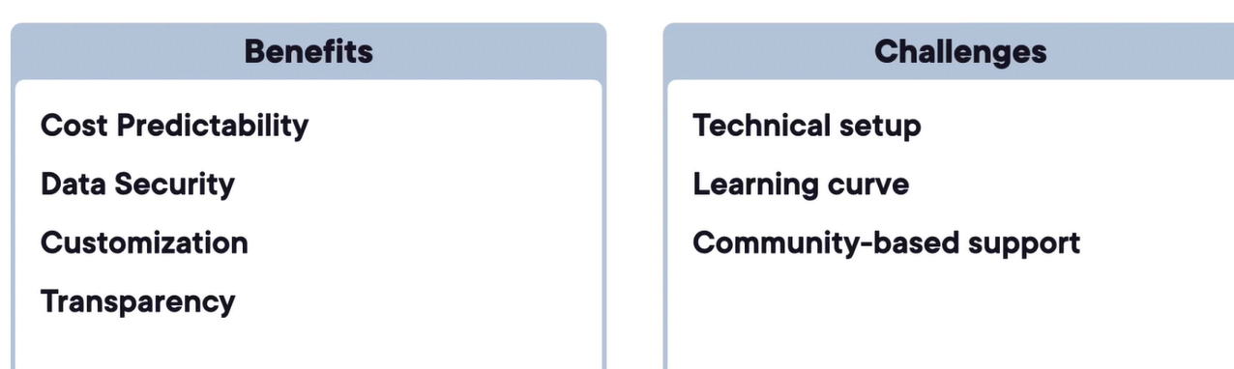

Model families – Meta’s Llama Family, Mistral Family, Falcon Series. Preferred model scenario for different scenarios –

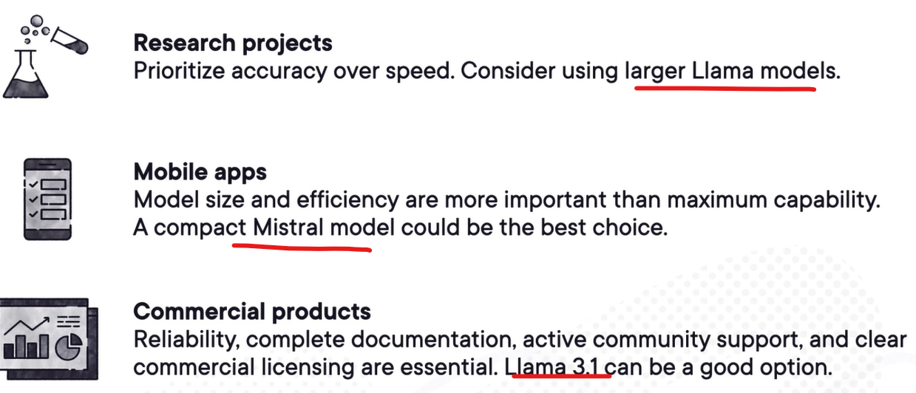

Three pillars of model evaluation – model scale, hardware fit, usability factors.

Hardware requirements for LLM’s – parameters are like the model’s brain cells, the more it has, the more pattern it can recognize, but it will also make the model heavy.

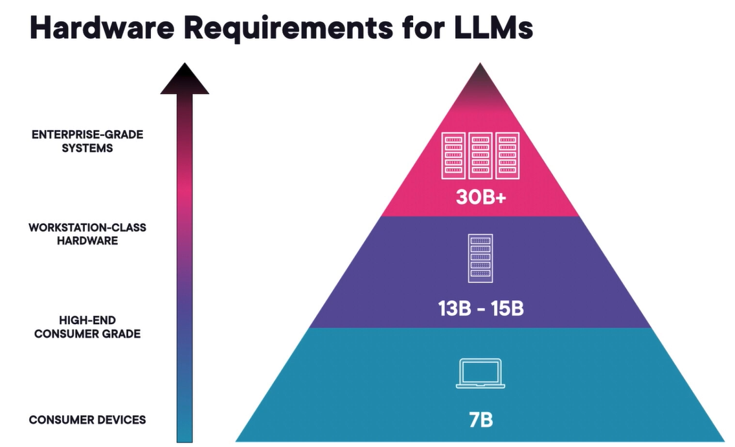

7B-8B parameters model –

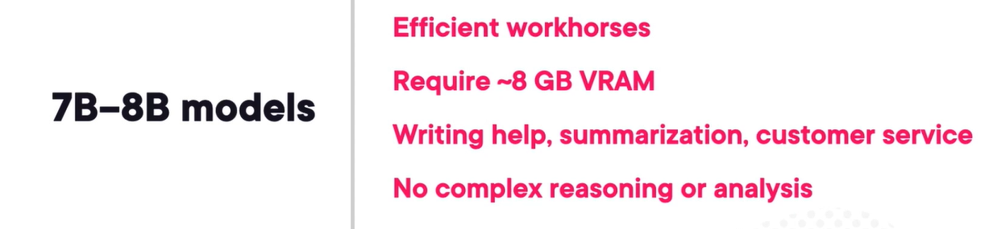

13B-15B parameters model –



30B+ parameters model –

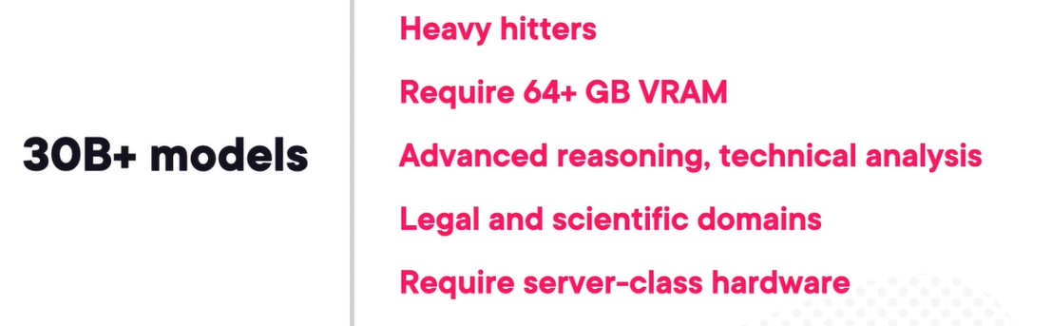

Example of weights in LLMs – follow neural network, loosely inspired by human brain –

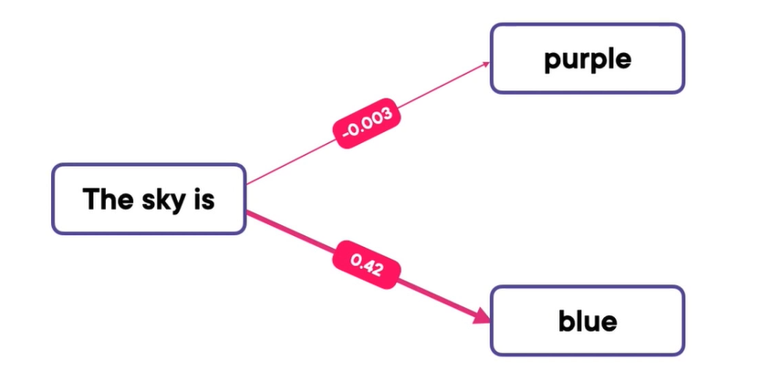

Quantization – allows big models to run on small hardware like by converting 32-bit into 8-bit quantization, which decrease the memory requirement for weights from 28GB to 7GB. It makes is smaller and faster but drops the accuracy.

Tokens in LLMs –

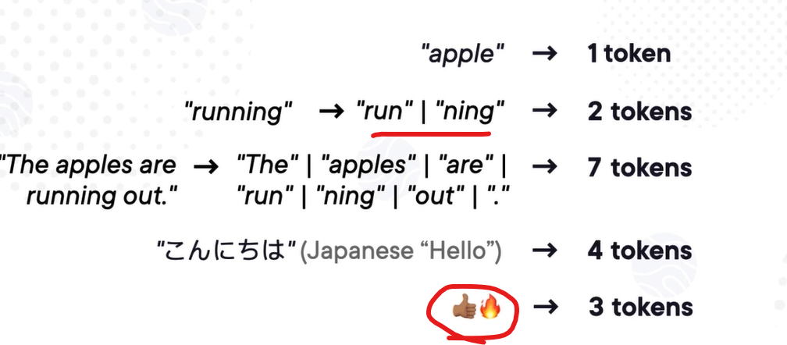

Choosing the right context size –

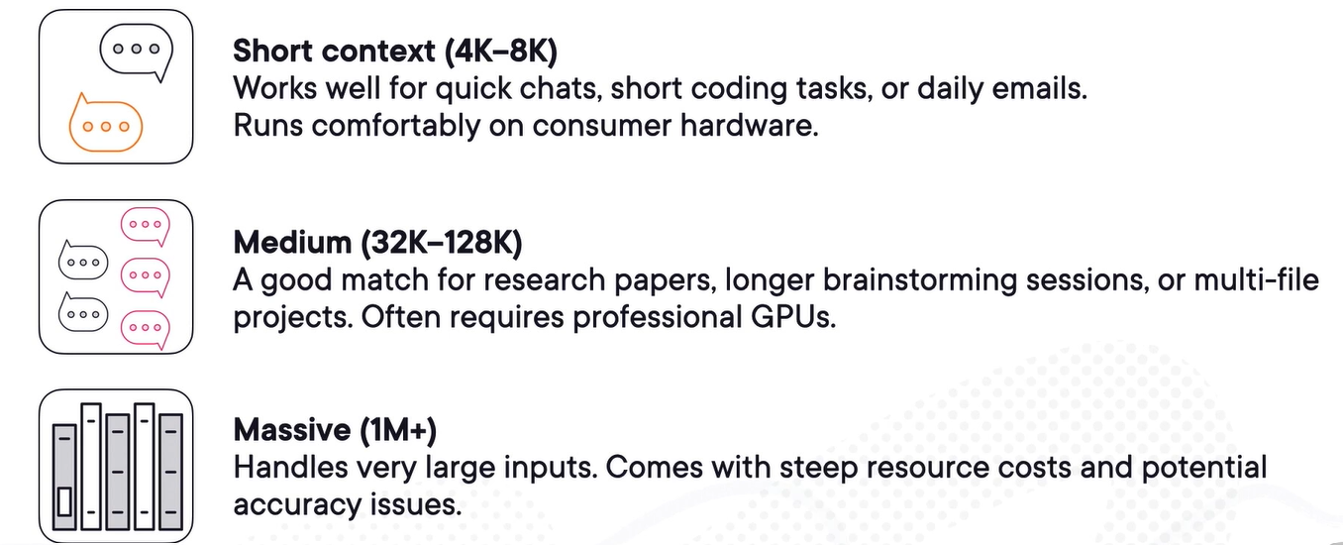

Architecture consideration –

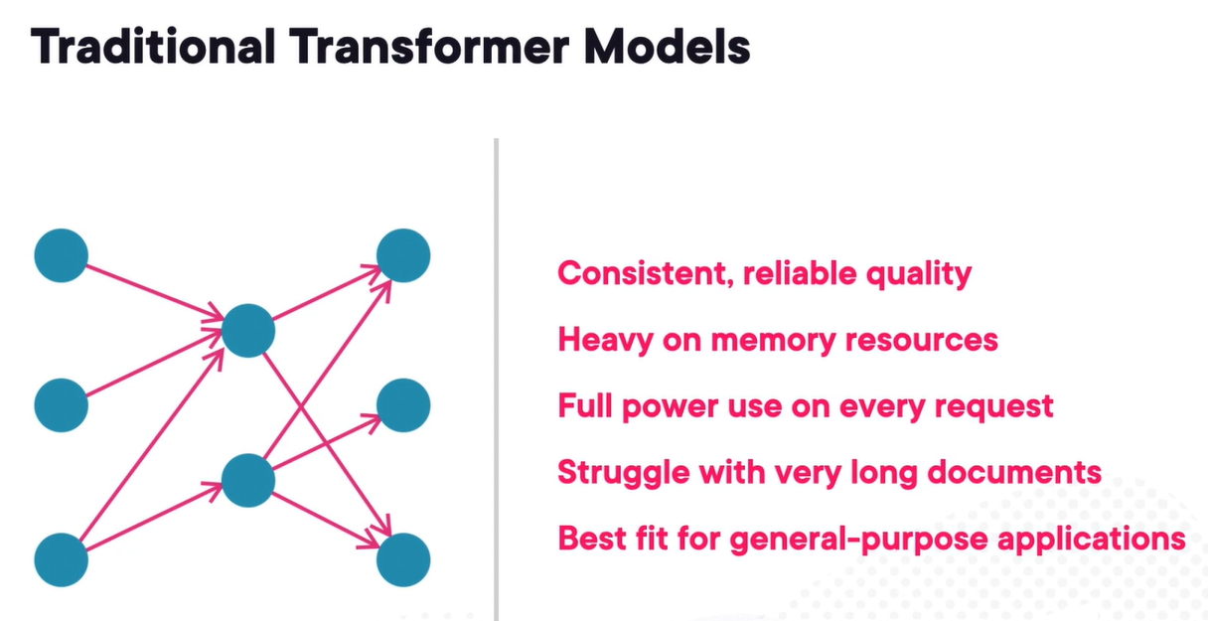

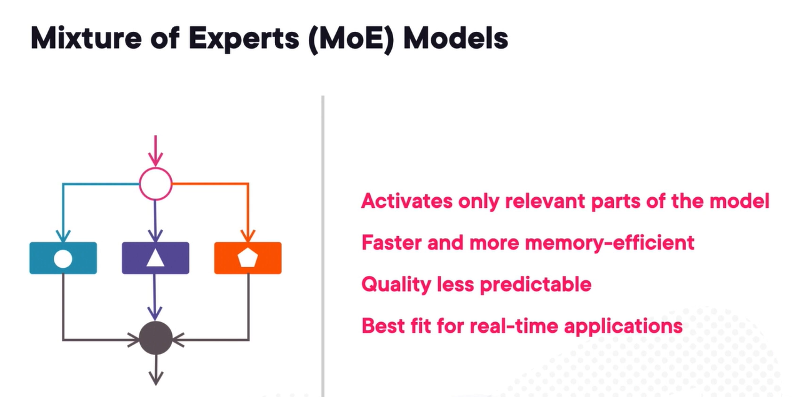

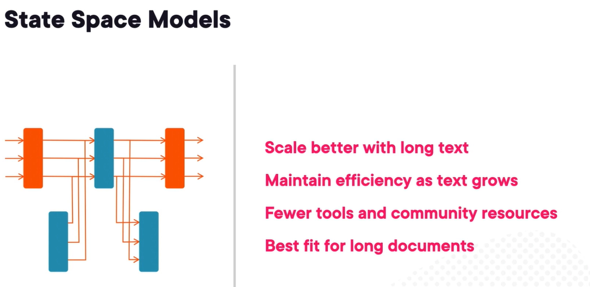

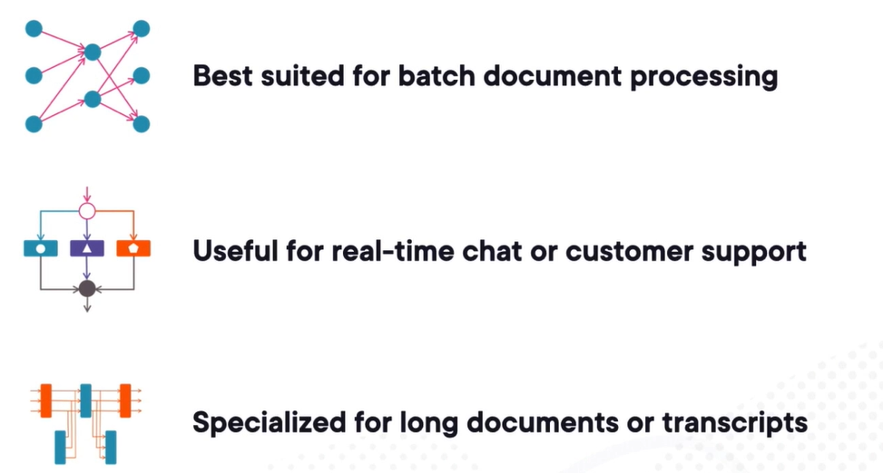

Benchmarks and metrics – MMLU (massive multitask language understanding) – it scores represent the percentage of multiple-choice questions answered correctly. It evaluates the breadth not depth.

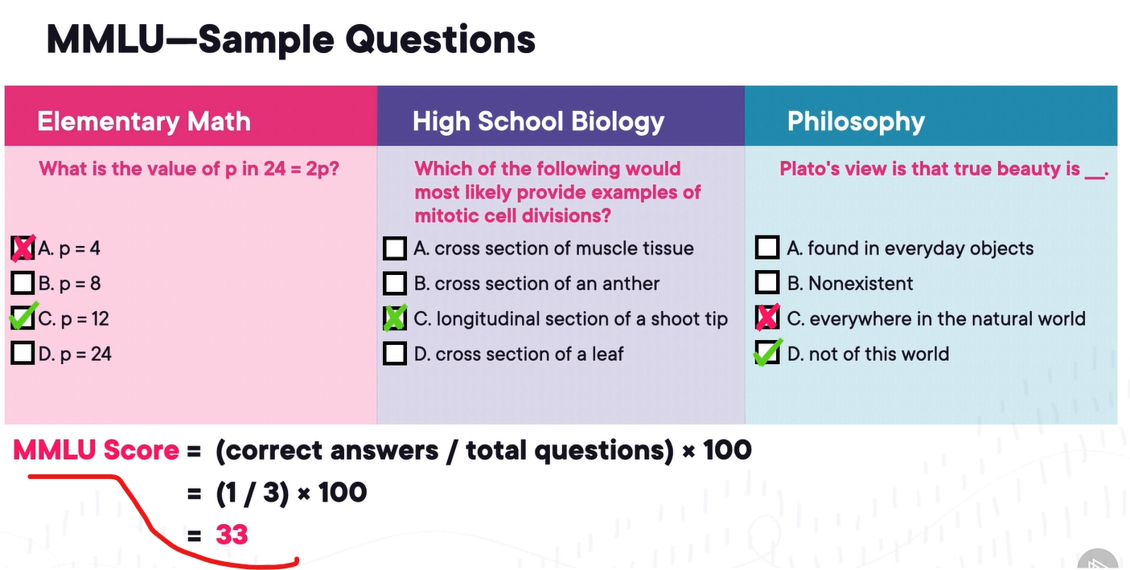

Another benchmark is HLM (holistic evaluation of language models) – it evaluates against multiple metrics like Accuracy, calibration, robustness, fairness, bias, toxicity, efficiency. It gives us detailed report card.

Coding benchmark – HumanEval, MBPP (mostly basic python problems).

We can focus on domain relevance benchmarks as our own use case and application domain instead of going to the general benchmark –

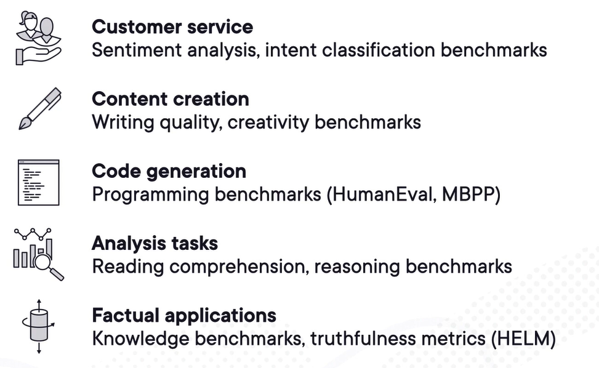

Local testing – 3B-8B models run smoothly on modern laptops, 10-14B still run fine but might take longer to respond and meanwhile the laptop might not be functional for other task. 70B+ models need special hardware as they need cloud server or multi-GPU servers.

Ollama library is best for open-source models also provides tech insights for the different models.

To start with, start on local system and go for a smaller parameter model, find the gaps, research the bigger models and run a cost-benefit analysis.

Hardware path –

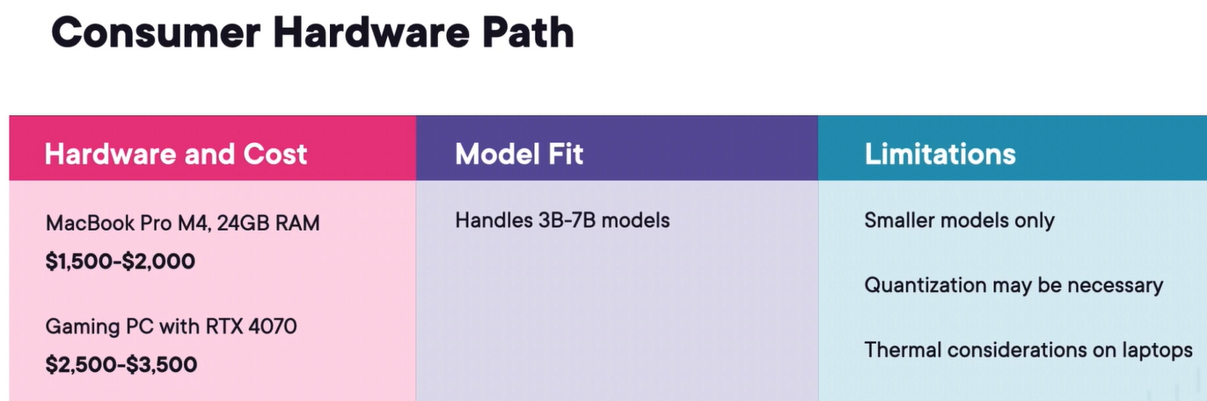

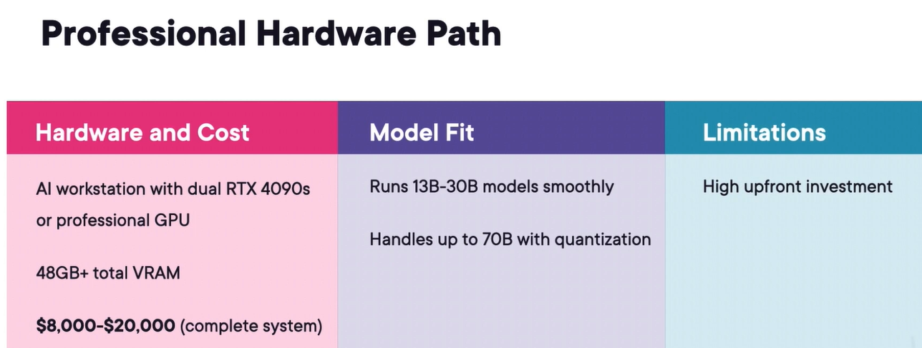

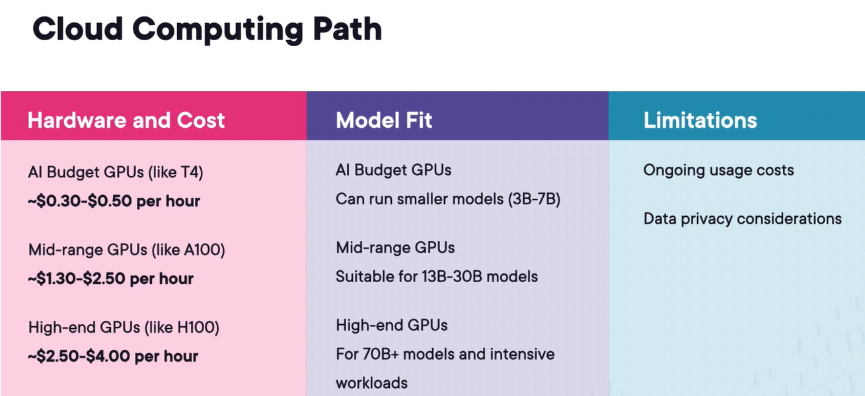

The real decision scenario path looks like below –

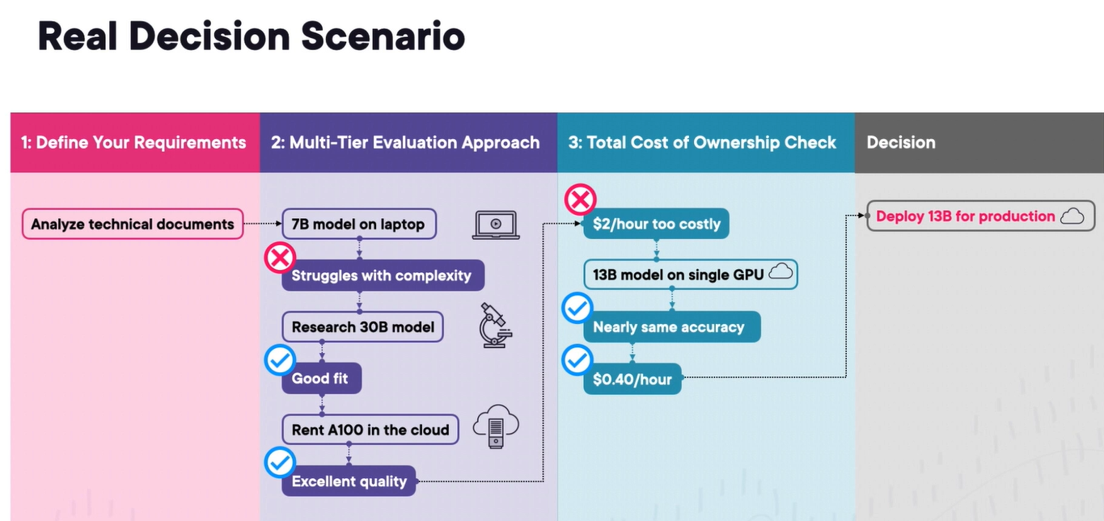

Running our first LLM –

<https://app.pluralsight.com/ilx/video-courses/edc139b2-856c-4eba-96f8-7a287117fd91/a1a7fed9-afdc-4912-a007-280fd1e77a57/68cb2283-9abd-43f8-aecb-7982fc645ad6>

First try lighter model –

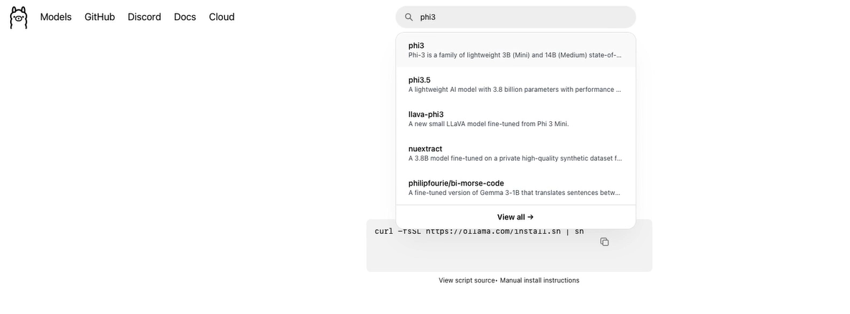

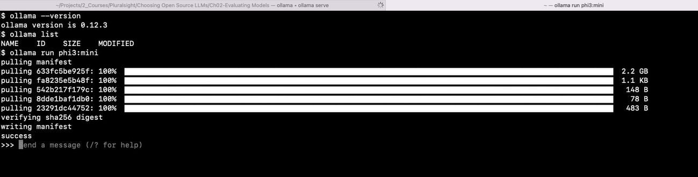

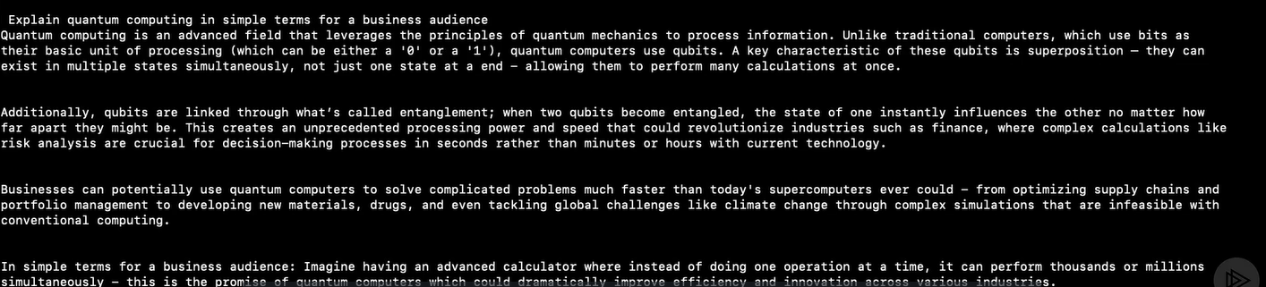

Now try heavier model – it will cause more spike in CPU but will give more detailed response.

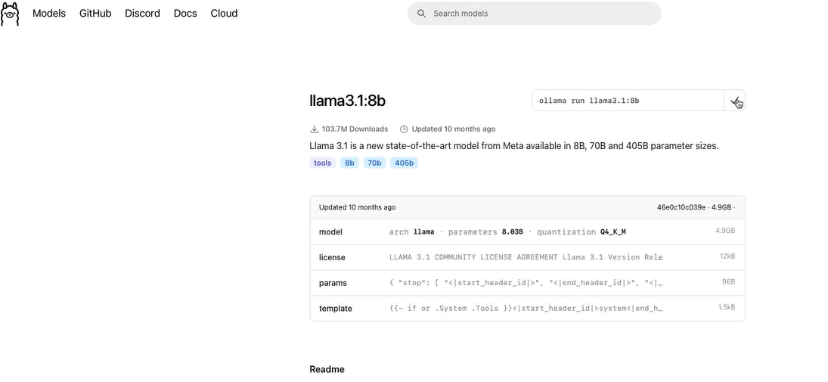

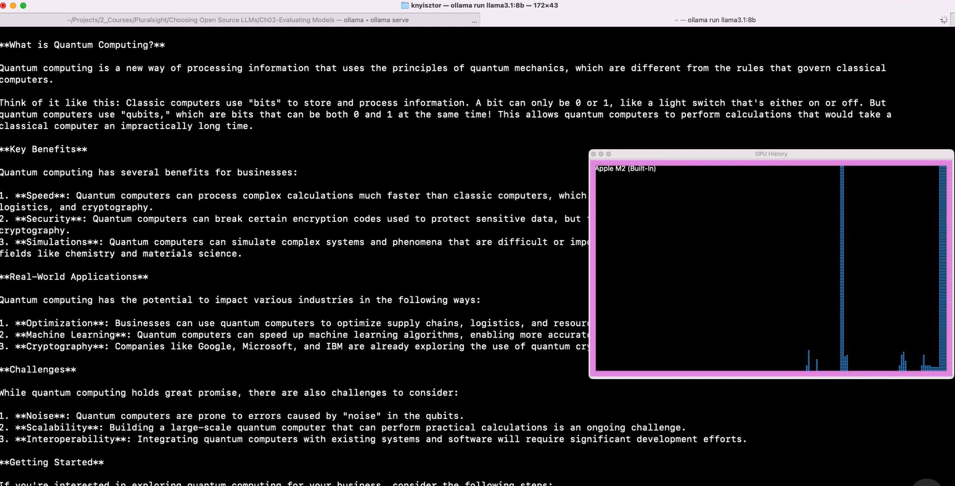

License types – research-only license (good for hobby project not for commercial), permissive license, custom community licenses.

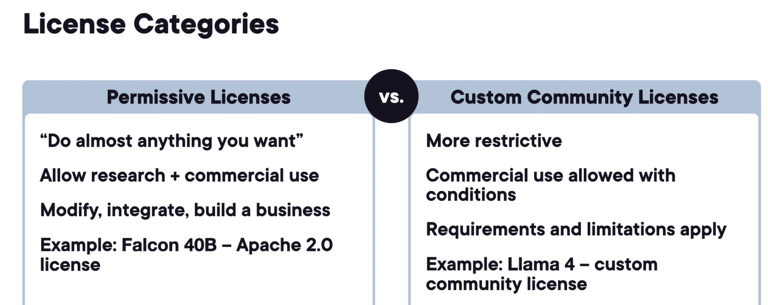

Common license red flags – research-only like Mistral’s MNPL license, user limits and revenue caps like Llama 4 license caps to 700M MAU cap, attribution requirements like for Llama 4 we need to put “Built with Llama” on web UI or in documentation, Geographic restrictions, acceptable use policies like ban illegal activities like hate speech, unauthorized professional advice.

# OpenAI ChatGPT Advanced Features

In starting days, ChatGPT started with cutoff knowledge, but ChatGPT and OpenAI introduced capabilities to include document in its UI, with that it gave ChatGPT the ability to extend its abilities on fresher real-time data which is now available on demand. Another advance features are understanding generate, and fix complete code snippets. It can analyze visual inputs and provide visual outputs. It can maintain memory across different interactions.

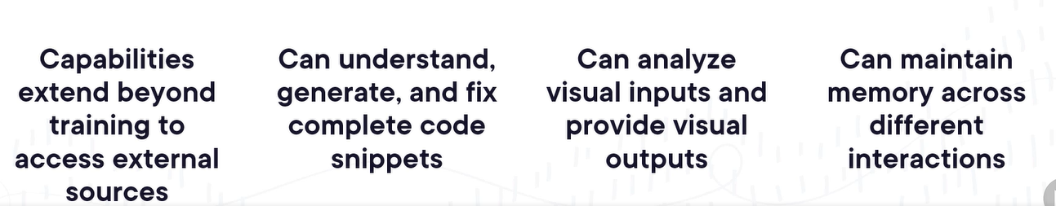

ChatGPT’s search architecture – it first analyze if it can be respond with its existing knowledge set otherwise it will do the web search –

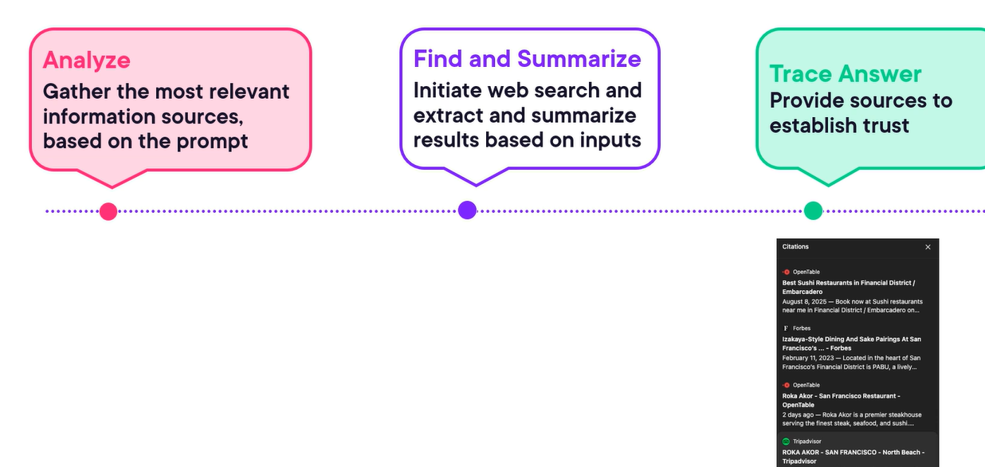

Research planning by activities to find issues in our application for finding the declining sales volume recently –

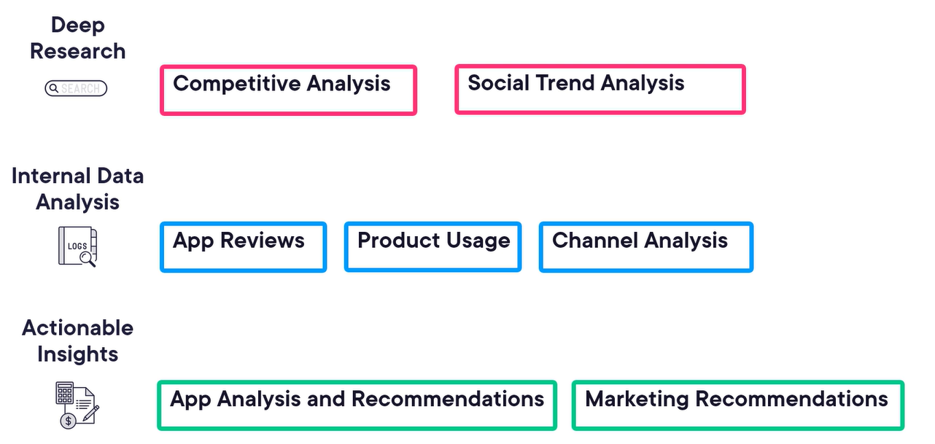

We should customize the chat GPT configuration –

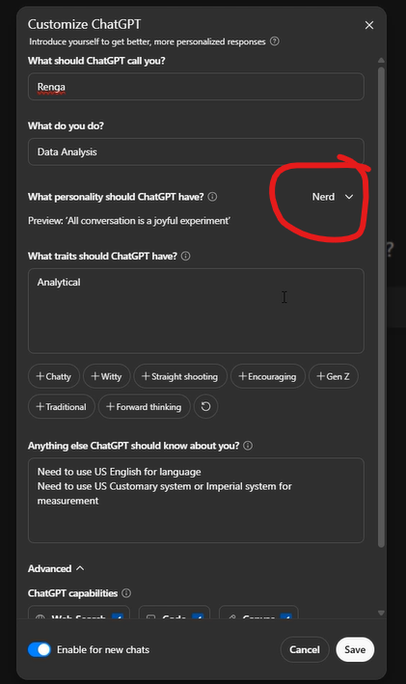

Prompt for deep research – it will give app review data, user sentiments, etc.

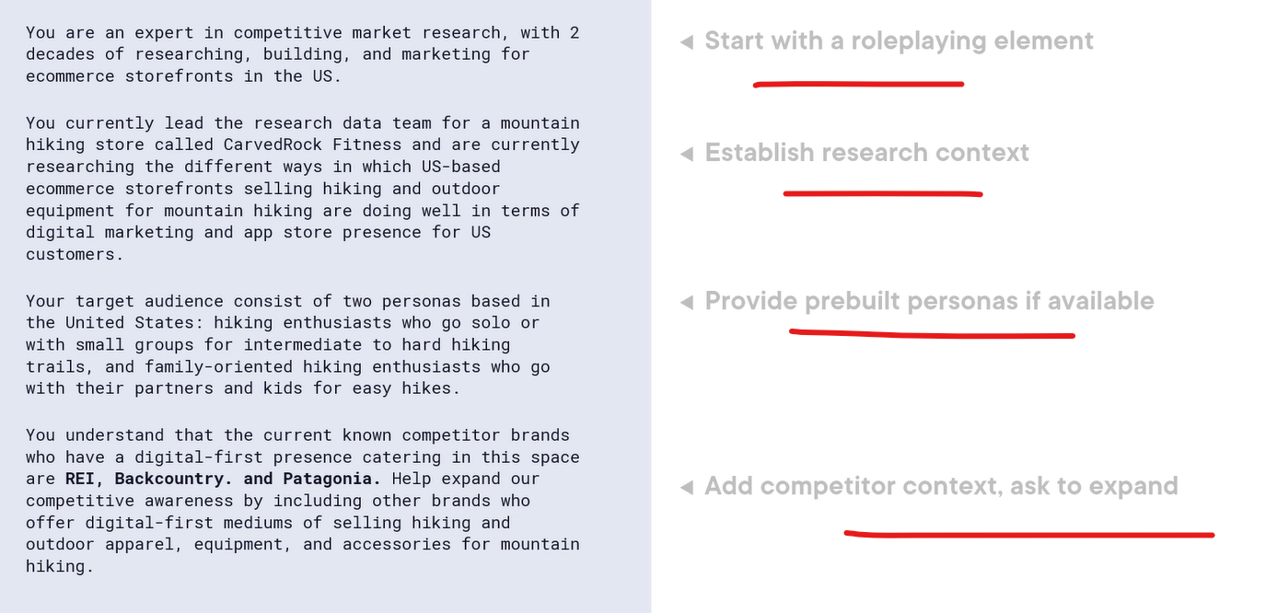

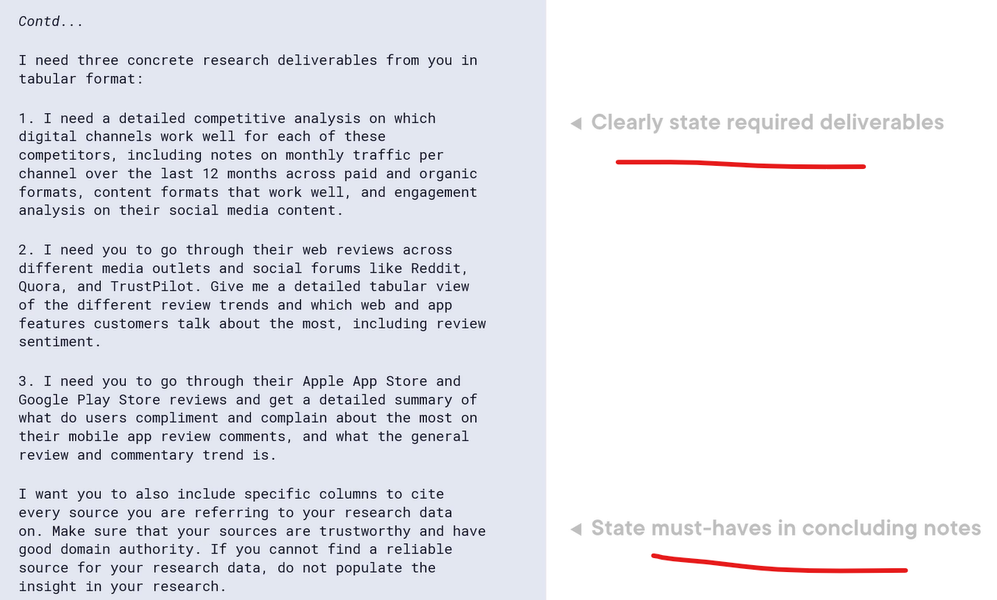

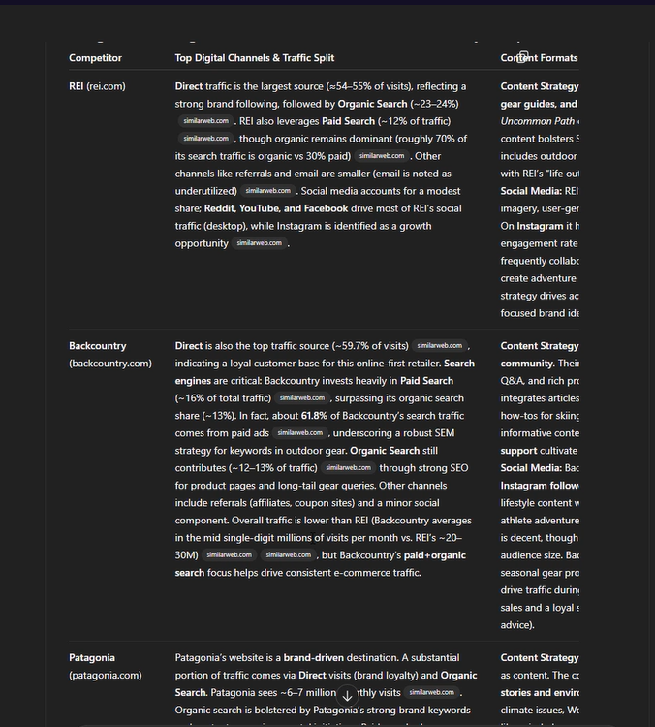

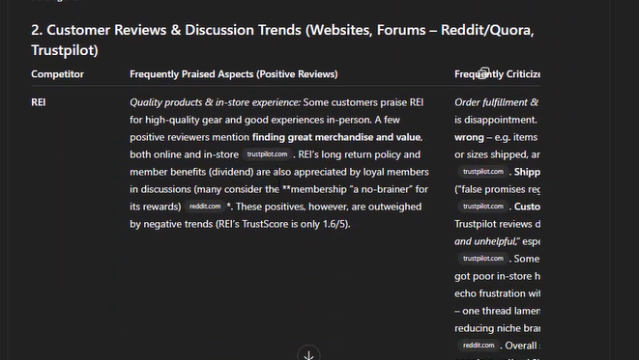

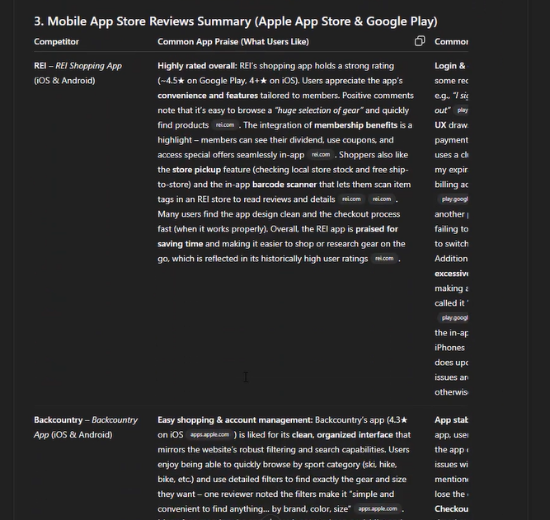

We can feed ChatGPT our app’s user review to analyze what people are complaining about, the patterns and how to quickly fix the most common ones –

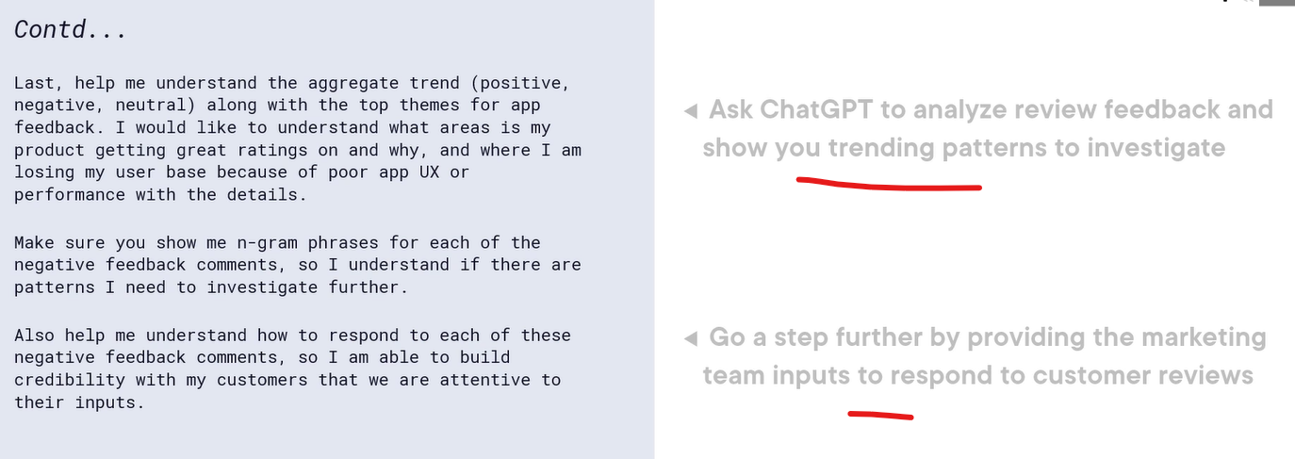



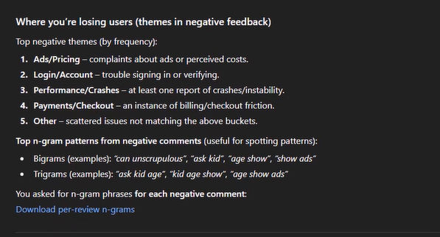

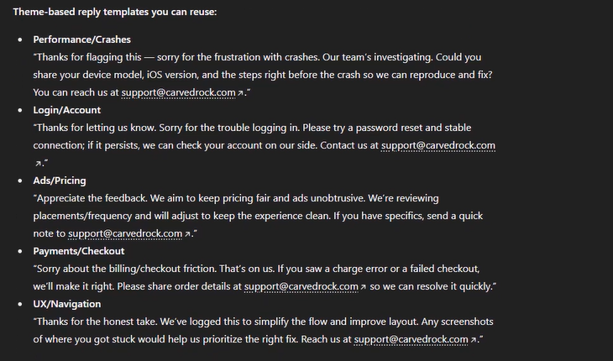

We can feed the Google analytics GFO report to get better insights and action plan to fix the problems.

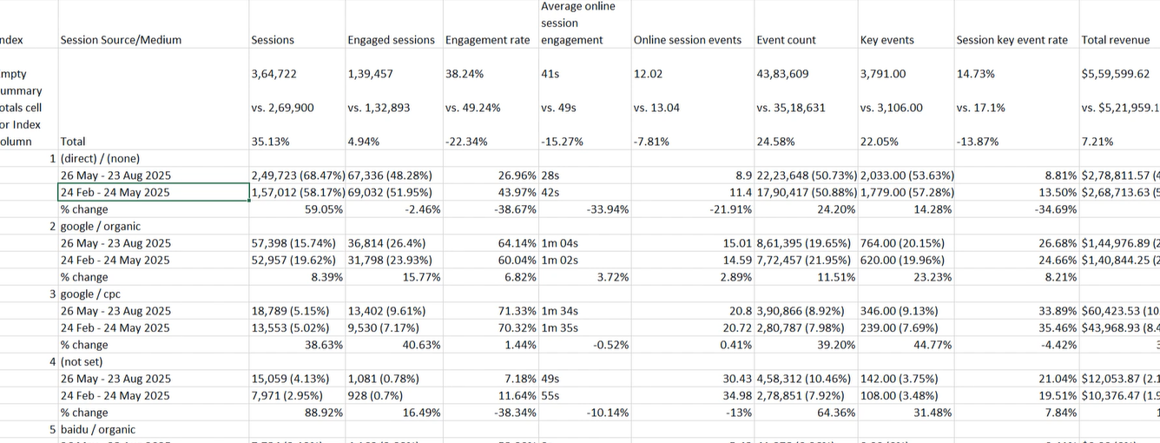

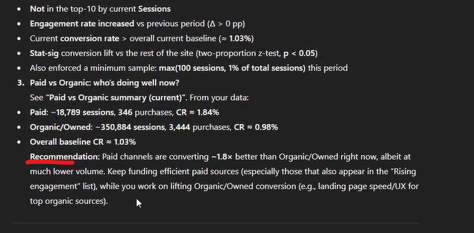

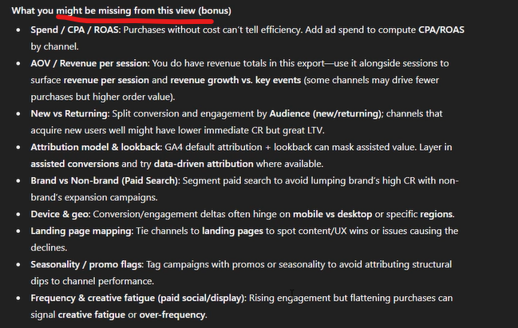

We can upload images (UI screens) to get suggestion on increasing engagement and user experience as a Heuristic expert evaluation –

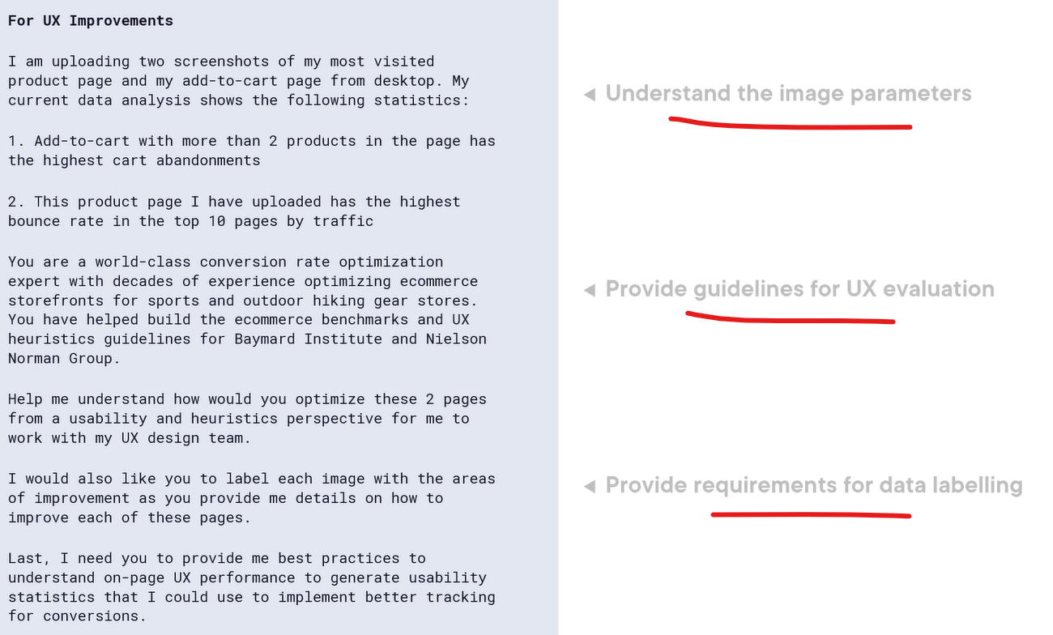



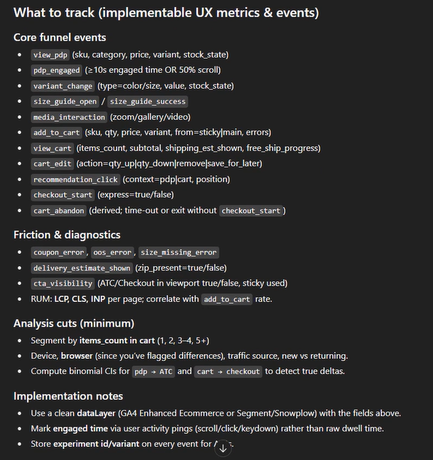

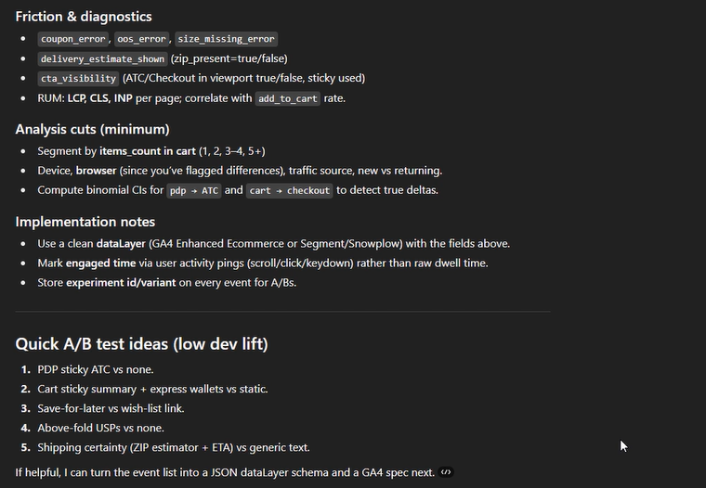

It can even create the revised screenshots for that improved UI designs with action items –

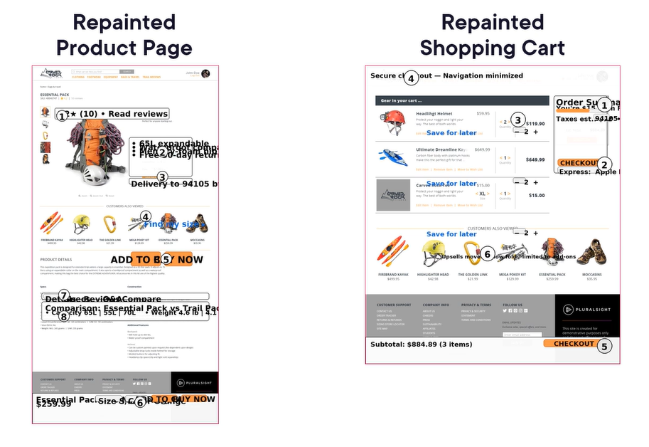



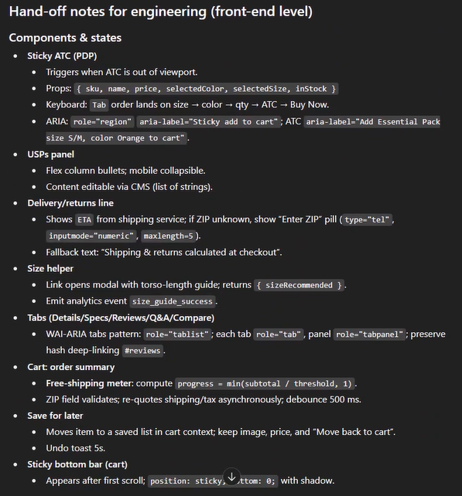

ChatGPT memory – it remembers explicit and implicit nuances and builds a memory bank from past interacts and remembers instructional preferences like generating code in python.

Types of custom instructions and memory – system preferences, project instructions, memory.

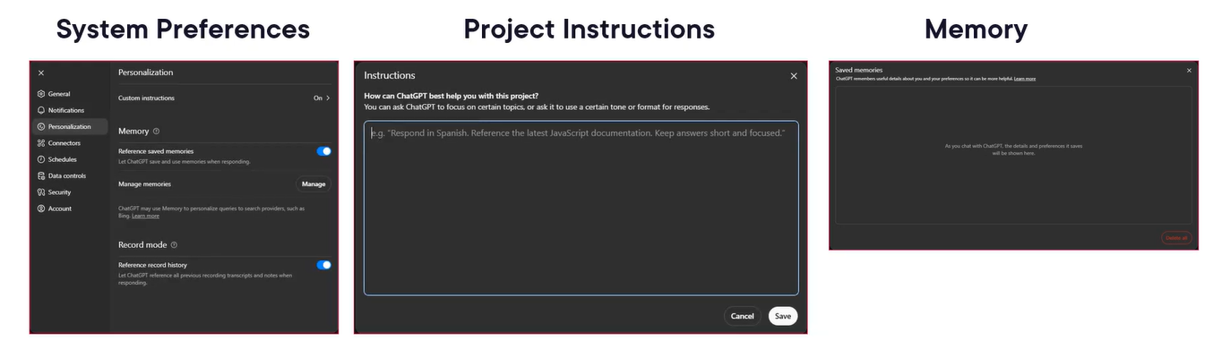

# Introduction to AI-assisted Coding

AI-assisted coding isn’t about replacing us! It is about augmenting our capabilities.

Vibe coding vs. professional coding – vibe coding is not professional software development. Professional developers build systems that real users depend on, and they cannot ship code that they don’t understand.

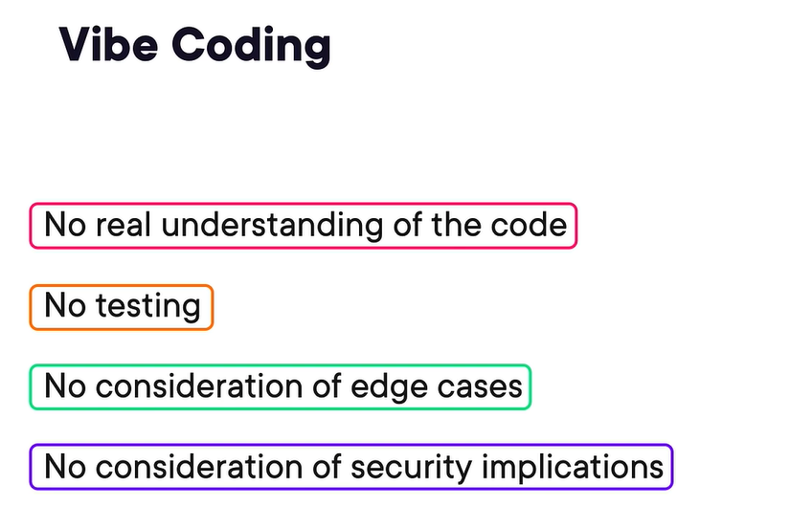

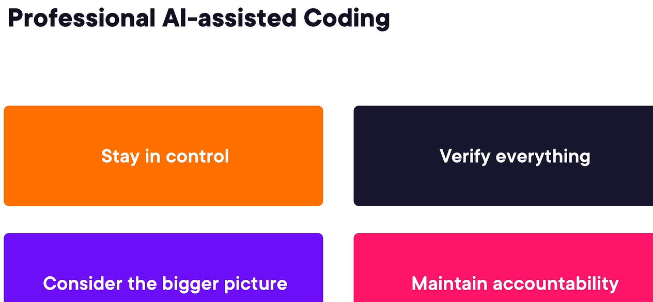

AI-assisted coding is powerful, but not magical. It can hallucinate solutions that don’t work, generate code that creates technical debt, and introduce security vulnerabilities.

Human in the loop – AI doesn’t work alone; it works with you. You are an active participant who reviews validates and makes final decisions.

The modern coder’s toolkit – ide-integrated, ai-first IDE, web-based, terminal based, general purpose chant interfaces.

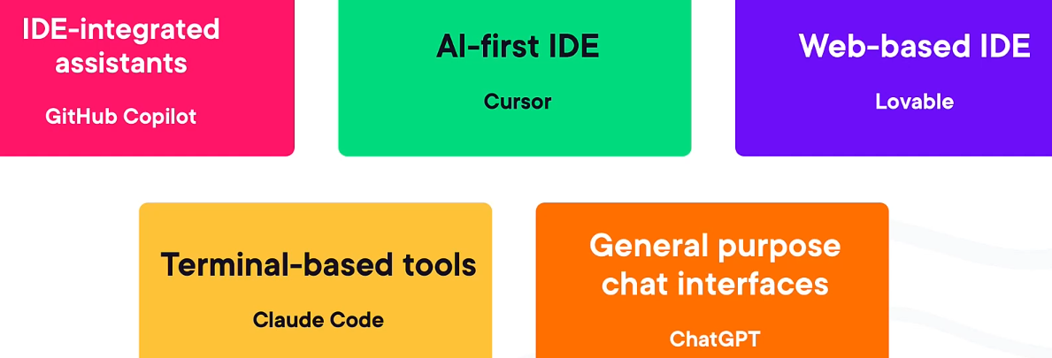

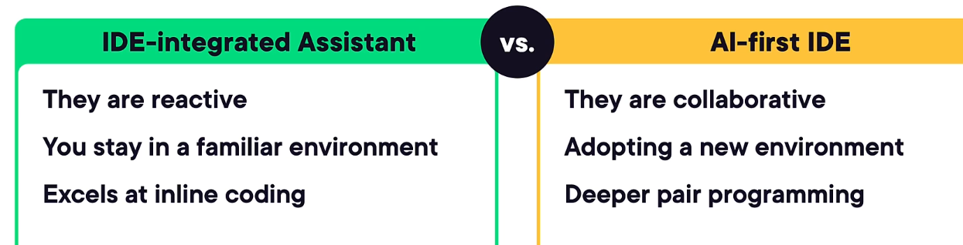

Best practices - Choosing your AI coding partner –

